Supplementary material
Figure S4: “Country Road” Mass Casualty Simulation Scenario

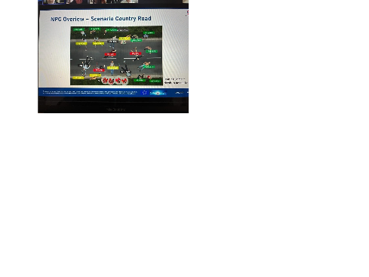
Figure S5: Estimated marginal means of self-efficacy in performing mass casualty incidents across time points, by gender.

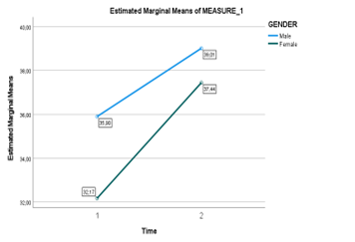
Figure S6: Estimated marginal means of self-efficacy in performing mass casualty incidents across time points, by country of participants.
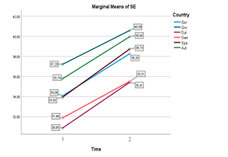
FigureS 7: Estimated marginal means of self-efficacy in performing mass casualty incidents across time points, by occupation.
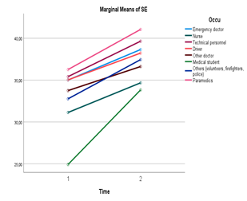
Table S3: Item differences between categories with Independent-Samples Kruskal-Wallis Test.
ITEM | CATEGORY | SIGNIFICANT DIFFERENCE (Sig.)
ITEM 1: Mental reminder of MCI protocol | Hours of MCI training | *
ITEM 2: Use of self-protective techniques and material |  | ns
ITEM 3: Coordination with the team | Gender  Hours of MCI experience | **  **
ITEM 4: Use communication devices | Gender  Hours of MCI training | *  *
ITEM 5: Manage the resources deployment | Gender  Country of participant | **  *
ITEM 6: Installation and supervision of working areas (zoning) | Gender | *
ITEM 7: Perform the first triage | Gender  Hours of MCI experience | *  *
ITEM 8: Perform life-saving manoeuvres | Gender  Hours of MCI experience | *  *
Notes: ns=not significant at p<.05, *p< .05, **p<.01

ANNEX I
Self-efficacy in performing mass casualty incidents (SESMCI).
Below are procedures typically performed in a mass casualty incident (MCI). Please indicate your confidence to achieve them successfully in a real MCI situation.
1: No confidence at all
2: Slightly confidence
3: Some confidence
4: Fairly confident
5: Highly confident
6: Completely confident

My degree of confidence in performing the following actions is...
Ítems |  | Degree of confidence
1. | Mental reminder to fulfil the MCI intervention protocol as I approach the scene. | 1 - 2 - 3 - 4 - 5 - 6
2. | Proper use of self-protective techniques and/or material at the scene (in order to prevent intrinsic and extrinsic hazards). | 1 - 2 - 3 - 4 - 5 - 6
3. | Coordination with the team members to initiate appropriate actions, according to my role in the MCI. (distribution of tasks). | 1 - 2 - 3 - 4 - 5 - 6
4. | Use communication devices correctly according to MCI procedures in each country | 1 - 2 - 3 - 4 - 5 - 6
5. | Manage the deployment of resources effective and efficiently. | 1 - 2 - 3 - 4 - 5 - 6
6. | Installation and supervision of working areas (zoning) and deployment of possible structures. | 1 - 2 - 3 - 4 - 5 - 6
7. | Perform the first triage (classification) within the allocated time and MCI procedures. | 1 - 2 - 3 - 4 - 5 - 6
8. | Perform life-saving manoeuvres when needed (according to MCI procedures). | 1 - 2 - 3 - 4 - 5 - 6

ANNEX II Day/week schedule during the Field Trials
Phase | What | Detail | Where | By whom | Minutes
Early Bird Coffee | Participants arrival | Welcome (coffee and tea)  Signing participants list & consent form(s)  Changing clothes to Operational dress | General meeting room | ICP* and/or Trainer
Pre –training  45 min | Welcome & Information | PowerPoint: “Welcome & information” | Research room | ICP and/or Trainer  (+ researchers) | 10
Pre –training  45 min | Administrations | Signing Informed consent on data collection & research | Research room | ICP and/or Trainer  (+ researchers) | 5
Pre –training  45 min | Sensor donning | Bring on Wearables (Bio-sensors) | Research room | ICP and/or Trainer  (+ researchers) | 10
Pre –training  45 min | Pre training Research | Registration in the MAS dashboard  Baseline questionnaire | Research room | ICP and/or Trainer  (+ researchers) | 15
Pre –training  45 min | Baseline setting 1 | Biosensor measuring before VR donning  2 minutes of standing still, fixation cross on the wall | Research room | ICP and/or Trainer  (+ researchers) | 5
Training  95 min | Briefing | Training pitch introduction | Training pitch | Trainer | 10
Training  95 min | VR donning | Bring on VR-equipment | Training pitch | Trainer | 10
Training  95 min | Calibration | VR-calibration | Training pitch | Trainer  (+ operator) | 5
Training  95 min | Tutorial | Demo scenario  Learning to use & getting used to the MR equipment  Short intro before the scenario | Training pitch | Trainer  (+ operator) | 5
Training  95 min | Baseline setting 2 | Heartrate variability measuring after the tutorial | Training pitch | Trainer  (+ researchers) | 5
Training  95 min | Trial run 1 | Country road Scenario  Short intro before the scenario  Run scenario  Data upload | Training pitch | Trainer  (+ operator) | 10
Training  95 min | Research run 1 | Questionnaires / interviews | Training pitch | Trainer  (+ researchers) | 10
Training  95 min | Hot wash run 1 | Hot wash debrief | Training pitch | Trainer | 5
Training  95 min | Trial run 2 | Tunnel Scenario  Short intro before the scenario  Run scenario  Data upload | Training pitch | Trainer  (+ operator) | 10
Training  95 min | Research run 2 | Questionnaires / interviews | Training pitch | Trainer  (+ researchers) | 10
Training  95 min | Hot wash run 2 | Hot wash debrief | Training pitch | Trainer | 10
Training  95 min | Sensor Doffing | Remove equipment & measurement tools  Disinfection VR equipment (no impact on timeline) | Training pitch | Trainer  (+ researchers) | 5
Post training  55 min | AAR* | Debriefing and summary of the training  Evaluate the Stress dashboard + smart scenario control | AAR-room | Trainer | 25
Post training  55 min | Post training research | Research questionnaires, quick interviews | AAR-room | Trainer  (+ researchers) | 20
Post training  55 min | Focus Group | Informed consent for follow-up with selected participants | AAR-room | Trainer  (+ researchers) | 10
ICP: institution contact person
AAR: After Action Review or Debriefing

