A Decade of Endemic Human Coronaviruses: Epidemiological Patterns and Clinical Significance in an Adult Cohort at a Tertiary Care Hospital in Germany

Christian Propach, Mario Hönemann, Vladan Vučinić, Armin Frille, Tom Berthold, Sandra Bergs, Melanie Maier and Corinna Pietsch

Supplementary Material
Table S1. Absolute species-specific coronavirus detections stratified by season and month.

Seasons | months | 229E | NL63 | HKU1 | OC43 | Total | Total per season
 | January | 0 | 0 | 0 | 0 | 0 | 15
 | February | 3 | 0 | 2 | 3 | 8 | 15
 | March | 1 | 1 | 4 | 1 | 7 | 15
 | April | 1 | 0 | 1 | 0 | 2 | 15
Season 2012 | May | 0 | 2 | 2 | 0 | 4 | 15
 | June | 0 | 2 | 0 | 0 | 2 | 15
 | July | 0 | 0 | 0 | 0 | 0 | 15
 | August | 0 | 0 | 0 | 0 | 0 | 15
 | September | 0 | 0 | 0 | 0 | 0 | 15
 | October | 0 | 0 | 0 | 0 | 0 | 41
 | November | 0 | 0 | 0 | 0 | 0 | 41
 | December | 0 | 3 | 0 | 3 | 6 | 41
 | January | 2 | 2 | 0 | 9 | 13 | 41
 | February | 3 | 3 | 0 | 7 | 13 | 41
Season 2012/2013 | March | 7 | 4 | 0 | 6 | 17 | 41
 | April | 6 | 2 | 0 | 1 | 9 | 41
 | May | 1 | 0 | 1 | 0 | 2 | 41
 | June | 0 | 0 | 0 | 0 | 0 | 41
 | July | 0 | 0 | 0 | 0 | 0 | 41
 | August | 0 | 0 | 0 | 0 | 0 | 41
 | September | 0 | 0 | 0 | 0 | 0 | 41
 | October | 0 | 0 | 0 | 0 | 0 | 32
 | November | 0 | 0 | 0 | 1 | 1 | 32
 | December | 0 | 0 | 1 | 1 | 2 | 32
 | January | 0 | 0 | 3 | 0 | 3 | 32
 | February | 0 | 0 | 6 | 1 | 7 | 32
Season 2013/2014 | March | 0 | 2 | 1 | 1 | 4 | 32
 | April | 0 | 2 | 0 | 0 | 2 | 32
 | May | 0 | 1 | 0 | 1 | 2 | 32
 | June | 0 | 0 | 0 | 0 | 0 | 32
 | July | 0 | 0 | 0 | 1 | 1 | 32
 | August | 0 | 0 | 0 | 0 | 0 | 32
 | September | 0 | 0 | 0 | 0 | 0 | 32

 | October | 0 | 0 | 0 | 0 | 0 | 35
 | November | 0 | 0 | 0 | 0 | 0 | 35
 | December | 0 | 0 | 0 | 3 | 3 | 35
 | January | 1 | 2 | 0 | 0 | 3 | 35
 | February | 1 | 4 | 1 | 0 | 6 | 35
Season 2014/2015 | March | 1 | 1 | 0 | 5 | 7 | 35
 | April | 2 | 1 | 2 | 5 | 10 | 35
 | May | 1 | 0 | 1 | 0 | 2 | 35
 | June | 1 | 0 | 0 | 1 | 2 | 35
 | July | 0 | 0 | 0 | 0 | 0 | 35
 | August | 0 | 0 | 0 | 0 | 0 | 35
 | September | 0 | 0 | 0 | 1 | 1 | 35
 | October | 0 | 0 | 0 | 0 | 0 | 38
 | November | 1 | 0 | 0 | 2 | 3 | 38
 | December | 0 | 1 | 1 | 0 | 2 | 38
 | January | 1 | 1 | 2 | 1 | 5 | 38
 | February | 2 | 3 | 5 | 1 | 11 | 38
Season 2015/2016 | March | 5 | 5 | 3 | 1 | 14 | 38
 | April | 8 | 4 | 1 | 1 | 14 | 38
 | May | 1 | 0 | 0 | 0 | 1 | 38
 | June | 0 | 1 | 0 | 0 | 1 | 38
 | July | 0 | 0 | 0 | 0 | 0 | 38
 | August | 0 | 0 | 0 | 0 | 0 | 38
 | September | 0 | 0 | 0 | 1 | 1 | 38
 | October | 0 | 0 | 0 | 2 | 2 | 46
 | November | 0 | 0 | 0 | 7 | 7 | 46
 | December | 0 | 1 | 0 | 19 | 20 | 46
 | January | 0 | 1 | 0 | 22 | 23 | 46
 | February | 2 | 3 | 0 | 10 | 15 | 46
Season 2016/2017 | March | 12 | 5 | 0 | 7 | 24 | 46
 | April | 6 | 1 | 0 | 1 | 8 | 46
 | May | 0 | 0 | 0 | 0 | 0 | 46
 | June | 0 | 1 | 0 | 0 | 1 | 46
 | July | 0 | 0 | 0 | 0 | 0 | 46
 | August | 0 | 0 | 0 | 0 | 0 | 46
 | September | 0 | 0 | 0 | 0 | 0 | 46
 | October | 0 | 0 | 0 | 0 | 0 | 53
 | November | 0 | 0 | 0 | 0 | 0 | 53
 | December | 0 | 0 | 1 | 3 | 4 | 53
 | January | 0 | 0 | 6 | 2 | 8 | 53
 | February | 0 | 1 | 1 | 0 | 2 | 53
Season 2017/2018 | March | 0 | 9 | 1 | 6 | 16 | 53
 | April | 0 | 7 | 0 | 2 | 9 | 53
 | May | 0 | 0 | 1 | 2 | 3 | 53
 | June | 0 | 1 | 0 | 0 | 1 | 53
 | July | 0 | 0 | 0 | 0 | 0 | 53
 | August | 0 | 0 | 0 | 0 | 0 | 53
 | September | 0 | 0 | 0 | 1 | 1 | 53

 | October | 0 | 0 | 0 | 1 | 1 | 58
 | November | 0 | 0 | 0 | 1 | 1 | 58
 | December | 0 | 0 | 0 | 2 | 2 | 58
 | January | 2 | 2 | 1 | 9 | 14 | 58
 | February | 11 | 8 | 0 | 5 | 24 | 58
Season 2018/2019 | March | 8 | 6 | 0 | 1 | 15 | 58
 | April | 1 | 2 | 1 | 1 | 5 | 58
 | May | 0 | 0 | 0 | 0 | 0 | 58
 | June | 0 | 0 | 0 | 0 | 0 | 58
 | July | 1 | 0 | 0 | 0 | 1 | 58
 | August | 0 | 0 | 0 | 0 | 0 | 58
 | September | 0 | 0 | 0 | 1 | 1 | 58
 | October | 0 | 1 | 0 | 0 | 1 | 25
 | November | 0 | 0 | 0 | 0 | 0 | 25
 | December | 0 | 2 | 0 | 0 | 2 | 25
 | January | 0 | 1 | 8 | 2 | 11 | 25
 | February | 1 | 6 | 3 | 0 | 10 | 25
Season 2019/2020 | March | 2 | 5 | 2 | 0 | 9 | 25
 | April | 1 | 4 | 0 | 0 | 5 | 25
 | May | 1 | 1 | 0 | 0 | 2 | 25
 | June | 0 | 0 | 0 | 0 | 0 | 25
 | July | 0 | 0 | 0 | 0 | 0 | 25
 | August | 0 | 0 | 0 | 0 | 0 | 25
 | September | 0 | 0 | 0 | 0 | 0 | 25
 | October | 0 | 0 | 0 | 0 | 0 | 36
 | November | 0 | 0 | 0 | 0 | 0 | 36
 | December | 0 | 0 | 0 | 0 | 0 | 36
 | January | 0 | 0 | 0 | 0 | 0 | 36
 | February | 0 | 0 | 0 | 0 | 0 | 36
Season 2020/2021 | March | 0 | 0 | 0 | 1 | 1 | 36
 | April | 0 | 2 | 0 | 0 | 2 | 36
 | May | 1 | 1 | 0 | 0 | 2 | 36
 | June | 1 | 1 | 0 | 1 | 3 | 36
 | July | 0 | 1 | 0 | 0 | 1 | 36
 | August | 0 | 0 | 0 | 0 | 0 | 36
 | September | 0 | 0 | 0 | 0 | 0 | 36
 | October | 0 | 0 | 0 | 4 | 4 | 28
 | November | 1 | 0 | 0 | 2 | 3 | 28
 | December | 1 | 0 | 0 | 4 | 5 | 28
 | January | 1 | 0 | 0 | 4 | 5 | 28
 | February | 1 | 0 | 0 | 0 | 1 | 28
Season 2021/2022 | March | 1 | 0 | 0 | 0 | 1 | 28
 | April | 0 | 0 | 0 | 0 | 0 | 28
 | May | 0 | 0 | 1 | 0 | 1 | 28
 | June | 1 | 0 | 0 | 0 | 1 | 28
 | July | 0 | 0 | 0 | 0 | 0 | 28
 | August | 0 | 0 | 0 | 0 | 0 | 28
 | September | 0 | 0 | 0 | 0 | 0 | 28
Total |  | 105 | 120 | 63 | 181 |  | 469

Figure S1a.
Monthly distribution of new HCoV-229E cases (n=105, bars). The dotted line represents the total amount of detected HCoV.

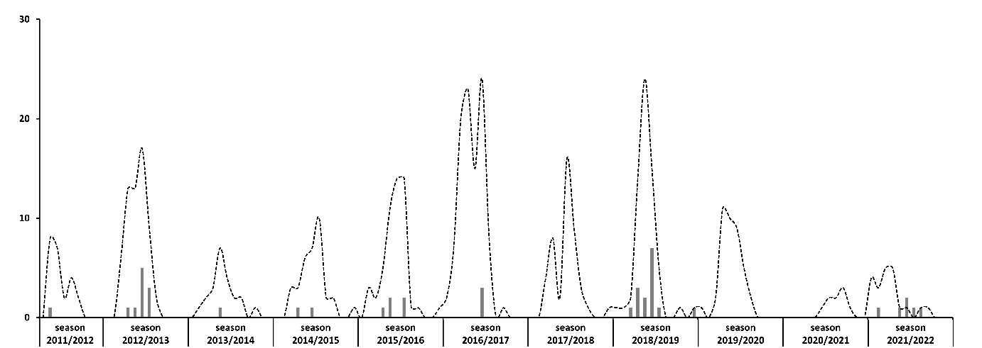

Figure S1b.
Monthly distribution of new HCoV-NL63 cases (n =120, bars). The dotted line represents the total amount of detected HCoV.

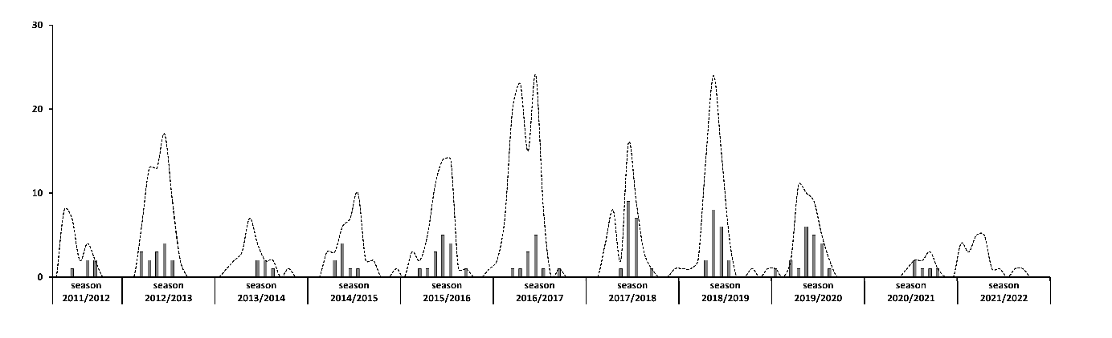

Figure S1c.
Monthly distribution of new HCoV-HKU1 cases (n =63, bars). The dotted line represents the total amount of detected HCoV.

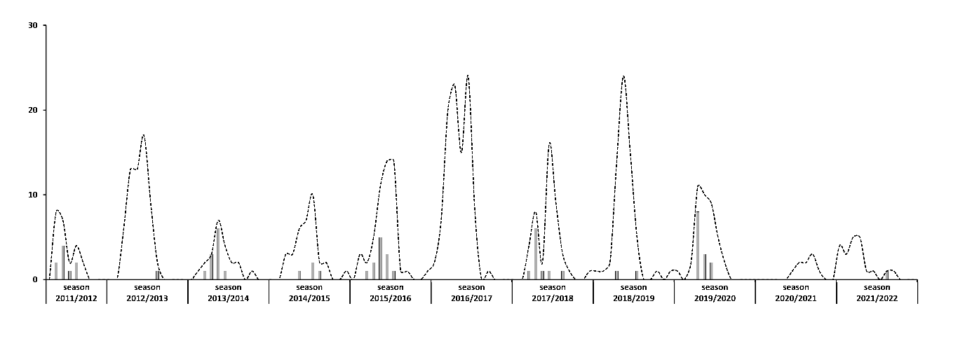

Figure S1d.
Monthly distribution of new HCoV-OC43 cases (n =181, bars). The dotted line represents the total amount of detected HCoV.

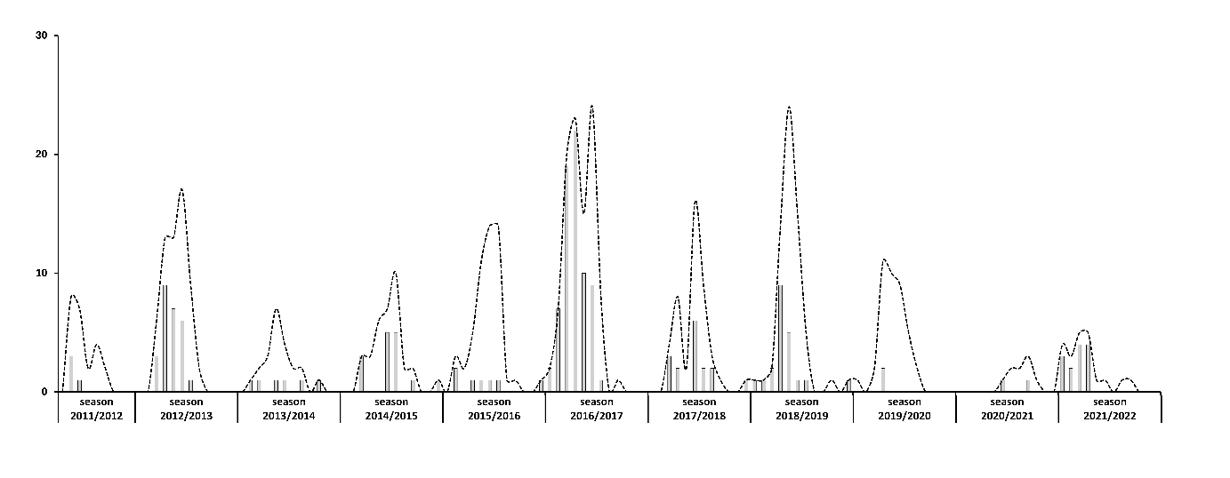

Table S2. Co-infecting pathogens.
Bacteria | n | Viruses | n | Fungi | n
Staphylococcus aureus | 18 | Influenza A H1N1 | 10 | Pneumocystis jiroveci | 3
Streptococcus pneumoniae | 8 | RSV | 12 | Aspergillus spp. | 3
Haemophilus influencae | 8 | Influenza A H3N2 | 10
Pseudomonas aeruginosa | 5 | Rhinovirus | 10
Escherichia coli | 4 | Parainfluenza type 3 | 6
Klebsiella pneumoniae | 4 | Influenza B | 4
Enterococcus faecium | 2 | Parainfluenza type 4 | 3
Moraxella catarrhalis | 3 | CMV | 3
Klebsiella oxytoca | 3 | Bocavirus | 2
Enterobacter cloacae | 3 | Parainfluenza type 1 | 1
Steptococcus dysgalactiae | 2 | Parainfluenza type 2 | 1
Proteus mirabilis | 2 | Metapneumono Virus | 1
Serratia marcescens  Serratia marcescens | 2 | Adenovirus | 1
Streptococcus agalactiae | 1
Granulicatella adiacans | 1
Raoultella ornithinolytica | 1
Pseudomonas fluorescens | 1
Pseudomonas putida | 1
Acinetobacter Baumannii 100.00CFU/ml | 1
Acinetobacter pitii | 1
Mycoplasma pneumoniae | 1
Stenotrophomonas maltophilia | 1
Mykobakterium chimaera | 1

Pathogens detected by type, with n showing their frequencies of detection. The co-infections included cases with detections of more than one pathogen.

Table S 3. Stratification of Co-infecting viral pathogens.

Co-Infection | HCOV-229E | HCoV-NL63 | HCoV-HKU-1 | HCoV-OC43
Influenza A | 6 | 5 | 1 | 8
RSV | 3 | 5 | 0 | 5
Rhinovirus | 2 | 3 | 0 | 4
Parainfluenza | 3 | 3 | 3 | 2
Influenza B | 1 | 1 | 1 | 1
CMV | 0 | 1 | 2 | 0
Bocavirus | 0 | 1 | 0 | 1
Human metapneumovirus | 1 | 0 | 0 | 0
Adenovirus | 1 | 0 | 0 | 0
Pathogens detected by type, with n showing their frequencies of detection. The co-infections included cases with detections of more than one pathogen.

Table S 4. Stratification of co-infecting bacterial pathogens.

Co-Infection | HCOV-229E | HCoV-NL63 | HCoV-HKU-1 | HCoV-OC43
Staphylococcus aureus | 4 | 4 | 2 | 8
Streptococcus pneumoniae | 1 | 3 | 1 | 3
Haemophilus influencae | 2 | 2 | 3 | 1
Pseudomonas aeruginosa | 0 | 1 | 1 | 3
Enterobacteriacae | 5 | 5 | 3 | 8
Moraxella catarrhalis | 1 | 0 | 1 | 1

Pathogens detected by type, with n showing their frequencies of detection. The co-infections included cases with detections of more than one pathogen.

Table S 5. Clinical characteristics and outcomes in patients with co-infection.
 |  | Without Co-infection | With Co-infection | p-Value
Clinical presentation
Fever | [% (n/total)] | 34.6 (79/228) | 47.9 (45/94) | 0.027
Dyspnea | [% (n/total)] | 31 (76/245) | 52.1 (49/94) | < 0.001
URTI | [% (n/total)] | 57.7 (131/227) | 42.4 (36/85) | 0.015
LRTI | [% (n/total)] | 27.2 (85/313) | 61.7 (71/115) | < 0.001
Pneumonia | [% (n/total)] | 16 (50/313) | 48.7 (56/115) | < 0.001
Bronchitis | [% (n/total)] | 5.4 (17/313) | 11.3 (13/115) | 0.035
Exacerbation of OLD | [% (n/total)] | 10.2 (32/313) | 12.2 (14/115) | n.s.
ARDS | [% (n/total)] | 1.8 (6/337) | 8.4 (10/119) | 0.001
ICU stay | [% (n/total)] | 18.3 (62/339) | 35.3 (42/119) | < 0.001
Ventilation | [% (n/total)] | 12.4 (42/339) | 25,2 (30/119) | 0.001
In-hospital mortality | [% (n/total)] | 7.7 (26/339) | 13.4 (16/119) | n.s.
Systemic prednisolone administration | [% (n/total)] | 8.8 (29/328) | 14.5 (17/117) | n.s.
Bronchodilator | [% (n/total)] | 12.5 (41/328) | 12.8 (15/117) | n.s.
Length of stay [days] | [median (IQR)] | 13 (7-24) | 16 (7.75-27) | n.s.
Length of ICU-stay [days] | [median (IQR)] | 4 (2-8.25) | 7 (3.75-14.25 | 0.004

Data are presented as frequencies (% [n/total]) or as median (IQR). In the presence of missing data, “(n/total)” indicates the number of cases meeting the respective criterion (n) out of the number of cases with available data for that parameter (total).

Table S 6. Distribution of co-infection types according to LRTI status.

Co-infection |  |  | LRTI | No LRTI | p-Value
Only viral |  | [% (n/total)] | 10.9 (17/156) | 10.7 (29/272) | n.s.
Only bacterial |  | [% (n/total)] | 22.4 (35/156) | 4.4 (12/272) | <0.001
Only fungal |  | [% (n/total)] | 3.8 (6/156) | 0.7 (2/272) | 0,03
Mixed |  | [% (n/total)] | 8.3 (13/156) | 0.4 (1/272) | <0.001

Pathogens detected by type presented as frequencies (% [n/total]). The co-infections included cases with detections of more than one pathogen.

