Supplementary Table 1: Social activity items assessed at ages 65 and 70
Domain | No. | Item | Age 65, n (%) | Age 70, n (%)
Community-oriented
Community-oriented | 1 | Participation in community events or festivals | 781 (46.5) | 1,025 (61.0)
Community-oriented | 2 | Participation in neighbourhood associations | 743 (44.2) | 1,022 (60.8)
Community-oriented | 3 | Membership in senior citizen clubs | 164 (9.8) | 620 (36.9)
Community-oriented | 4 | Participation in volunteer activities | 379 (22.5) | 650 (38.7)
Community-oriented | 5 | Participation in Silver Human Resources Centre activities | 81 (4.8) | 177 (10.5)
Interest/learning-oriented
Interest/learning-oriented | 6 | Membership in hobby groups | 892 (53.1) | 1,184 (70.4)
Interest/learning-oriented | 7 | Teaching or sharing one's skills and experience | 321 (19.1) | 573 (34.1)
Interest/learning-oriented | 8 | Attendance at senior college or schools for older adults | 76 (4.5) | 277 (16.5)
Interest/learning-oriented | 9 | Participation in culture centre learning activities | 342 (20.3) | 442 (26.3)
Interest/learning-oriented | 10 | Attendance at public lectures or study groups | 628 (37.4) | 830 (49.4)
Each item was assessed on a three-level scale: regularly doing, occasionally doing, or not doing the activity. Values are the number and percentage of participants reporting regular or occasional participation in each item, calculated using non-missing responses (analytic sample, n = 1,681). A participant was classified as participating when regular or occasional participation was reported for at least one of the 10 items (1,375 [81.8%] at age 65 and 1,515 [90.1%] at age 70).

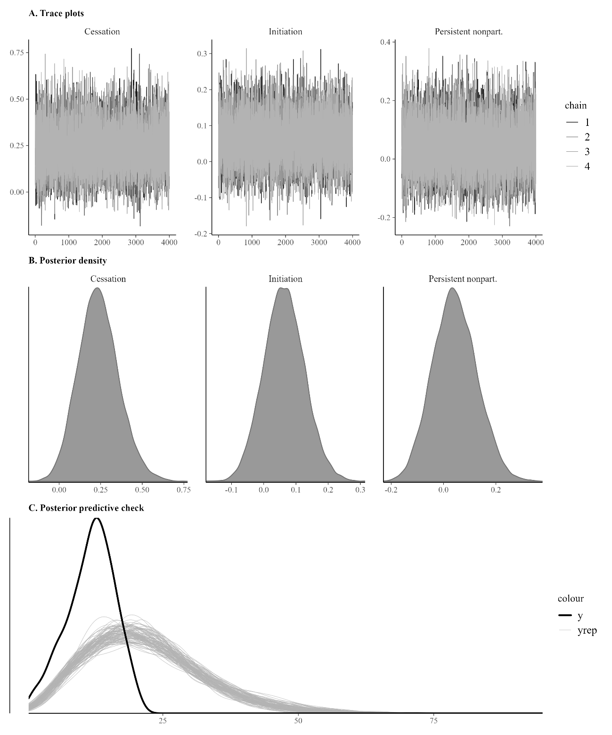
Supplementary Figure 1. Markov chain Monte Carlo diagnostic plots for the Bayesian Weibull cause-specific hazard model (Model 3, imputation 1).
(A) Trace plots for the exposure coefficients (cessation, initiation, and persistent nonparticipation vs. continuation), showing adequate mixing across four chains with 6,000 iterations (2,000 warmup). (B) Posterior density plots for the same coefficients. (C) Posterior predictive check comparing the distribution of observed follow-up times (uncensored observations) with 100 replicated datasets drawn from the posterior predictive distribution. All chains converged satisfactorily (R-hat range: 1.000 to 1.001; minimum effective sample size ratio: 0.363; zero divergent transitions).
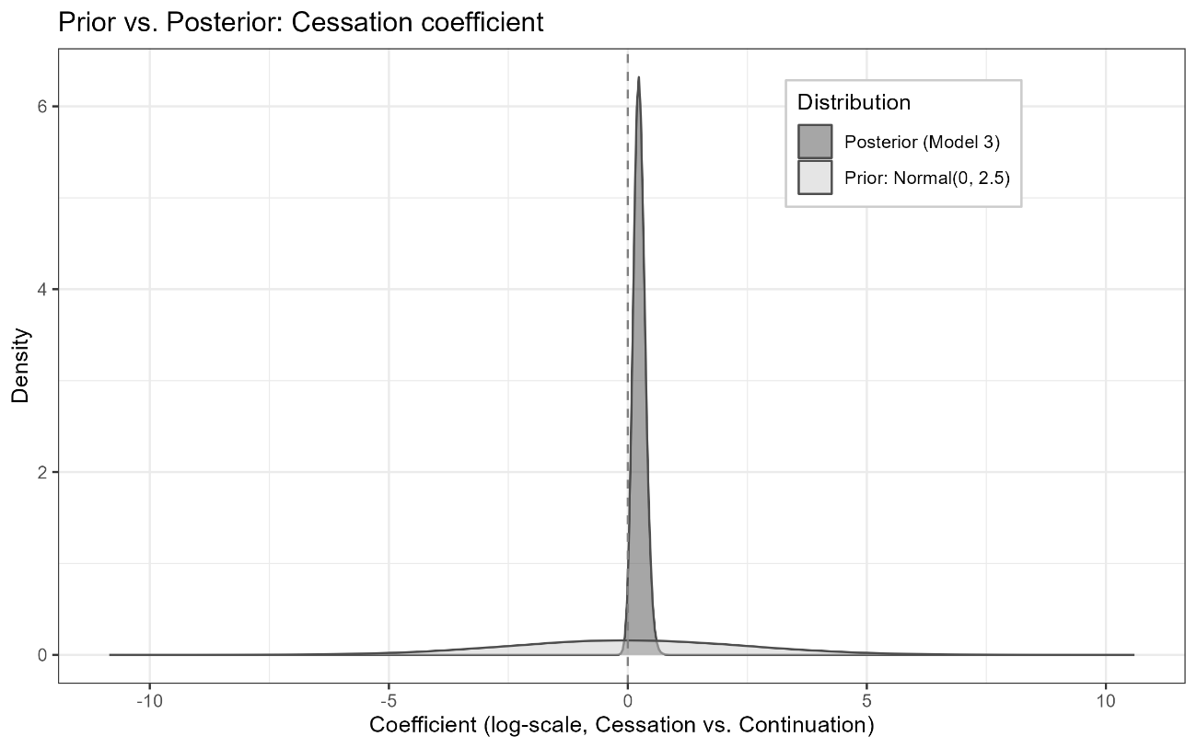
Supplementary Figure 2. Prior and posterior distributions of the regression coefficient for cessation of social activity participation (vs. continuation) in the Bayesian Weibull cause-specific hazard model for incident dementia (Model 3, fully adjusted).
The light-shaded density represents the weakly informative prior distribution (Normal(0, 2.5)), and the dark-shaded density represents the posterior distribution pooled across 20 multiply imputed datasets (320,000 draws). The dashed vertical line indicates the null value of zero (hazard ratio = 1 on the exponentiated scale). The posterior distribution is concentrated to the right of zero, with a posterior probability of 98.3% that the hazard ratio exceeds 1.

