Appendix 1
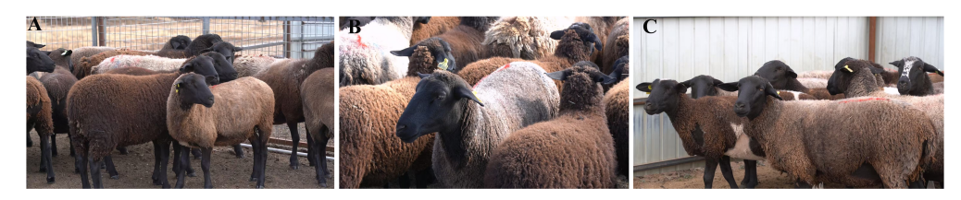
Supplement 1 Mongolian Sheep Hybrid Line (Xing'an Black Sheep)
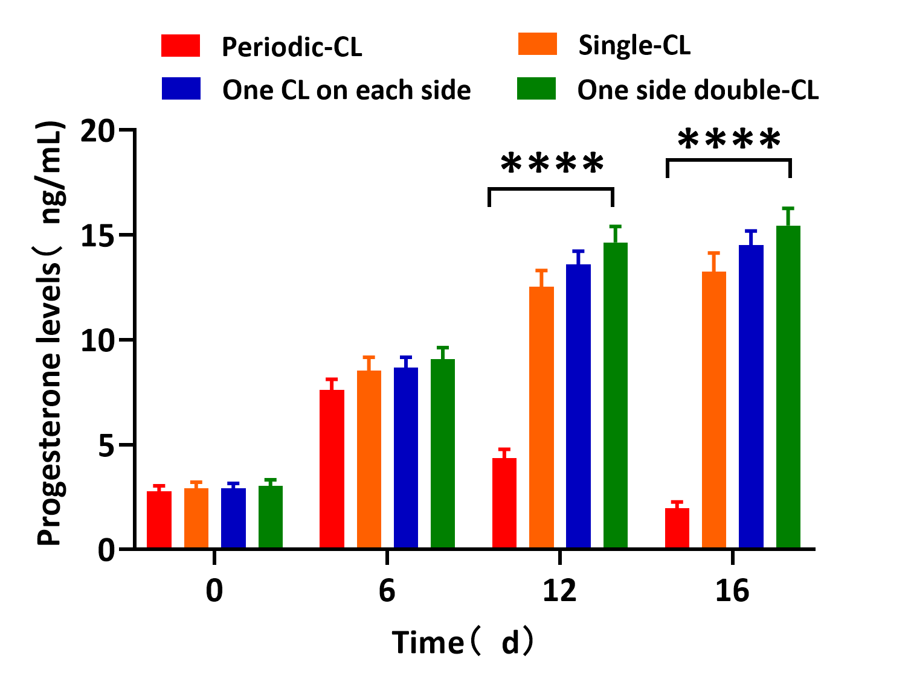
Figure 1 Progesterone secretion levels at different time points
Appendix 2
Table 1. Primer sequences used in this study.
Gene Name | Primer Sequence (5'-3') | Fragment Size
MSI2 gene exon primer
Exon 1/2/3 | F: AAGTTTCCAGCCGCTGCG  R: CCTGAGCCCCGTTCTAAATC | 1212 bp
Exon 4 | F: CCCTTGGCTCTGCGTTCT  R: GAGAGGGCGCTGTCTCTTTAAAC | 272 bp
Exon 5 | F: CTTCCAGGGCATCTCGGTGGT  R: CATGGCCGTCTTGGATGATCT | 366 bp
Exon 6 | F:TTTTGCAACCTCATGGACTGTAG  R: GAAACTGACCCCAGGTATTAGG | 373 bp
Exon 7 | F: GGCTTGTTCAACAGCTCAGTG  R: AGCATCTTCCCTGGGTTTCCT | 629 bp
Exon 8 | F: CAAATAGGTTTTAGTGAGCAGCATG  R: TAACGGTCCGGTATCAACTCTAGG | 363 bp
Exon 9 | F: GTAAATTTCCTGTTTGCTTCCG  R: CCCTACCAACTTAACCATTGTCTC | 513 bp
Exon 10 | F: CATTTACTCGGCGTGGCT  R: TGGGTCAGGCATCTGTATGTTTC | 415 bp
Exon 11 | F: ATAGGGTCTCATCACCAGCAGG  R: CCGGCACCCATGAAACACT | 471 bp
Exon 12 | F: CTTCAGCACTTTCCGCCAG  R: AGCCCACTAAATGCTAAGACTATCG | 315 bp
Exon 13 | F: GACAGACGGGAGGGAATCAG  R: GCGTCCGAAGTCCACAAGAA | 501 bp
Exon 14 | F: GAGTCCCTGCTGATGTCTTCG  R: TGCCTTAGCCTGTTTCCTTTA | 699 bp
Exon 15 | F: CAGGGCTTGGGAGGATGT  R: GGATGAGAGATTAAAAGGCTGG | 418 bp
Exon 8-14 | F: AGGCTAGACCCTCAGTACCATG  R: CCCCTCAAGACCGGGAAAG | 297 bp
Exon 10-12 | F: GGGCTAGATGTTTCGGGTAATTATT  R: AGCCCACCCGTGAAATGC | 705 bp
RT-qPCR
MSI2 | F: AGACGACCAACAGGCACAGAGG  R: AACATGACTTCCTTCGGCTGAGC | 142 bp
GDF9 | F: CATTTCTGCTCCGCACTAC  R: GGAACCCTGACGCTTT | 196 bp
BMP15 | F: AGCCTTCCCTGTTGCCCAAAAC  R:GCCACCAGAACTCAAGAACCTCAC | 150 bp
β-Actin | F: GTCACCAACTGGGACGACA  R: AGGCGTACAGGGACAGCA | 208 bp

Table 2. Antibodies used for immunofluorescence in this study
Antibody | Species | Primary Antibody Dilution Ratio | Source | Catalog Number | HRP secondary antibod | Multi staining working solution
MSI2 | Rabbit | 1:200 | Abcam | Ab76148 | Rabbit two-step detection kit | TSA-488
GDF9 | Rabbit | 1:200 | Abcam | Ab93892 | Rabbit two-step detection kit | TSA-555
BMP15 | Rabbit | 1:200 | ABclonal | A4148 | Rabbit two-step detection kit | TSA-555

Table 3. Western blot antibody usage information
Antibody | Molecular Weight (kDa) | Species | Primary Antibody Dilution Ratio | Source | Catalog Number | Secondary Antibody | Secondary Antibody Dilution Ratio
β-Tubulin | 55 | Rabbit | 1:2500 | ABclonal | A12289 | IRDye®800RD Donkey anti-Rabbit IgG | 1:10,000
GDF9 | 51 | Rabbit | 1:1000 | Affinity | AF7535 | IRDye®800RD Donkey anti-Rabbit IgG | 1:10,000
BMP15 | 55 | Rabbit | 1:1000 | ABclonal | A4148 | IRDye®800RD Donkey anti-Rabbit IgG | 1:10,000
MSI2 | 53 | Rabbit | 1:1000 | Affinity | BF0657 | IRDye®800RD Donkey anti-Rabbit IgG | 1:10,000
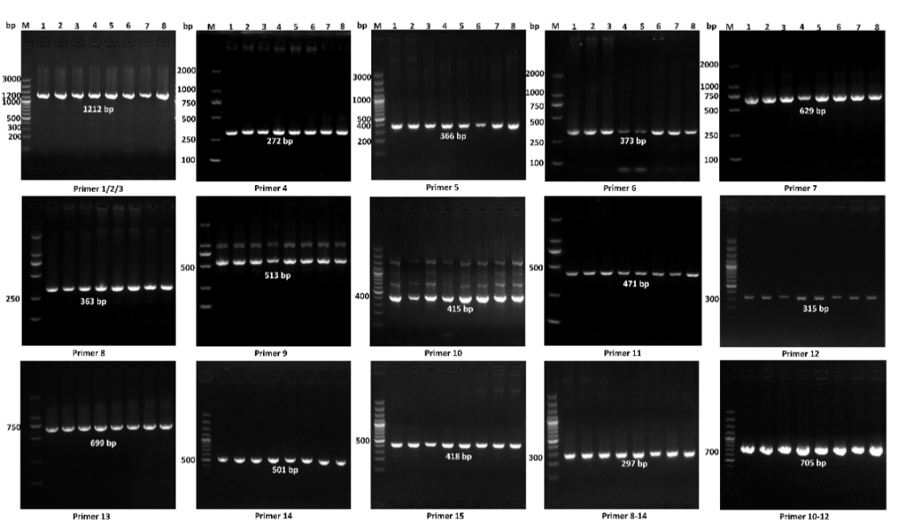
Appendix 3
Supplement 3. PCR amplification results of all exons of the MSI2 gene
Notes: M: DNA Marker; band 1-8 is the PCR product of different DNA samples.
Appendix 4
Table 4. Genetic polymorphism statistics of MSI2 loci.
SNPs | Genotype | Gene frequency | Allele | Allele frequency | χ² | P | PIC | He | Ne
g.7828531 A>G | AA | 0.66 | A | 0.817 | 0.226 | 0.85 | 0.254 | 0.701 | 1.427
g.7828531 A>G | AG | 0.31 | G | 0.183
g.7828531 A>G | GG | 0.03
g.8144512 C>G | CC | 0.64 | C | 0.821 | 0.81 | 0.63 | 0.251 | 0.706 | 1.416
g.8144512 C>G | CG | 0.32 | G | 0.179
g.8144512 C>G | GG | 0.04
Note: PIC<0.25 is low polymorphism; 0.25<PIC<0.50 is moderate polymorphism, PIC>0.50 is high polymorphism
Table 5. Association analysis between corpus luteum number and SNP loc
SNPs | Genotype | Number of single corpus luteum (n) | Number of unilateral double corpora lutea (n) | Number of bilateral single corpora lutea (n) | Total number of this genotype (n)
g.7828531 A>G | AA | 36 | 26 | 12 | 74
g.7828531 A>G | AG | 3 | 9 | 23 | 35
g.7828531 A>G | GG | 1 | 1 | 1 | 3
g.8144512 C>G | CC | 32 | 27 | 13 | 72
g.8144512 C>G | CG | 6 | 8 | 22 | 36
g.8144512 C>G | GG | 2 | 1 | 1 | 4

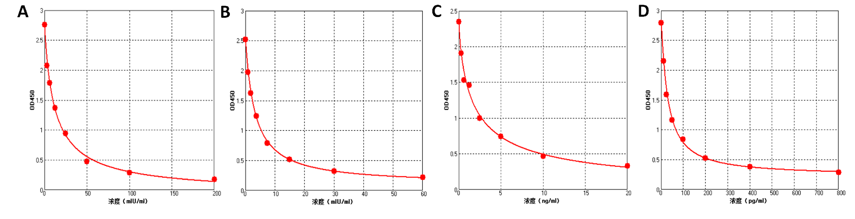
Appendix 5
Supplement 5. Hormone standard curve
Note: A: Standard curve of FSH, y=2.8187/[1+(x/12.52661)^0.90454]-0.07424, r²=0.99786; B: Standard curve of LH, y=2.4218/[1+(x/3.23861)^1.01765]+0.09189, r²=0.99970; C: Standard curve of P4,y=2.3598/[1+(x/1.87149)^0.77450]-0.01535, r²=0.99186; D: Standard curve of E₂, y=2.57546/[1+(x/30.66650)^1.08568]+0.22576, r²=0.99817.

