Supplementary Methods
Propensity Score Generation and Outcomes Analysis: To help mitigate potential biases introduced due to a lack of randomization in this study between treatment groups, propensity scores and corresponding inverse probability weighting was used on identified key covariates of interest. Specifically, logistic regression models were used to generate propensity scores based on covariates that were consistently collected and available from each of the participating institutions in this multi-institution and international analysis cohort. These covariates included: age at time of relapse, time to relapse, presence of extranodal disease (yes vs. no), and number of salvage therapies (2 or more vs. less than 2). These were factors that were deemed to be potential confounders for PFS and were available through the data sets that were provided across institutions. The specific code used to generate the propensity scores in SAS is provided below:
title "Modeling Propensity Score";
proc logistic data=master;
class ex_nod_ind(ref="Yes") therapies_ind(ref="<2");
model bv_m (event="Maintenance”) = age_relapse ex_nod_ind therapies_ind
time_to_relapse;
output out=master2 pred=propensity;
run;

where bv_m is an indicator variable for having received BV maintenance, ex_nod_ind is whether or not patients had extra nodal involvement, and therapies_ind is an indicator of whether or not patients had 2 or more therapies. Further, the age_relapse variable is a continuous measure of the age of the patient at the time of relapse (in years), and time_to_relapse is the time from initiation of therapy to when they relapsed (in months).
To calculate the propensity scores corresponding to each patient, we calculated predicted values from the multivariable logistic regression model that included the covariates listed above in relation to whether or not patients had BV maintenance as the dependent variable in this model. Generation of propensity scores were done using the SAS statistical program, following standard methods outlined by Leslie and Thiebaud^{1,2} as well as a breadth of established work in this area. For the inverse probability treatment weights (IPTWs), we used the following code:
if bv_m=1 then stweight=1/propensity;
else if bv_m=0 then stweight=1/(1-propensity);

These IPTW were then incorporated, with normalized weights included in the Cox regression models used to evaluate differences in the time to event outcomes (e.g. PFS) between groups. Additional analyses to evaluate homogeneity and distribution of the resulting propensity scores and their weights were done using the statistical programs SAS as well as R (version 4.2.2).

Evaluation of Bias Mitigation and Distribution of Propensity Scores
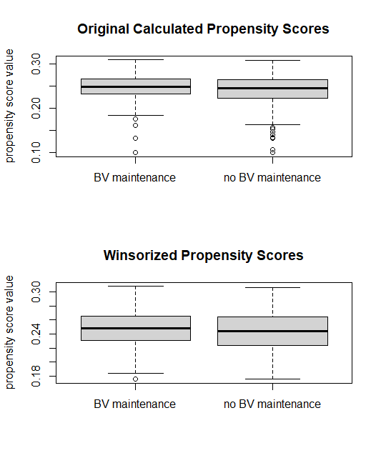
To evaluate and assess balance in propensity scores, we evaluated the distributions of propensity scores in those who did vs. did not receive BV maintenance treatment vs. those who did not. The distribution of the propensity scores were very similar. However, we did recognize a set of patients who had outlying propensity score values. To avoid issues that outliers in this setting could introduce, we Winsorized the propensity score values at 0.175, where those with a calculated propensity score <0.175 were given a score of 0.175. This affected 23 of the 733 patients in our analysis data set.
Evaluation of Homogeneity of Treatment Effect
To evaluate the homogeneity of treatment effect on the outcomes of interest, we evaluated Cox regression models for PFS to assess influence of BV maintenance (vs. not). Given that whether or not treatment was given pre- vs. post-FDA approval for BV in this setting had a significant influence on whether not patients received BV maintenance post-ASCT, we also used Cox models that stratified on whether or not treatment was given pre- vs. post-FDA approval of BV. Thus, we also evaluated homogeneity of effect by also stratifying on the timing of treatment in relation to FDA approval for these analyses as well. No significant differences were observed when looking at subsets based on quartile of the propensity scores. No significant differences were observed when looking at a higher breakdown using deciles.

Evaluation of Potential Unobserved Confounding
Post-hoc sensitivity analyses were not conducted to evaluate the potential influence of unobserved confounders. In lieu of this, our analyses incorporated subgroup and stratified analyses to further evaluated and assess the robustness of or differences in these results between these potential confounders that were not included in the propensity score calculation but evaluated directly. Here, we stratified analyses on whether or not treatment was given pre- vs. post-FDA approval of BV in the Cox regression models, and where we also conducted subgroup analyses in those who were treated post-FDA approval. Due to the heavy influence of this variable on whether or not BV was given in maintenance post-ASCT, we could not effectively include it in the propensity scores calculated, where doing so would result in strongly bimodal distributions reflecting the latent confounding influence of this variable.
Further, subset analyses were also conducted focusing on potential differences of effects in those who had achieved a partial metabolic response (PMR) or a complete metabolic response (CMR) to therapy prior to ASCT. Finally, we also directly evaluated the influence of having a high Athera score on treatment effects in this setting for both PMR and CMR patients.

¹Leslie S, Thiebaud P. Using Propensity Scores to Adjust For Treatment Selection Bias, Paper 184-2007. 2007 SAS Global Forum. https://support.sas.com/resources/papers/proceedings/proceedings/forum2007/184-2007.pdf
²Leslie S. Using Propensity Scores to Adjust For Treatment Selection Bias. https://www.lexjansen.com/wuss/2008/tut/tut09.pdf

Supplementary table 1
 | Post-ASCT treatment
 | No BV Maintenance  (N=556) | BV Maintenance  (N=177) | Total  (N=733) | P-value
Center, n (%) |  |  |  | <.0001¹
CCF | 13 (92.9%) | 1 (7.1%) | 14 (1.9%)
Czech | 95 (75.4%) | 31 (24.6%) | 126 (17.2%)
John Hopkins | 16 (88.9%) | 2 (11.1%) | 18 (2.5%)
Mayo | 93 (72.7%) | 35 (27.3%) | 128 (17.5%)
Mount Sinai | 28 (80.0%) | 7 (20.0%) | 35 (4.8%)
NYU | 7 (77.8%) | 2 (22.2%) | 9 (1.2%)
Rutgers | 31 (68.9%) | 14 (31.1%) | 45 (6.1%)
Stanford | 110 (85.9%) | 18 (14.1%) | 128 (17.5%)
UAB | 27 (61.4%) | 17 (38.6%) | 44 (6.0%)
UMN | 29 (59.2%) | 20 (40.8%) | 49 (6.7%)
UPMC | 37 (88.1%) | 5 (11.9%) | 42 (5.7%)
UWCC | 22 (91.7%) | 2 (8.3%) | 24 (3.3%)
Utah | 7 (35.0%) | 13 (65.0%) | 20 (2.7%)
WashU | 41 (80.4%) | 10 (19.6%) | 51 (7.0%)
¹Chi-Square p-value;

Abbreviations: ASCT, autologous stem cell transplant, BV, brentuximab vedotin, CCF, Cleveland clinic foundation, Czech, Czech Republic, NYU, New York University, Mayo, Mayo Clinic, UAB; University of Alabama Birmingham, UMN, University of Minnesota, UPMC, University of Pittsburg Medical Center, UWCC, University of Wisconsin Cancer Center, Utah, University of Utah, N; numbers, %, percentages.

Supplementary figures:
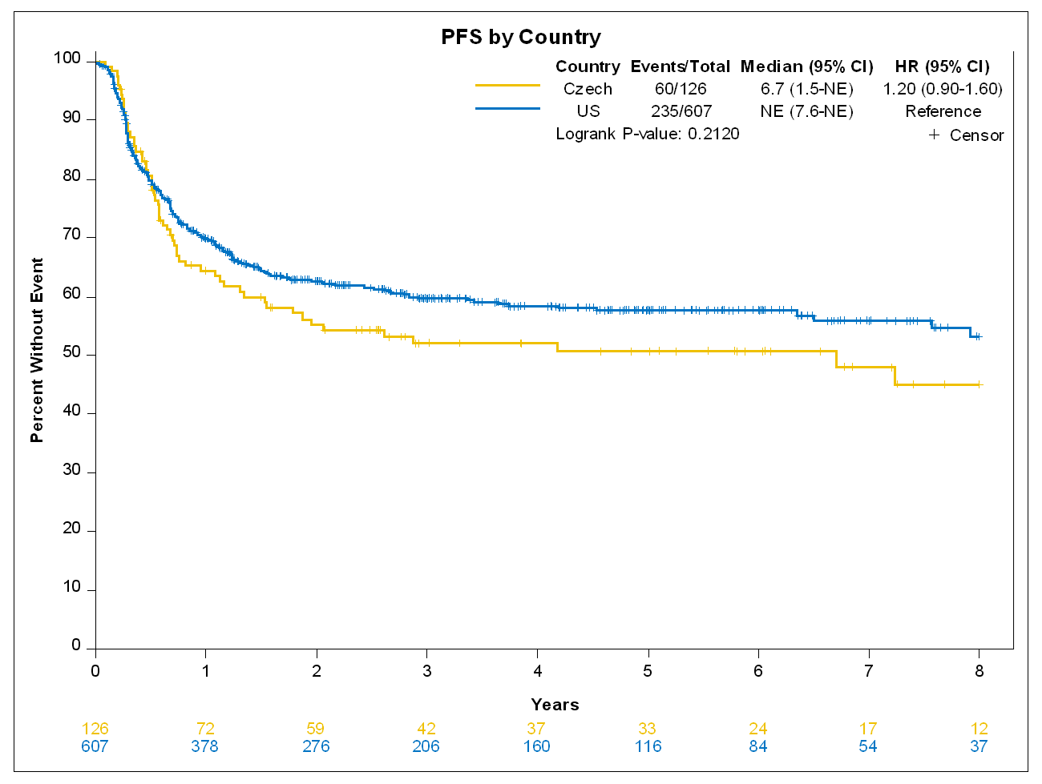
Supplementary Figure 1: Progression free survival by Country
Abbreviations: PFS, progression free survival, US; the United States, Czech; The Czech Republic, HR; hazard ratio.

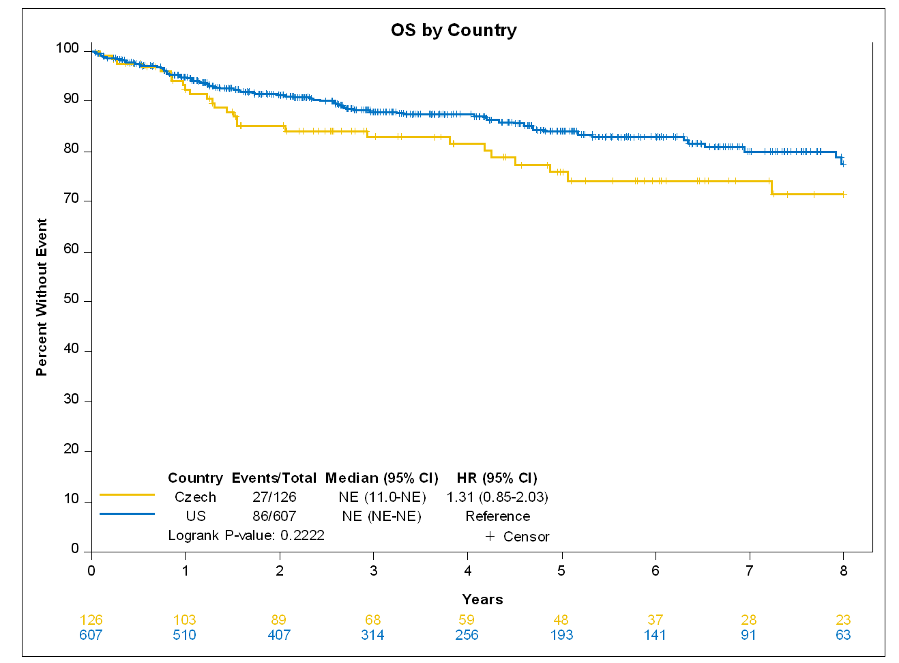
Supplementary Figure 2: Overall Survival by Country
Abbreviations: OS, Overall survival, US; the United States, Czech; The Czech Republic, HR; hazard ratio.

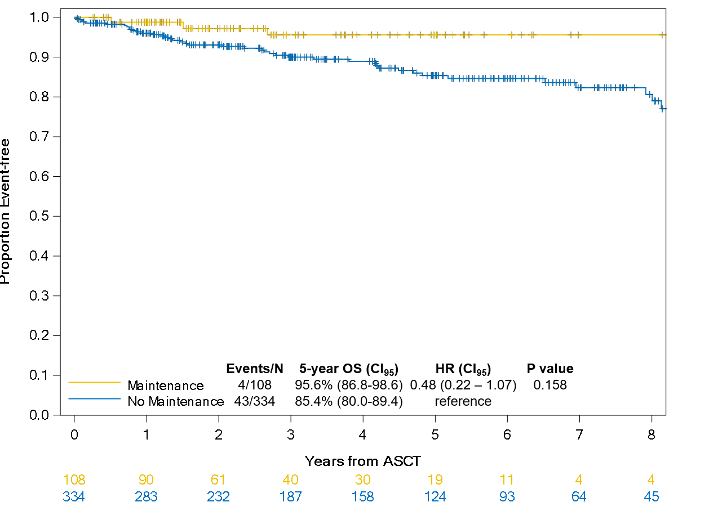

Supplementary Figure 3: Overall survival by BV maintenance in the subgroup of CMR
Abbreviations: CMR; complete metabolic response, BV; brentuximab vedotin, ASCT, autologous stem cell transplant,HR; Hazard Ratio, CI₉₅: 95% confidence interval.

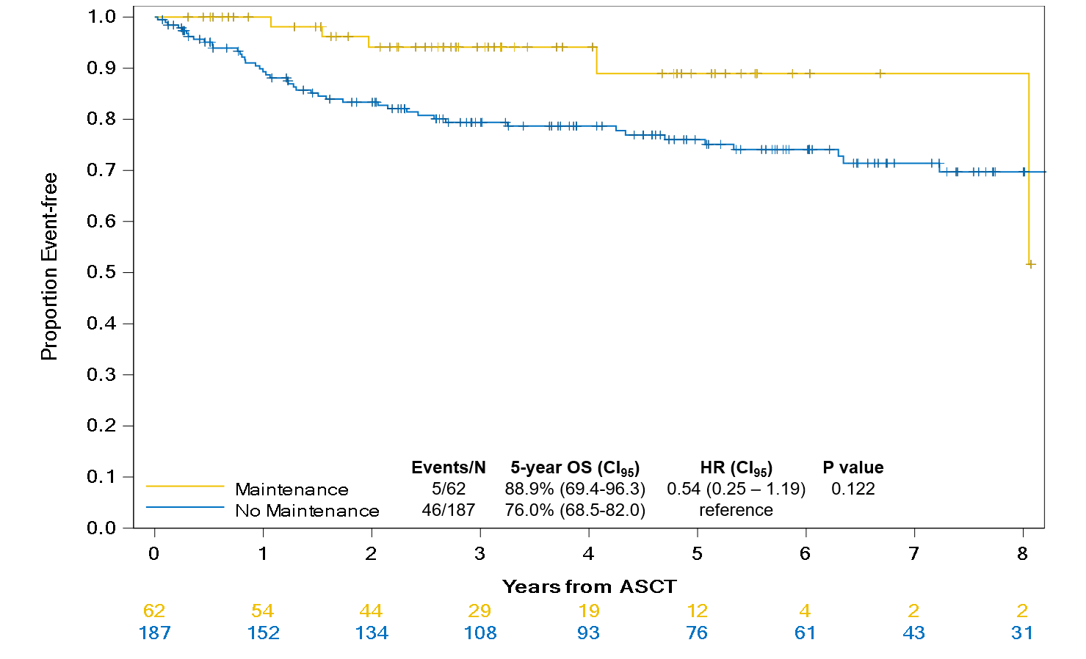
Supplementary Figure 4: Overall survival by BV maintenance in the subgroup of PMR
Abbreviations: PMR; partial metabolic response, BV; brentuximab vedotin, ASCT, autologous stem cell transplant,HR; Hazard Ratio, CI₉₅: 95% confidence interval.

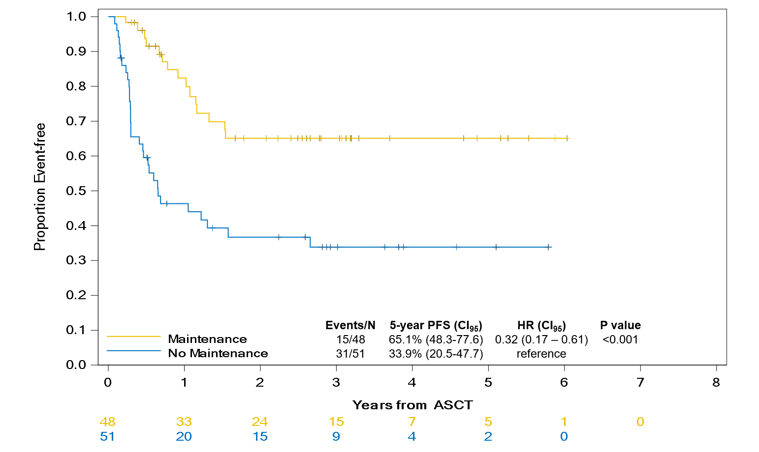
Supplementary Figure 5: Progression free survival by BV maintenance in the subgroup of PMR in post-FDA approval era.
Abbreviations: PMR; complete metabolic response, BV; brentuximab vedotin, ASCT, autologous stem cell transplant, HR; Hazard Ratio, CI₉₅: 95% confidence interval, FDA; Food and Drug Administration.

