Supplementary Material

Lovró Z et al. Safety, Tolerability and Immunogenicity of Vaccine ALZ-101 in Patients with Early Alzheimer’s Disease

Supplementary Figures

Supplementary Figure 1. Example of a rabbit immunization study. Rabbits (N=4) were immunised with 0.5 mL of 150 µg Aβ42CC oligomers (∼724 kDa) formulated with 0.3% aluminium hydroxide on days 1, 21, and 42. Sera were collected on day 56 and split into two fractions where one was pre-adsorbed with Aβ42 fibrils. IgG:s were purified with Protein A chromatography before analysis. The reactivity towards fibrillar Aβ42 and the antigen was assessed by ELISA using antibody 6E10 as control (recognises the N‑terminal epitope of Aβ corresponding to amino acids 3–8; sequence EFRHDS) since it binds Aβ oligomers and fibrils equally well. IgG:s purified from rabbits (N=4) immunised with Aβ42CC oligomers displayed a strong Aβ42CC oligomer‑specific IgG response that dominated the overall profile. Incubation with Aβ42 fibrils eliminated the reactivity toward fibrillar Aβ, whereas oligomer‑specific antibodies remained in solution. This, and similar experiments on rabbits and mice, suggests that >90% of the polyclonal ALZ-101 immune response in research animals is specifically directed towards oligomers and a minor part towards the N-terminal. The error bar is the SD.

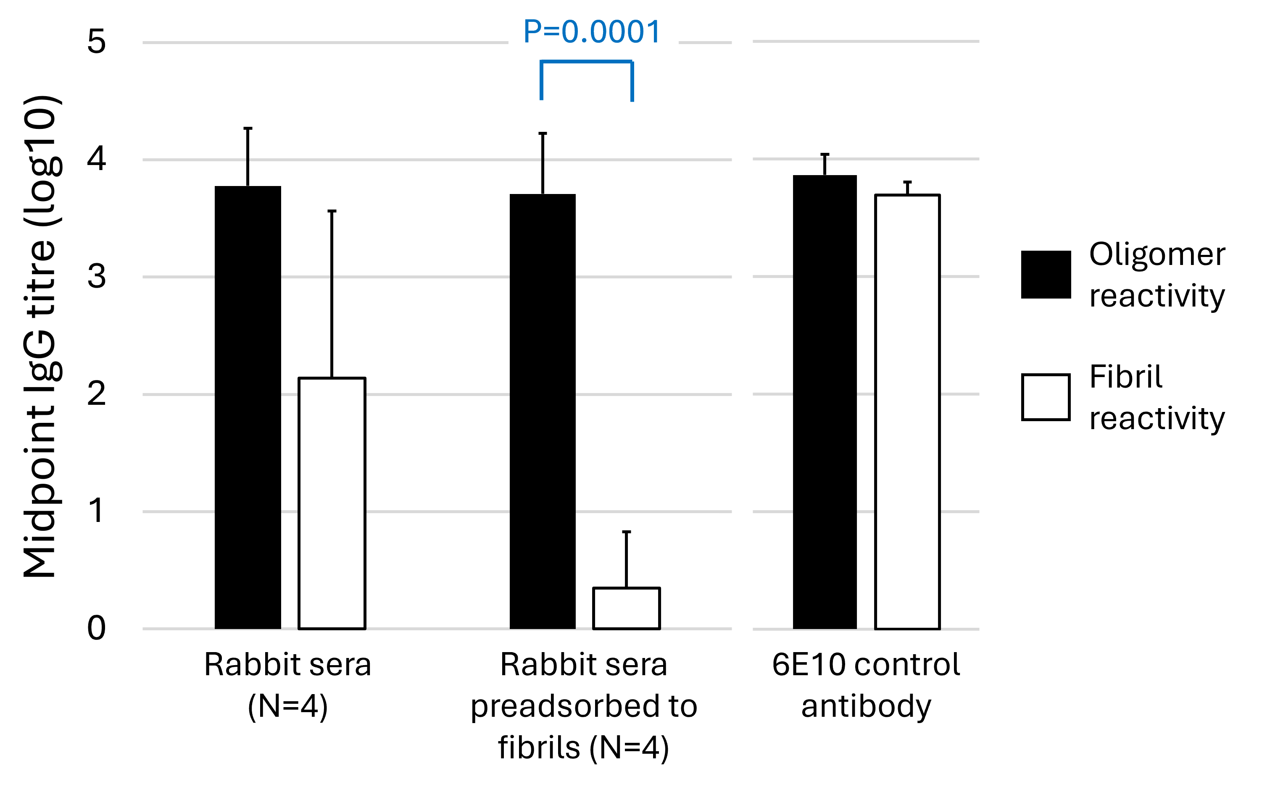

Supplementary Figure 2. Average anti-ALZ-101 IgG ELISA responses in drug-naïve healthy controls and patients in ALZ-C-001. Serum from ten (10) healthy young (average age of 26.7 ± 0.5 SEM) and ten (10) healthy elderly (average age of 66.4 years ± 1.1 SEM) individuals were compared with the baseline serum samples from the 32 early AD patients in clinical study ALZ-C-001 (average age of 68.5 years ± 1.1 SEM). The difference between healthy younger and healthy older was assessed using a pooled t-test and amounted to 3394 counts (95% CI, -334 to 7122; P=0.072). A Welch’s t-test comparing the healthy older and AD patient samples estimated their difference as 3746 counts (95% CI, -101 to 7593; P=0.055).

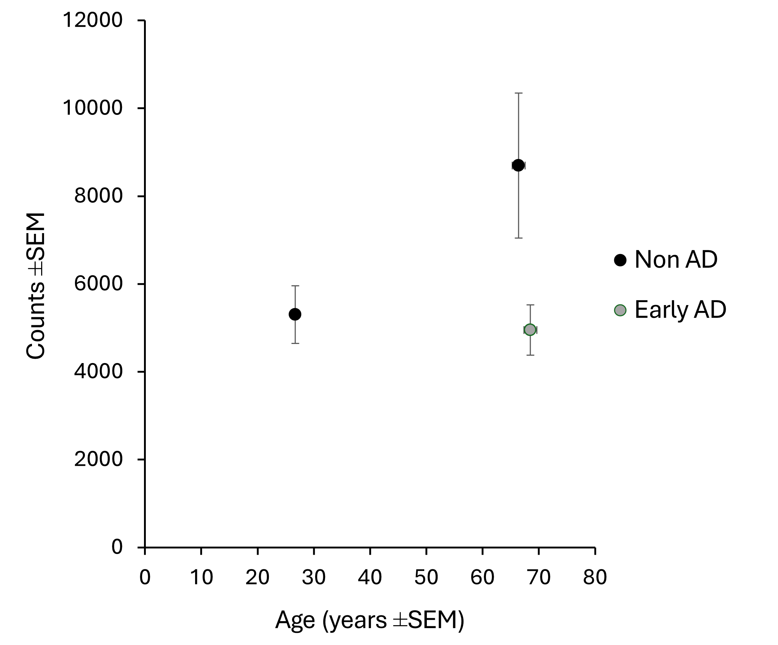

Supplementary Figure 3. Spaghetti plots of anti-ALZ-101 antibody subclass immunoglobulin G (IgG) titres in serum, Part A1/A2 and Part B (full analysis set). IgG was detected using a Protein G–based assay recognizing all human IgG subclasses; subclass‑specific titres (IgG1–4) were not measured. Each line represents an individual participant, and colours distinguish individual trajectories without additional biological meaning.

Part A1/A2
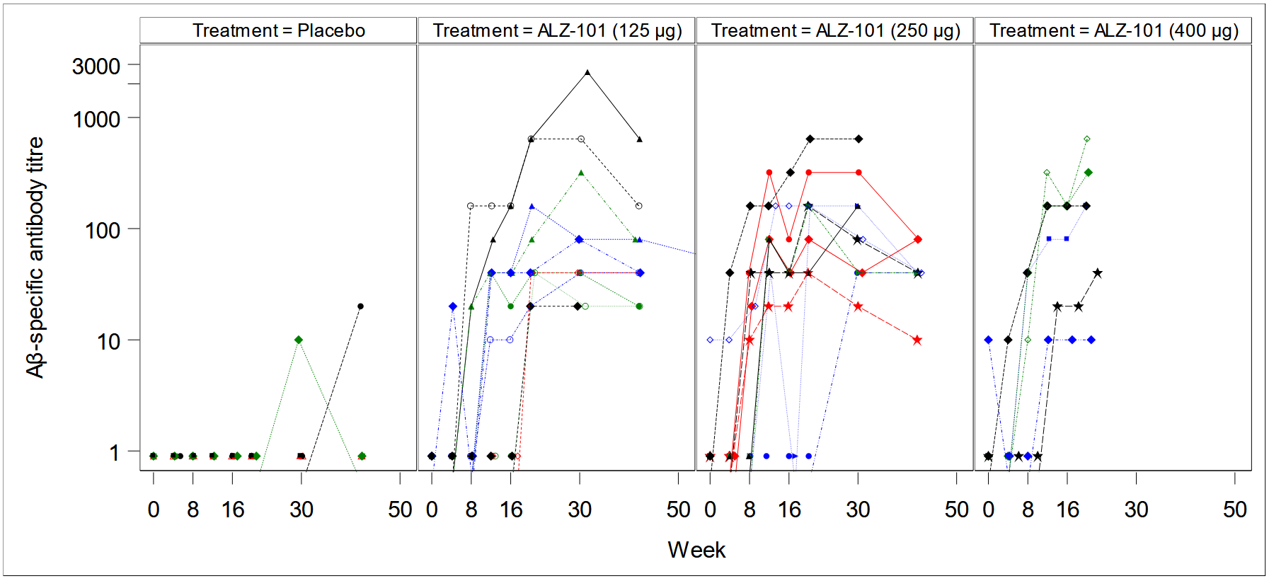

Part B; Patients grouped according to treatment allocation in Part A1.
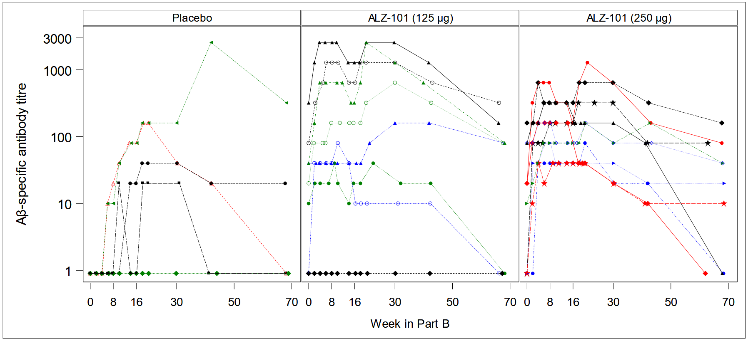

Supplementary Figure 4. Spaghetti plots of anti-ALZ-101 antibody subclass immunoglobulin M (IgM) titres in serum, Part A1/A2 and Part B (full analysis set). Each line represents an individual participant, and colours distinguish individual trajectories without additional biological meaning.

Part A1/A2
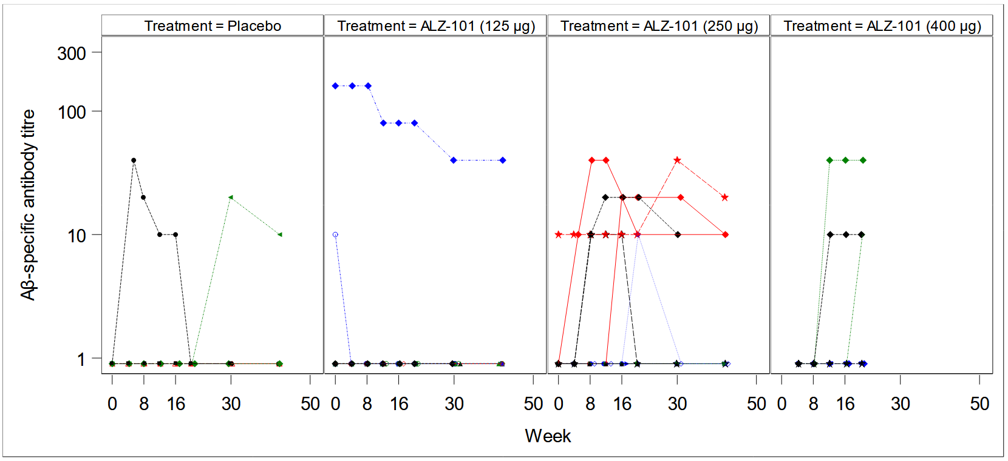

Part B; Patients grouped according to treatment allocation in Part A1.
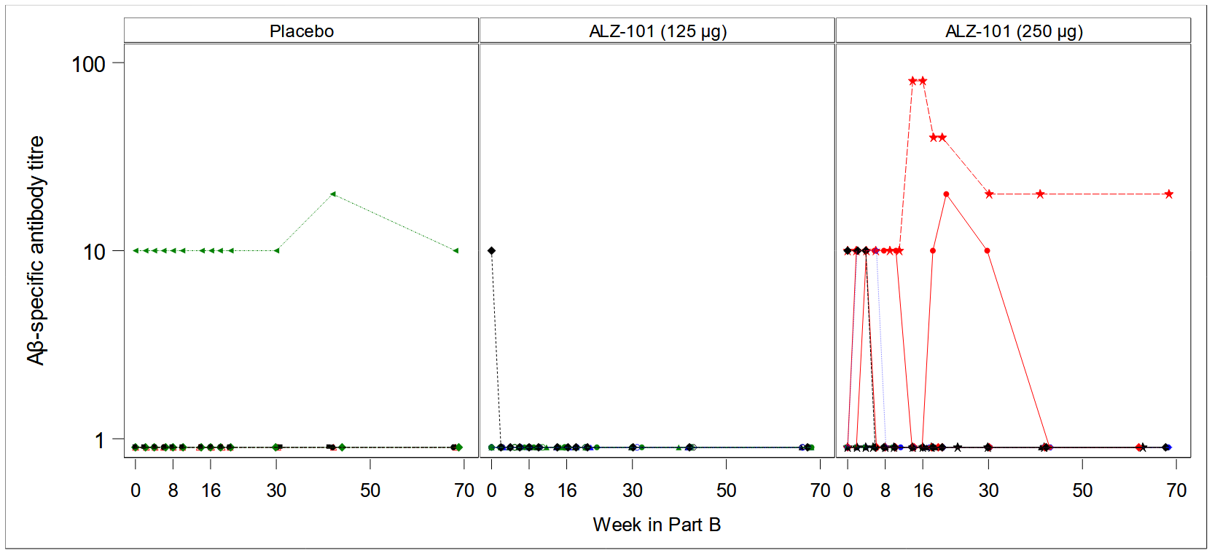

Supplementary Figure 5. Spaghetti plots of anti-ALZ-101 antibody subclass immunoglobulin A (IgA) titres in serum, Part A1/A2 and Part B (full analysis set). Each line represents an individual participant, and colours distinguish individual trajectories without additional biological meaning.

Part A1/A2
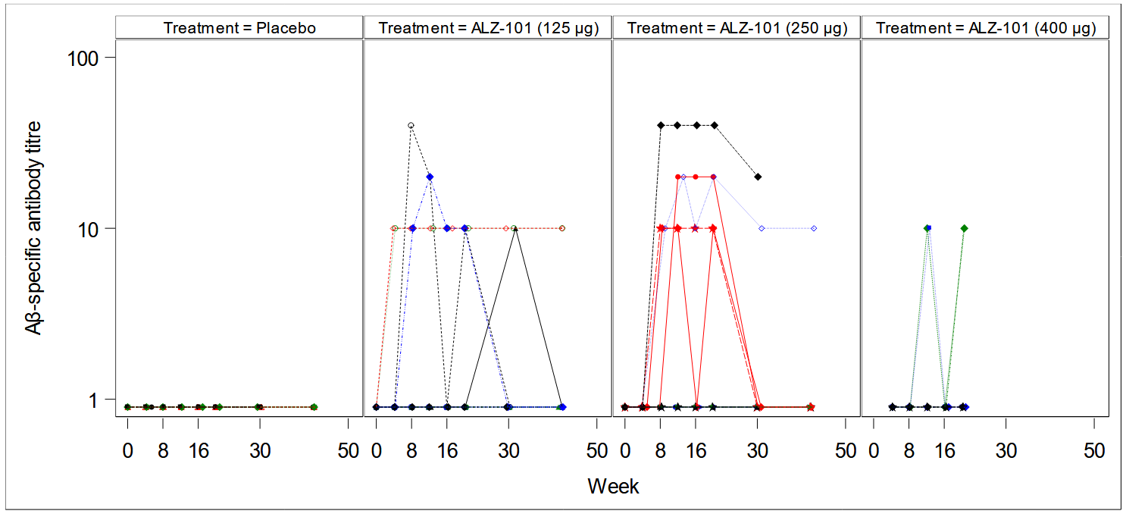

Part B; Patients grouped according to treatment allocation in Part A1.
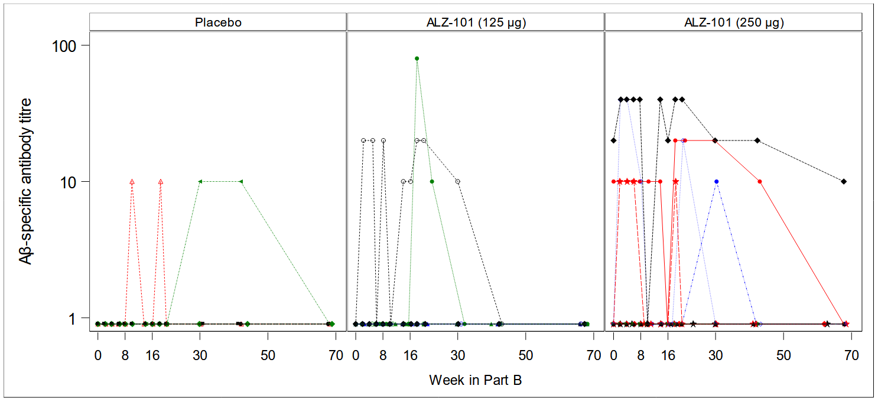

Supplementary Figure 6. Exploratory ELISA inhibition experiments. Sera were obtained from two individuals, one vaccinated with four doses of 125 µg and the other with four doses of 250 µg ALZ‑101 (sera collected at Week 20 of Part A1). Sera were pre-adsorbed with increasing amounts of ALZ-101 (oligomeric Aβ42CC) or non-aggregated (monomeric) Aβ42 before being applied to ELISA plates coated with ALZ-101. The monoclonal antibody ALZ-201 was treated identically as a positive control. Pre‑adsorption with Aβ42 had minimal effect on the signal, whereas ALZ‑101 pre‑adsorption almost completely abolished binding for both immune sera and ALZ‑201, indicating similar, oligomer‑preferring binding profiles (n=2; no formal statistical testing performed).

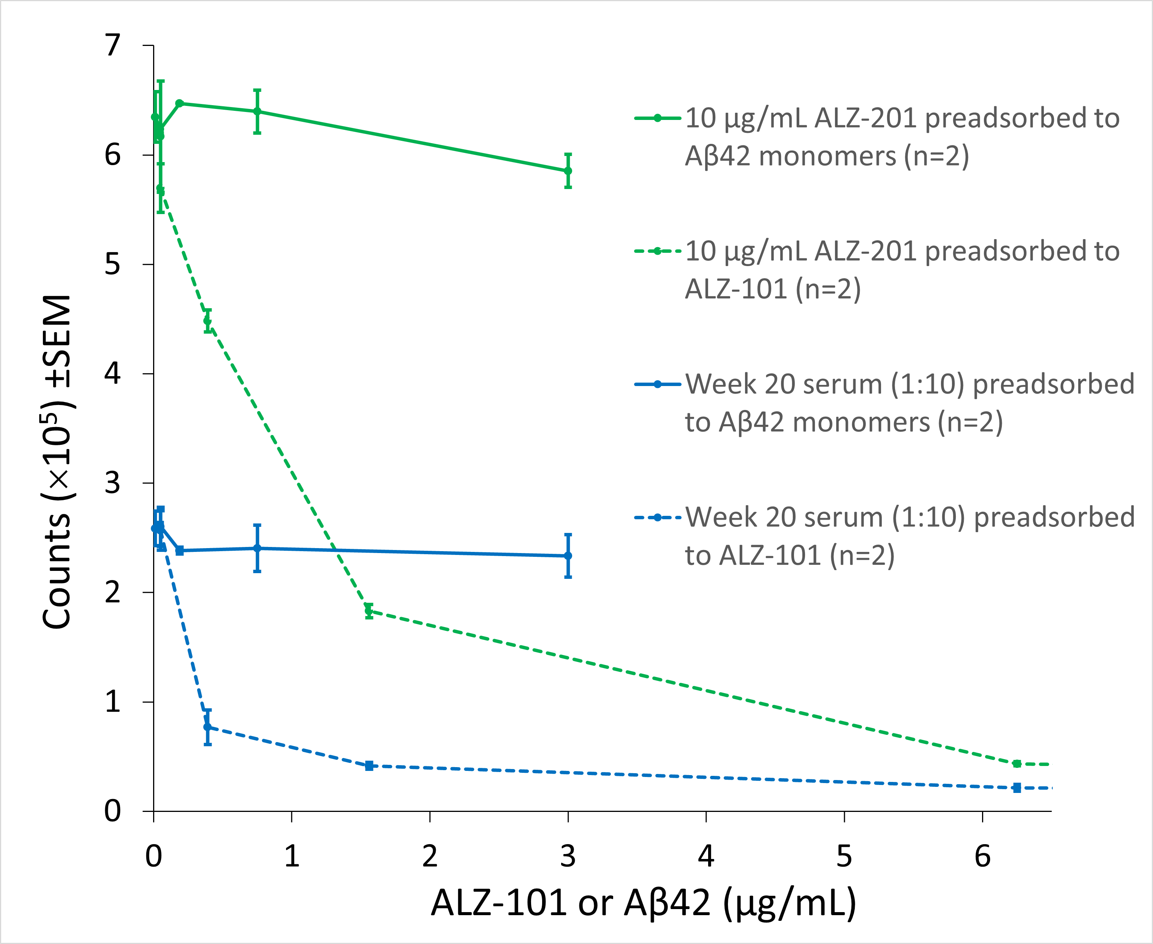
Supplementary Figure 7. Box plots of baseline and changes from baseline values for cerebrospinal fluid (CSF) neurofilament light chain (NfL). Baseline samples were collected at screening approximately 9 weeks prior to the first study drug administration. As all datasets significantly deviated from a normal distribution according to the Shapiro-Wilk test (p < 0.05), the interquartile range (IQR) method for outlier analyses was prioritised and confirmed by Modified Z-scores and Grubbs’ test.

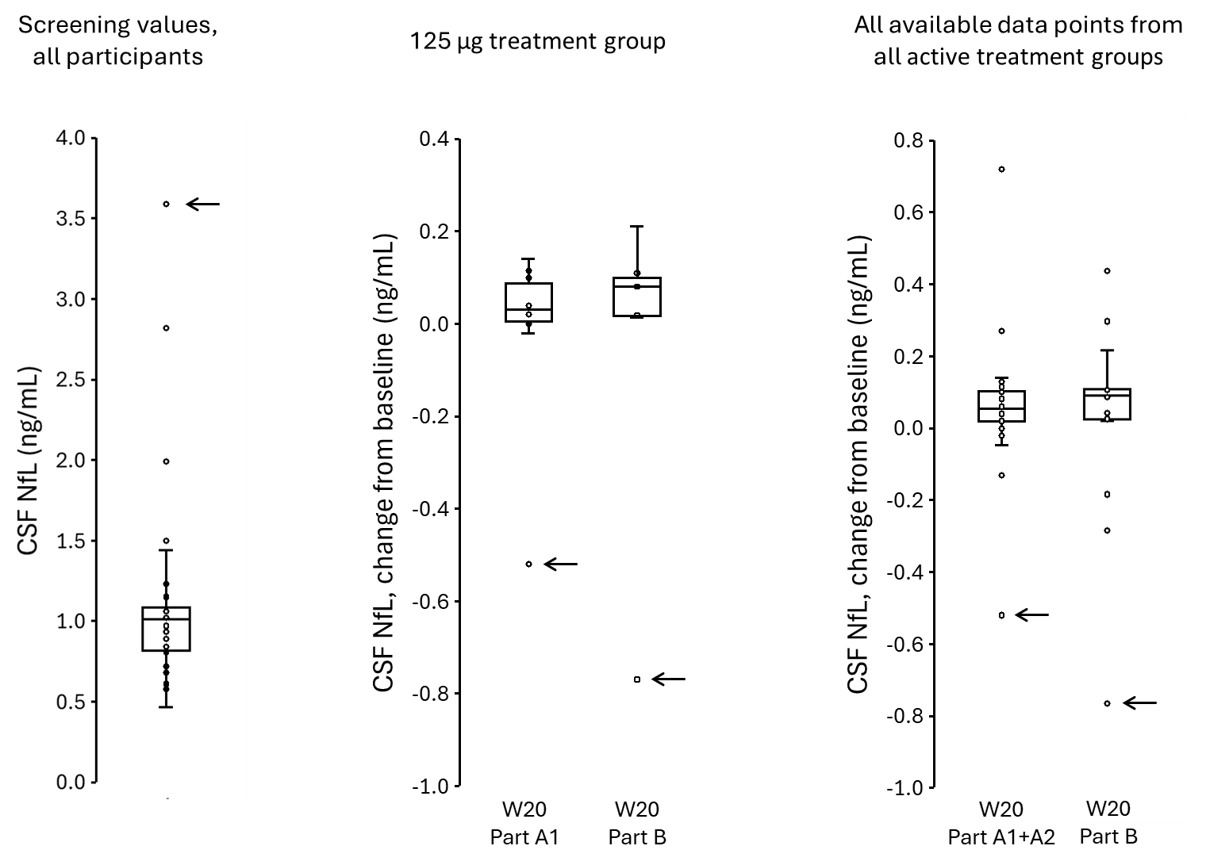

In the 125 µg treatment group, two values (marked by arrows) for the change in CSF NfL from baseline (middle panel) lay far outside the IQR thresholds and were confirmed as the only outliers by Modified Z-scores (M = −9.05 and −9.40) and by Grubbs’ test (p < 0.05). These values stemmed from the same participant. Baseline CSF NfL across all participants (n = 32; left panel) revealed four possible outliers of which the most extreme value, 3590 pg/mL (marked by an arrow), corresponded to the same individual (M = 10.27) and was confirmed as the only significant outlier by Grubbs’ test (p < 0.05). In the combined active-dose datasets (right panel) from Part A1/A2 (n = 26) and Part B (n = 16; restricted to A1 active-dose patients with available samples), the IQR method identified several outliers at the second sampling point at Week 20 of Part A1 and the third sampling point at Week 20 of Part B. The patient in the 125 µg dose group who had the highest baseline value again exhibited the most extreme negative change values at both assessments (−520 pg/mL, M = −8.81; −770 pg/mL, M = −10.20) and was confirmed as the only outlier by Grubbs’ test (p < 0.05).

Supplementary Figure 8. Mean (standard error) changes from baseline screening values for cerebrospinal fluid (CSF) neurofilament light chain (NfL). Screening samples were collected approximately 9 weeks prior to the first study drug administration. Participants are grouped according to their treatment allocation in the main study, although all received 250 µg ALZ-101 in the extension phase (Part B). Top panel: All data points. Bottom panel: The same data excluding one individual in the 125 µg dose group who was identified as an outlier. Variability in the x-axis is due to differences in the timing of transition from the main study into Part B.

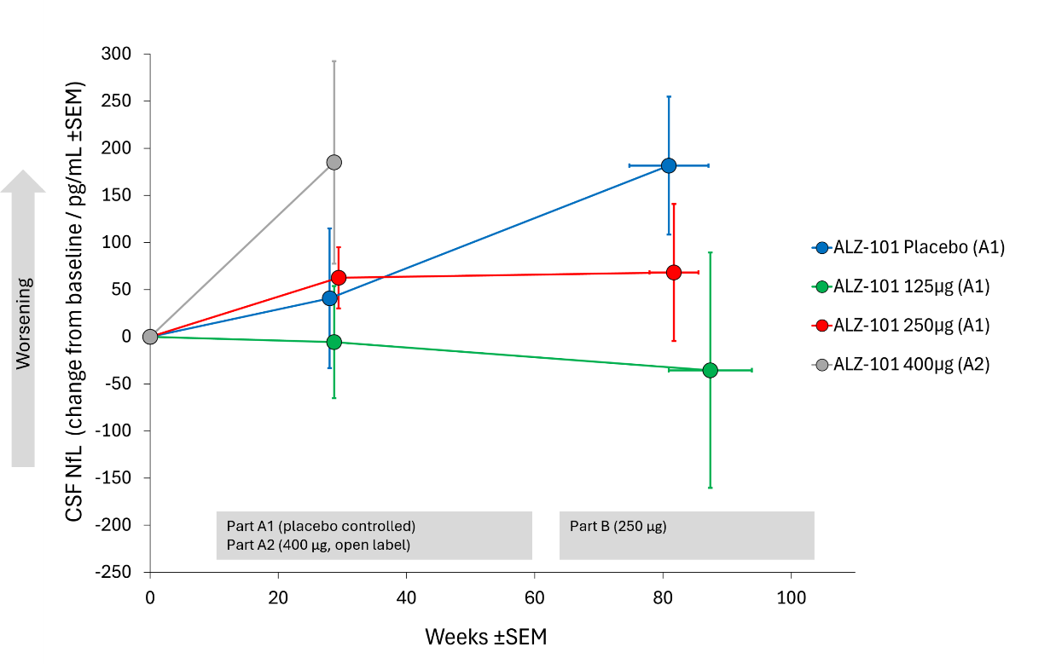
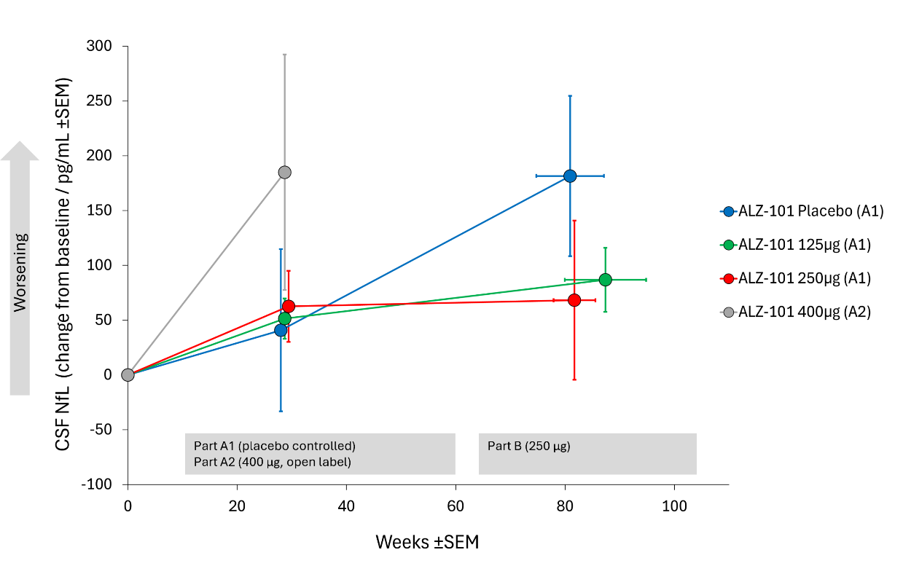
Supplementary Figure 9. LS mean (standard error) changes from baseline for plasma NfL (pg/mL) (Full analysis set). Participants are grouped according to their treatment allocation in the main study (Part A1).

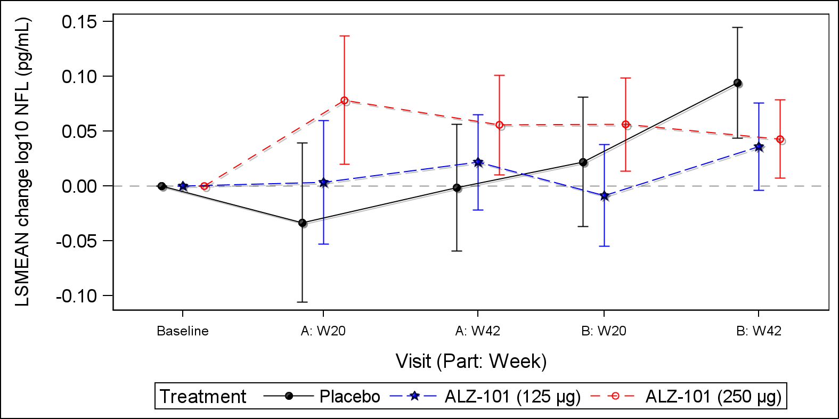

Supplementary Figure 10. LS mean (standard error) changes from baseline for plasma P-tau217 (pg/mL) (Full analysis set). Participants are grouped according to their treatment allocation in the main study (Part A1).

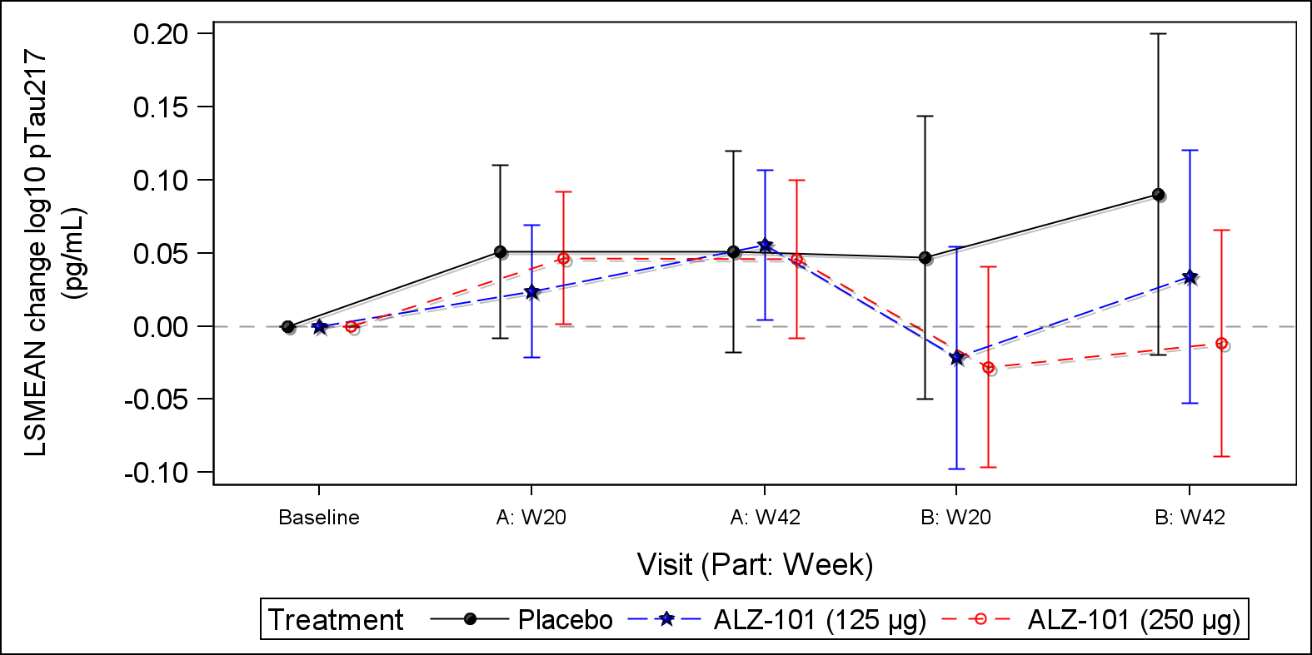

Supplementary Figure 11. Mean (standard error) changes from baseline in ADCOMS scores. Baseline values represent screening assessments approximately 9 weeks prior to the first study drug administration. Participants are grouped according to treatment allocation in the main study (Part A1), although all received 250 µg ALZ-101 in the extension phase (Part B). Variation in the x-axis reflects differences in timing of transitions from Part A1 into Part B.

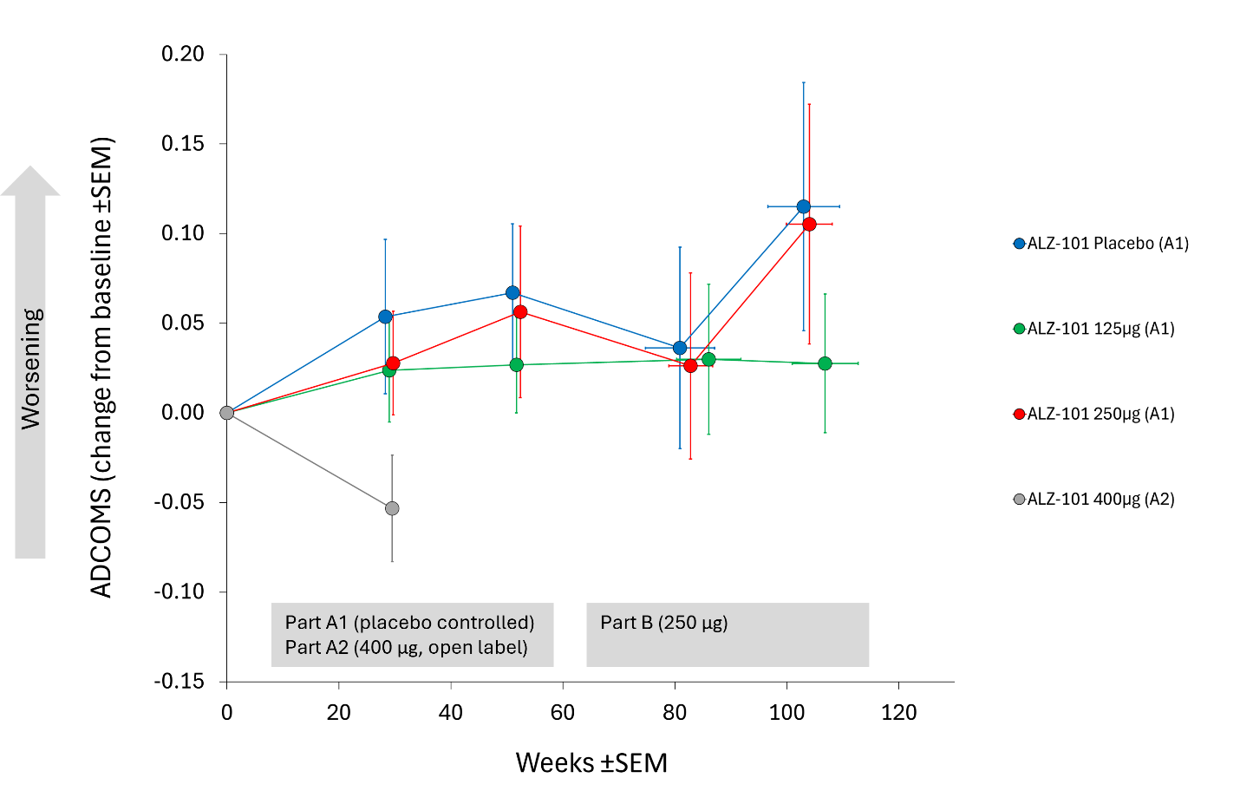

Supplementary Figure 12. Estimated ADCOMS scores by group with group-wise simultaneous 95% confidence intervals.

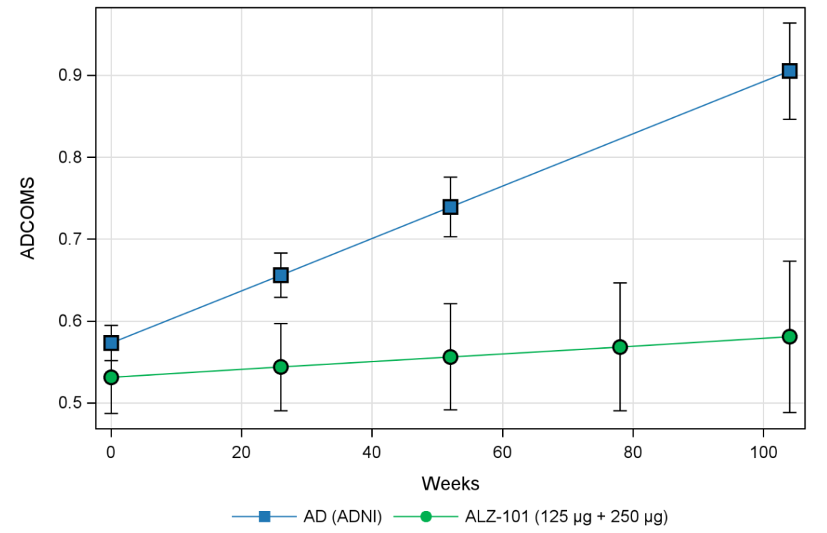

Supplementary Figure 13. ELISpot assays on peripheral blood mononuclear cells (PBMCs) stimulated with overlapping Aβ peptide fragments (top) or anti-CD3 positive control antibody (bottom). Samples were collected at baseline and 4 weeks after the last administration of study drug, representing peak immune activation (Week 20). For the placebo, 125 µg, and 250 µg treatment groups, a sample was also collected 26 weeks after the last administration of study drug (Week 42). In the IFN-γ ELISpot assay, the anti-CD3 stimulation resulted in spot counts that exceeded the quantifiable range in several samples, including 24% of baseline samples, indicating a higher sensitivity for detection of IFN-γ producing cells compared to IL-4 producing cells. For calculation of the mean spot count, samples that surpassed the counting threshold were assigned a value of 4500 SFC/10E+06 cells, corresponding to 109% of the highest countable value (4115 SFC/10E+06 cells). This approach allowed inclusion of these data points while acknowledging their over-range status. SFC: Spot Forming Colonies. #: Not measured.

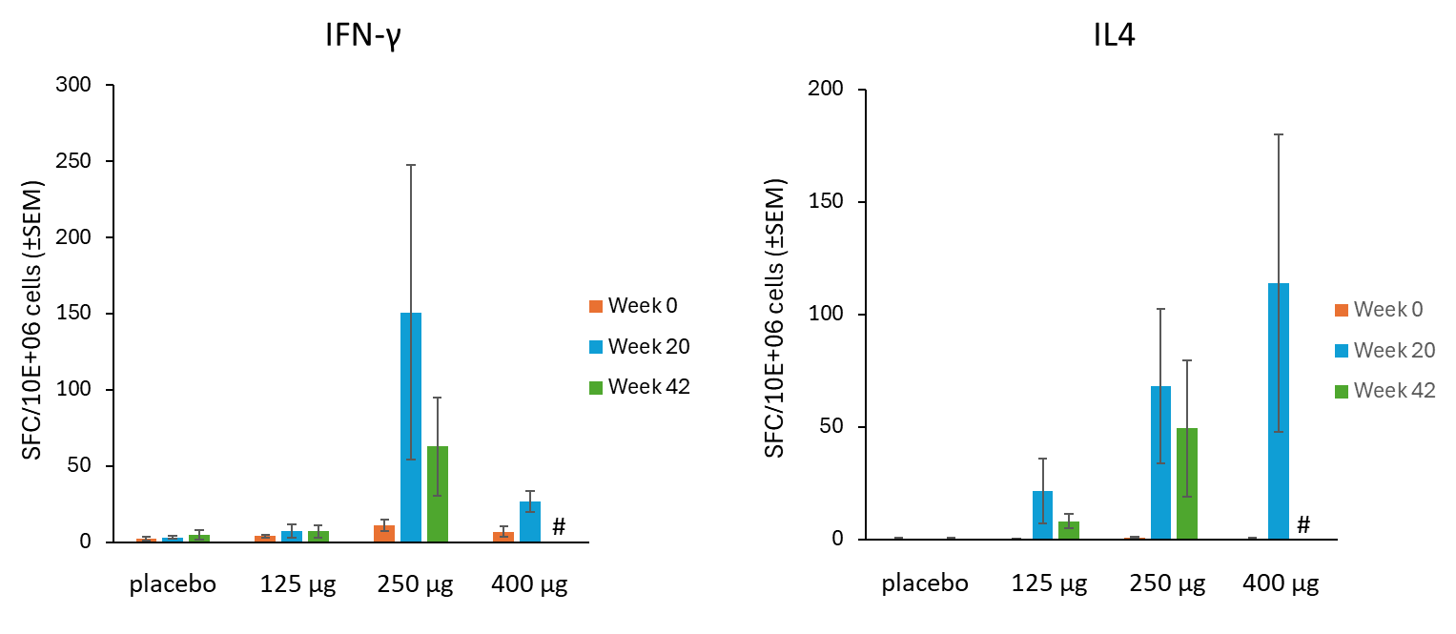

ELISpot assays on PBMCs stimulated with Aβ peptide fragments.

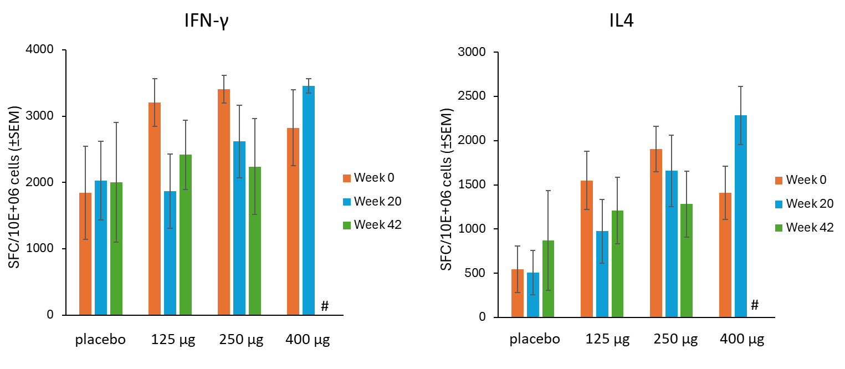
ELISpot assays on PBMCs stimulated with the anti-CD3 positive control antibody.

Supplementary Tables

Supplementary Table 1. Baseline characteristics of the ALZ‑C‑001 ALZ‑101 125/250 μg cohort and the ADNI Alzheimer’s disease cohort (Evenden et al. 2024, Alzheimers Dement 16:e12540) used in the external‑comparator analysis.

Characteristic | ALZ-C-001  125 µg (N=10) | ALZ-C-001  250 µg (N=10) | ALZ-C-001  125 µg+250 µg | ADNI AD  (N=383)
Age, years ± SD | 72.1 ± 6.0 | 66.8 ± 7.4 | 69.5 ± 6.9 | ∼75¹
Female, % | 40 | 20 | 30 | ~47²
MMSE ± SD | 24.1 ± 3.3 | 23.3 ± 3.2 | 23.7 ± 3.2 | 23.3³
ADCOMS ± SD | 0.57 ± 0.09 | 0.52 ± 0.08 | 0.55 ± 0.09 | 0.57 ± 0.19
ADAS-Cog13 ± SD | 33.0 ± 8.0 | 38.1 ± 10.9 | 35.6 ± 9.6 | 30.3⁴
CDR-GS ± SD | 0.6 ± 0.16 | 0.5 ± 0 | 0.55 ± 0.12 | Not reported
CDR-SB ± SD | 3.5 ± 1.1 | 2.7 ± 1.0 | 3.1 ± 1.1 | 4.42⁵
% Mild AD / % MCI | 70 / 30 | 80 / 20 | 75 / 25 | 100 / 0⁶

1. Age for the ADNI AD baseline group is reported by Evenden et al. as an average of approximately 75 years (overall ADNI cohort mean 73.5 years, range 54.4–91.4 years)
2. In the overall ADNI cohort 1071/2256 subjects were female; sex distribution by individual baseline diagnosis category (including AD) was not provided.
3. SD not reported, only median (=23)
4. SD not reported, only median (=29.3)
5. SD not reported, only median (=4.5)
6. By ADNI baseline diagnosis: Meets NINCDS–ADRDA criteria for probable AD (progressive dementia, impairment in at least two cognitive domains, onset between 40–90 years, and no alternative cause), and a CDR global score of 0.5 or 1.0, with MMSE usually between 20–26 at baseline.

Supplementary Table 2. Summary of most common adverse events (safety analysis set)

 | Number (%) of Patients
 | Placebo  (N=6) | ALZ-101  125 µg  (N=10) | ALZ-101 250 µg  (N=10) | ALZ-101 400 µg  (N=6) | Total  (N=32)
Injection site pain | 6 (100) | 8 (80) | 9 (80) | 3 (50) | 26 (81)
Nasopharyngitis | 3 (50) | 6 (60) | 3 (30) | 1 (17) | 13 (41)
Fatigue | 2 (33) | 4 (40) | 5 (50) | 1 (17) | 12 (38)
Headache | 2 (33) | 4 (40) | 2 (20) | 3 (50) | 11 (34)
COVID-19 | 1 (17) | 5 (50) | 3 (30) | 1 (17) | 10 (31)
Injection site erythema | 3 (50) | 4 (40) | 2 (20) | - | 9 (28)
ARIA-H | 2 (33) | 6 (60) | 1 (10) | - | 9 (28)
Diarrhoea | 1 (17) | 2 (20) | 3 (30) | 3 (50) | 9 (28)
Dizziness | 1 (17) | 2 (20) | 4 (40) | 1 (17) | 8 (25)
Back pain | 2 (33) | 3 (30) | 1 (10) | 2 (33) | 8 (25)
Injection site warmth | 1 (17) | 3 (30) | 2 (20) | 1 (17) | 7 (22)
Muscle spasms | 2 (33) | - | 4 (40) | - | 6 (19)
Nausea | 1 (17) | 2 (20) | 2 (20) | 1 (17) | 6 (19)
Onychomycosis | 1 (17) | 2 (20) | 1 (10) | - | 4 (13)
Rhinitis | - | 2 (20) | 2 (20) | - | 4 (13)
Gastroenteritis | - | 1 (10) | 2 (20) | 1 (17) | 4 (13)
Cough | - | 3 (30) | 1 (10) | - | 4 (13)
Rhinorrhoea | - | 1 (10) | 2 (20) | 1 (17) | 4 (13)
Hypercholesterolemia | - | 2 (20) | 2 (20) | - | 4 (13)
Hypertension | 2 (33) | 1 (10) | 1 (10) | - | 4 (13)
Puncture site haematoma | 1 (17) | 1 (10) | 1 (10) | - | 3 (9)
Dementia Alzheimer’s type | - | 1 (10) | 2 (20) | - | 3 (9)
Pain in extremity | 1 (17) | - | 2 (20) | - | 3 (9)
Arthralgia | - | 1 (10) | 1 (10) | 1 (17) | 3 (9)
GGT increased | - | 2 (20) | 1 (10) | - | 3 (9)
Insomnia | - | 1 (10) | 1 (10) | 1 (17) | 3 (9)
Depression | 1 (17) | 2 (20) | - | - | 3 (9)
Fall | 2 (33) | 1 (10) | - | - | 3 (9)
Haematuria | 1 (17) | 1 (10) | - | 1 (17) | 3 (9)
Malaise | - | 1 (10) | - | 1 (17) | 2 (6)
Injection site swelling | - | - | 2 (20) | - | 2 (6)
Injection site granuloma | - | 1 (10) | 1 (10) | - | 2 (6)
Injection site haematoma | - | 2 (20) | - | - | 2 (6)
Conjunctivitis | 1 (17) | - | 1 (10) | - | 2 (6)
Myalgia | - | 1 (10) | 1 (10) | - | 2 (6)
Abdominal pain lower | 1 (17) | 1 (10) | - | - | 2 (6)
Vomiting | - | 2 (20) | - | - | 2 (6)
Dyspepsia | 1 (17) | - | - | 1 (17) | 2 (6)
Asthma | - | 1 (10) | 1 (10) | - | 2 (6)
CRP increased | - | - | 1 (10) | 1 (17) | 2 (6)
Blood creatinine increased | - | - | 1 (10) | 1 (17) | 2 (6)
Blood CK increased | - | - | 2 (20) | - | 2 (6)
Eczema | - | - | 1 (10) | 1 (17) | 2 (6)
Pruritus | 1 (17) | - | 1 (10) | - | 2 (6)
Hyperkalaemia | 1 (17) | - | - | 1 (17) | 2 (6)
Type 2 diabetes mellitus | - | 1 (10) | 1 (10) | - | 2 (6)
Palpitations | - | 2 (20) | - | - | 2 (6)
Hypertonic bladder | - | 2 (20) | - | - | 2 (6)
Leucocytosis | - | 1 (10) | 1 (10) | - | 2 (6)
Lymphopenia | - | 1 (10) | 1 (10) | - | 2 (6)
Cataract | - | - | 2 (20) | - | 2 (6)
CK: creatine phosphokinase; CRP: C-reactive protein; GGT: gamma-glutamyl transferase; N: number of patients; n (%): number (percent) of patients with observation

Supplementary Table 3. Mean values and mean changes from baseline for ECG parameters (safety analysis set)

 |  | Placebo  (N=6) | ALZ-101  125 µg  (N=10) | ALZ-101  250 µg  (N=10) | ALZ-101  400 µg  (N=6)
Parts A1+A2 | Heart rate (bpm)  min-max mean values  min-max mean changes | 48.8 – 59.5  -7.8 – 2.8 | 58.4 – 67.7  -5.9 – 3.4 | 53.3 – 62.4  -5.4 – 2.9 | 52 – 64.5  -4.5 - 8
Parts A1+A2 | PR interval (ms)  min-max mean values  min-max mean changes | 152.7 – 162.7  -4.7 – 5.3 | 163 – 178.8  2.4 – 15.8 | 174 – 189.8  -4 – 4.6 | 157 – 168.3  -8.3 - 3
Parts A1+A2 | QRS duration (ms)  min-max mean values  min-max mean changes | 92.3 – 99  -1.3 – 5.3 | 92.4 – 98.8  -4.4 – 2 | 97.2 – 103  -3.2 – 0.4 | 86.7 – 91  -3 – 1.3
Parts A1+A2 | QT interval (ms)  min-max mean values  min-max mean changes | 427 – 462.7  0.7 – 35.7 | 403 – 431  -9.8 – 18.2 | 408.6 – 438.2  -6.6 – 20.4 | 401.7 – 441  -22 – 17.3
Parts A1+A2 | QTcF interval (ms)  min-max mean values  min-max mean changes | 415 – 438.8  -1.5 – 22.3 | 413.8 – 424.3  -4.1 – 6.4 | 408 – 418.8  -3.1 – 6.3 | 407.5 – 421  -5.7 – 7.8
Part B | Heart rate (bpm)  min-max mean values  min-max mean changes | 49 – 55.4  -6.4 - 2 | 62.6 – 67.9  -3.4 – 1.9 | 55. – 62.1  -4 – 2.6 | NA
Part B | PR interval (ms)  min-max mean values  min-max mean changes | 158.4 – 169.2  -2.8 – 6.8 | 166.8 – 178.3  3.5 – 11.3 | 181 – 190  -2 – 7 | NA
Part B | QRS duration (ms)  min-max mean values  min-max mean changes | 97.6 – 103.2  -0.4 – 6 | 90.3 – 94.8  -3.8 – 0.3 | 89.4 – 100.4  -3.8 – 0.6 | NA
Part B | QT interval (ms)  min-max mean values  min-max mean changes | 427.2 – 445.2  -3.2 – 20 | 398 – 416.3  -7.8 – 11 | 403.6 – 441  -11.6 – 11.6 | NA
Part B | QTcF interval (ms)  min-max mean values  min-max mean changes | 412.8 – 426.4  0.6 – 14.2 | 407.3 – 421.4  -6.8 – 7.4 | 404 – 413  -7.1 – 1.9 | NA
bpm: beats per minute; min-max: minimum-maximum; N: number of patients; NA: not applicable

Supplementary Table 4. Statistical analysis of Aβ-specific IgG, Part A1 (full analysis set, MMRM)

 | LS Means (95% CI)
Timepoint | Placebo  (N=6) | 125 µg  (N=10) | 250 µg  (N=10) | Relative treatment difference  (95% CI) | p-value
Baseline | - | -0.00  (-0.60, 1.53) | 0.27  (-0.50, 2.21) | - | 0.717
Week 4 | - | 0.36  (-0.46, 2.42) | 0.84  (-0.27, 3.65) | 2.37  (0.06, 94.08) | 0.643
Week 8 | - | 2.06  (0.21, 6.72) | 7.16  (2.23, 19.62) | 3.48  (0.66, 18.41) | 0.140
Week 12 | - | 13.48  (4.73, 35.58) | 51.40  (19.75, 131.36) | 3.81  (0.98, 14.91) | 0.054
Week 16 | - | 13.51  (4.74, 35.64) | 26.51  (9.89, 68.49) | 1.96  (0.49, 7.81) | 0.335
Week 20 | - | 75.29  (29.20, 191.70) | 83.62  (32.50, 212.74) | 1.11  (0.29, 4.19) | 0.876
Week 30 | - | 99.50  (38.79, 252.85) | 92.42  (35.99, 234.98) | 0.93  (0.25, 3.49) | 0.912
Week 42 | - | 58.96  (21.99, 155.38) | 51.36  (18.31, 140.98) | 0.87  (0.21, 3.56) | 0.847
CI: Confidence Interval; LS Means: Least Squares Means; N: number of patients; MMRM: Mixed Model for Repeated Measures log(IgG+1) modelled using MMRM with treatment group, visit, and treatment by visit interaction as fixed effects, and repeated measures within patient. The placebo group was excluded from the statistical analysis as pre-specified in the SAP. Comparison of the baseline visit fail because of division by zero. Relative difference >1 means higher immunoglobulin levels in the ALZ-101 250 µg group compared to the 125 µg group. P-values are for the two-sided hypothesis that the two groups differ.

.

Supplementary Table 5. Descriptive statistics of peak anti-ALZ-101 IgG titres (Cmax) by initial treatment group and study part (Full Analysis Set).

Study part | Treatment group | N | GeoMean | GeoSD | Q1 | Median | Q3 | Min | Max
Part A1 | Placebo | 6 | 1.5 | 4.14 | 0 | 0 | 10 | 0 | 20
Part A1 | ALZ-101 125 µg | 10 | 114.1 | 4.61 | 40 | 60 | 320 | 20 | 2560
Part A1 | ALZ-101 250 µg | 10 | 139.7 | 2.33 | 80 | 160 | 160 | 40 | 640
Part A2 | ALZ-101 400 µg | 6 | 114.8 | 4.35 | 40 | 160 | 320 | 10 | 640
Part B | Placebo | 5 | 50.3 | 17.64 | 20 | 40 | 160 | 0 | 2560
Part B | ALZ-101 125 µg | 8 | 202.0 | 14.19 | 60 | 400 | 1920 | 0 | 2560
Part B | ALZ-101 250 µg | 10 | 197.5 | 2.80 | 80 | 160 | 320 | 40 | 1280

Geometric mean (GeoMean), geometric standard deviation (GeoSD), quartiles (Q1, median, Q3), and range (Min–Max) of peak IgG titres are shown for each dose group in Part A1/A2 and Part B. All ALZ-101 dose levels elicited markedly higher peak IgG titres than placebo in Part A, with 250 µg showing the highest and most consistent responses, while 400 µg did not further increase titres compared with 250 µg. In Part B, Part A1 placebo recipients developed measurable titres consistent with vaccination, and both 125 µg and 250 µg groups demonstrated higher geometric mean peak titres after boosting than after the priming doses in Part A1, with 125 µg characterised by greater inter-individual variability and very high responders compared with the more homogeneous 250 µg group.
Supplementary Table 6. Mean baseline (at screening) and changes from baseline for prespecified CSF biomarkers (full analysis set)

 | Placebo  (N=6) | ALZ-101
 | Placebo  (N=6) | 125 µg (N=10) |  | 250 µg (N=10) | 400 µg (N=6)
Aβ42 (pg/ml)
mean baseline (BL) value (SD) | 424 (144) | 457 (96) | 437 (113) |  | 486 (129)
Part A1+A2/W20  mean change from BL (SD) | 2.5 (38) | 0.1 (15.9) | -2.5 (28) |  | -1.0 (30)
Part B/W20  mean change from BL (SD) | -14.2 (11.4) | 35 (119) | 31 (91) |  | NA
Aβ40 (pg/ml)
mean baseline value (SD) | 10100 (3390) | 11300 (2560) | 9960 (2290) |  | 11900 (3730)
Part A1+A2/W20  mean change from BL (SD) | 202 (676) | 165 (500) | 141 (616) |  | -98 (742)
Part B/W20  mean change from BL (SD) | -560 (851) | -254 (1170) | 151 (970) |  | NA
Aβ42/40 ratio
mean baseline value (SD) | 0.43 (0.09) | 0.41 (0.6) | 0.44 (0.7) |  | 0.43 (0.11)
Part A1+A2/W20  mean change from BL (SD) | -0.008 (0.015) | -0.002 (0.016) | -0.008 (0.020) |  | 0.008 (0.017)
Part B/W20  mean change from BL (SD) | 0.004 (0.029) | 0.064 (0.201) | 0.020 (0.078) |  | NA
T-tau (pg/ml)
mean baseline value (SD) | 635 (180) | 712 (283) | 580 (198) |  | 755 (243)
Part A1+A2/W20  mean change from BL (SD) | 39.0 (55.5) | 28.6 (45.2) | 23.3 (38.6) |  | 26.3 (65.1)
Part B/W20  mean change from BL (SD) | 36.6 (116) | 26.7 (137) | 22.1 (53.1) |  | NA
P-tau181 (pg/ml)
mean baseline value (SD) | 87.7 (25.1) | 99.6 (42.5) | 76.5 (26.1) |  | 101 (34.6)
Part A1+A2/W20  mean change from BL (SD) | 7.3 (5.7) | 5.0 (7.3) | 3.2 (5.5) |  | 1.8 (8.8)
Part B/W20  mean change from BL (SD) | 4.6 (17.8) | 0.7 (18.9) | 2.6 (8.4) |  | NA
NfL (pg/ml)
mean baseline value (SD) | 1010 (392) | 1230 (842) | 1210 (698) |  | 863 (160)
Part A1+A2/W20  mean change from BL (SD) | 41 (59) | -6 (188) | 63 (102) |  | 185 (263)
Part B/W20  mean change from BL (SD) | 182 (164) | -36 (330) | 68 (218) |  | NA
Neurogranin (pg/ml)
mean baseline value (SD) | 303 (83) | 311 (75) | 274 (74) |  | 337 (137)
Part A1+A2/W20  mean change from BL (SD) | 6.7 (36.7) | 8.0 (30.5) | -4.0 (20.7) |  | -15.0 (38.9)
Part B/W20  mean change from BL (SD) | 2.0 (46.0) | -8.6 (50.8) | 6.7 (47.7) |  | NA
YKL-40 (ng/ml)
mean baseline value (SD) | 187 (64) | 221 (67) | 208 (60) |  | 159 (65)
Part A1+A2/W20  mean change from BL (SD) | 11.7 (24.0) | 15.0 (17.8) | 3.0 (9.5) |  | 2.5 (11.7)
Part B/W20  mean change from BL (SD) | 18.0 (22.8) | 11.4 (24.1) | 8.9 (10.5) |  | NA
sTREM-2 (pg/ml)
mean baseline value (SD) | 3900 (2060) | 3600 (2290) | 4460 (2760) |  | 3510 (1230)
Part A1+A2/W20  mean change from BL (SD) | 283 (499) | 100 (257) | -45 (404) |  | 47 (73)
Part B/W20  mean change from BL (SD) | 84 (210) | -352 (1360) | 323 (494) |  | NA
BL: baseline; N: number of patients; NfL: neurofilament light; P-tau: phosphorylated tau; SD: standard deviation; sTREM-2: soluble triggering receptor expressed on myeloid cells 2; T-tau: total tau; W20: Week 20
Groups are presented according to the initial allocation to treatment groups in Part A (A1+A2). During Part B, patients in the placebo group received 4 doses of 250 µg of ALZ-101, and patients in the active ALZ-101 groups in Part A1, received 2 doses of 250 µg of ALZ-101 during Part B

Supplementary Table 7. Mean baseline and changes from baseline values for cognitive and functional tests by treatment group (full analysis set)

 | Placebo  (N=6) | ALZ-101
 | Placebo  (N=6) | 125 µg (N=10) | 250 µg (N=10) | 400 µg (N=6)
ADAS-Cog13
Mean baseline (BL) (SD) | 31.8 (10.05) | 33.0 (7.96) | 38.1 (10.89) | 33.3 (10.27)
Part A1+A2/W20  mean change from BL (SD) | 4.5 (6.25) | 4.1 (5.4) | 0.8 (5.94) | -0.3 (6.92)
Part A1+A2/W42  mean change from BL (SD) | 5.0 (6.44) | 1.9 (9.74) | 5.5 (7.45) | NA
Part B/W20  mean change from BL (SD) | 3.4 (5.55) | 3.1 (6.94) | 3 (8.42) | NA
Part B/W42  mean change from BL (SD) | 6.6 (7.47) | 6.8 (8.38) | 4.0 (8.96) | NA
ADCOMS
Mean baseline (BL) (SD) | 0.46 (0.087) | 0.57 (0.086) | 0.52 (0.075) | 0.52 (0.065)
Part A1+A2/W20  mean change from BL (SD) | 0.05 (0.105) | 0.02 (0.091) | 0.02 (0.093) | -0.05 (0.074)
Part A1+A2/W42  mean change from BL (SD) | 0.07 (0.086) | 0.03 (0.08) | 0.06 (0.135) | NA
Part B/W20  mean change from BL (SD) | 0.04 (0.126) | 0.03 (0.117) | 0.03 (0.164) | NA
Part B/W42  mean change from BL (SD) | 0.11 (0.161) | 0.03 (0.109) | 0.11 (0.203) | NA
ADCS-ADL
Mean baseline (BL) (SD) | 73.0 (2.19) | 69.8 (3.74) | 71.5 (4.25) | 72.3 (3.33)
Part A1+A2/W20  mean change from BL (SD) | -0.2 (1.94) | -1.1 (3.51 | -0.1 (3.31) | 1.2 (1.94)
Part A1+A2/W42  mean change from BL (SD) | -1 (3.39) | -1.6 (4.72) | -0.5 (5.86) | NA
Part B/W20  mean change from BL (SD) | -0.8 (4.66) | -4.5 (7.89) | -2.8 (7.66) | NA
Part B/W42  mean change from BL (SD) | -3.8 (10.5) | -1.4 (4.47) | -3.8 (8) | NA
CDR-Global score
Mean baseline (BL) (SD) | 0.5 (0.0) | 0.6 (0.16) | 0.5 (0.0) | 0.5 (0.0)
Part A1+A2/W20  mean change from BL (SD) | 0.1 (0.2) | 0.1 (0.21) | 0.1 (0.21) | 0 (0)
Part A1+A2/W42  mean change from BL (SD) | 0.1 (0.22) | 0.1 (0.25) | 0.3 (0.53) | NA
Part B/W20  mean change from BL (SD) | 0.1 (0.22) | 0.1 (0.18) | 0.3 (0.49) | NA
Part B/W42  mean change from BL (SD) | 0.1 (0.22) | 0.1 (0.23) | 0.3 (0.48) | NA
CDR-SB
Mean baseline (BL) (SD) | 2.3 (0.88) | 3.5 (1.05) | 2.7 (1) | 2.8 (0.82)
Part A1+A2/W20  mean change from BL (SD) | 0.1 (1.16) | 0.1 (0.88) | 0.5 (1.2) | -0.7 (0.52)
Part A1+A2/W42  mean change from BL (SD) | 0.8 (1.25) | 0.4 (0.6) | 1.1 (1.96) | NA
Part B/W20  mean change from BL (SD) | 0.3 (2.33) | 0.3 (1.16) | 1 (2.4) | NA
Part B/W42  mean change from BL (SD) | 1.5 (2.52) | 0.5 (1.49) | 1.7 (2.54) | NA
NPI Total Score
Mean baseline (BL) (SD) | 6.2 (5.91) | 9.1 (7.61) | 6.6 (8.64) | 2.8 (4.4)
Part A1+A2/W20  mean change from BL (SD) | -3.8 (6.55) | -3.4 (7.55) | 0.5 (5.52) | -2.3 (4.13)
Part A1+A2/W42  mean change from BL (SD) | -4 (5.34) | -1.3 (7.63) | -1 (3.96) | NA
Part B/W20  mean change from BL (SD) | 1.2 (11.17) | -2 (8.59) | -2.8 (2.97) | NA
Part B/W42  mean change from BL (SD) | -0.8 (5.36) | -0.9 (4.64) | -3.1 (4.12) | NA
NTB Score
Mean baseline (BL) (SD) | 0 (0.96) | 0.1 (0.49) | -0.1 (0.92) | -0.1 (0.43)
Part A1+A2/W20  mean change from BL (SD) | -0.1 (0.36) | -0.1 (0.57) | -0.1 (0.36) | 0.1 (0.22)
Part A1+A2/W42  mean change from BL (SD) | 0 (0.29) | -0.2 (0.65) | 0 (0.2) | NA
Part B/W20  mean change from BL (SD) | 0.2 (0.35) | -0.3 (0.63) | -0.1 (0.34) | NA
Part B/W42  mean change from BL (SD) | -0.1 (0.46) | -0.5 (0.66) | -0.3 (0.31) | NA
ADAS-Cog13: Alzheimer’s Disease Assessment Scale – Cognitive Subscale 13; ADCOMS: Alzheimer’s Disease Composite Score; ADCS-ADL: Alzheimer’s Disease Cooperative Study – Activities of Daily Living; BL: baseline; N: number of patients with observations; NA: not applicable; NPI: Neuropsychiatric Inventory; NTB: Neuropsychological Test Battery; SD: standard deviation; W42: Week 42
Groups are presented according to the initial allocation to treatment groups in Part A (A1+A2). During Part B, patients in the placebo group received 4 doses of 250 µg of ALZ-101 and patients in the active ALZ-101 groups in Part A1 received 2 doses of 250 µg of ALZ-101 during Part B.

Supplementary Table 8. Statistical analysis of cognitive and functional assessments at Weeks 20 and 42 (full analysis set).

 |  |  | LS Means |  |  |  | LS Means treatment-differences
Treatment | Visit(week) | N | Estimate | 95% CI |  |  | Comparisons | Estimate |  | 95% CI |  | P-value⁽¹⁾
MMSE
Placebo | Part A: Visit 13/ Week 20 | 6 | -0.64 | (-3.30, 2.03) |  |  | ALZ-101 (250 µg) vs ALZ-101 (125 µg) | 0.92 |  | (-2.01, 3.85) |  | 0.523
Placebo | Part A: Visit 17/ Week 42 | 5 | -2.04 | (-4.25, 0.17) |  |  | ALZ-101 (250 µg) vs ALZ-101 (125 µg) | -0.50 |  | (-2.93, 1.92) |  | 0.669
ALZ-101  (125 µg) | Part A: Visit 13/ Week 20 | 10 | -0.63 | (-2.69, 1.44) |  |  | ALZ-101 (125 µg) vs Placebo | 0.01 |  | (-3.36, 3.38) |  | 0.996
ALZ-101  (125 µg) | Part A: Visit 17/ Week 42 | 9 | -0.39 | (-2.05, 1.27) |  |  | ALZ-101 (125 µg) vs Placebo | 1.65 |  | (-1.10, 4.41) |  | 0.225
ALZ-101  (250 µg) | Part A: Visit 13/ Week 20 | 10 | 0.29 | (-1.79, 2.37) |  |  | ALZ-101 (250 µg) vs Placebo | 0.92 |  | (-2.47, 4.32) |  | 0.578
ALZ-101  (250 µg) | Part A: Visit 17/ Week 42 | 8 | -0.89 | (-2.64, 0.85) |  |  | ALZ-101 (250 µg) vs Placebo | 1.15 |  | (-1.69, 3.98) |  | 0.409
CDR-SB
Placebo | Part A: Visit 13/ Week 20 | 6 | 0.49 | (-0.29, 1.27) |  | ALZ-101 (250 µg) vs ALZ-101 (125 µg) |  | 0.94 |  | (0.06, 1.81) |  | 0.037
Placebo | Part A: Visit 17/ Week 42 | 5 | 0.78 | (-0.40, 1.96) |  | ALZ-101 (250 µg) vs ALZ-101 (125 µg) |  | 0.84 |  | (-0.47, 2.15) |  | 0.194
ALZ-101  (125 µg) | Part A: Visit 13/ Week 20 | 10 | -0.28 | (-0.90, 0.34) |  | ALZ-101 (125 µg) vs Placebo |  | -0.77 |  | (-1.82, 0.28) |  | 0.143
ALZ-101  (125 µg) | Part A: Visit 17/ Week 42 | 9 | 0.14 | (-0.78, 1.05) |  | ALZ-101 (125 µg) vs Placebo |  | -0.64 |  | (-2.16, 0.88) |  | 0.391
ALZ-101  (250 µg) | Part A: Visit 13/ Week 20 | 10 | 0.65 | (0.07, 1.24) |  | ALZ-101 (250 µg) vs Placebo |  | 0.16 |  | (-0.79, 1.11) |  | 0.723
ALZ-101  (250 µg) | Part A: Visit 17/ Week 42 | 8 | 0.98 | (0.06, 1.89) |  | ALZ-101 (250 µg) vs Placebo |  | 0.20 |  | (-1.28, 1.68) |  | 0.777
CDR Global
Placebo | Part A: Visit 13/ Week 20 | 6 | 0.08 |  | (-0.10, 0.26) |  | ALZ-101 (250 µg) vs ALZ-101 (125 µg) |  | -0.01 |  | (-0.21, 0.19) |  | 0.939
Placebo | Part A: Visit 17/ Week 42 | 5 | 0.07 |  | (-0.26, 0.41) |  | ALZ-101 (250 µg) vs ALZ-101 (125 µg) |  | -0.02 |  | (-0.39, 0.35) |  | 0.915
ALZ-101  (125 µg) | Part A: Visit 13/ Week 20 | 10 | 0.10 |  | (-0.04, 0.25) |  | ALZ-101 (125 µg) vs Placebo |  | 0.02 |  | (-0.21, 0.26) |  | 0.831
ALZ-101  (125 µg) | Part A: Visit 17/ Week 42 | 9 | 0.23 |  | (-0.03, 0.49) |  | ALZ-101 (125 µg) vs Placebo |  | 0.16 |  | (-0.27, 0.58) |  | 0.451
ALZ-101  (250 µg) | Part A: Visit 13/ Week 20 | 10 | 0.10 |  | (-0.04, 0.24) |  | ALZ-101 (250 µg) vs Placebo |  | 0.02 |  | (-0.21, 0.24) |  | 0.881
ALZ-101  (250 µg) | Part A: Visit 17/ Week 42 | 8 | 0.21 |  | (-0.05, 0.48) |  | ALZ-101 (250 µg) vs Placebo |  | 0.14 |  | (-0.29, 0.57) |  | 0.510
ADAS-Cog13
Placebo | Part A: Visit 13/ Week 20 | 6 | 4.37 |  | (-0.71, 9.44) |  | ALZ-101 (250 µg) vs ALZ-101 (125 µg) |  | -3.06 |  | (-8.73, 2.61) |  | 0.275
Placebo | Part A: Visit 17/ Week 42 | 5 | 6.35 |  | (-1.34, 14.05) |  | ALZ-101 (250 µg) vs ALZ-101 (125 µg) |  | 2.43 |  | (-6.02, 10.87) |  | 0.557
ALZ-101  (125 µg) | Part A: Visit 13/ Week 20 | 10 | 4.02 |  | (0.11, 7.93) |  | ALZ-101 (125 µg) vs Placebo |  | -0.35 |  | (-6.69, 6.00) |  | 0.911
ALZ-101  (125 µg) | Part A: Visit 17/ Week 42 | 9 | 1.80 |  | (-4.02, 7.62) |  | ALZ-101 (125 µg) vs Placebo |  | -4.55 |  | (-14.17, 5.06) |  | 0.335
ALZ-101  (250 µg) | Part A: Visit 13/ Week 20 | 10 | 0.96 |  | (-3.04, 4.96) |  | ALZ-101 (250 µg) vs Placebo |  | -3.41 |  | (-9.98, 3.17) |  | 0.294
ALZ-101  (250 µg) | Part A: Visit 17/ Week 42 | 8 | 4.22 |  | (-1.84, 10.29) |  | ALZ-101 (250 µg) vs Placebo |  | -2.13 |  | (-12.00, 7.74) |  | 0.659
ADCS-ADL
Placebo | Part A: Visit 13/ Week 20 | 6 | -0.12 |  | (-2.96, 2.71) |  | ALZ-101 (250 µg) vs ALZ-101 (125 µg) |  | 1.04 |  | (-2.02, 4.10) |  | 0.490
Placebo | Part A: Visit 17/ Week 42 | 5 | -0.46 |  | (-4.77, 3.85) |  | ALZ-101 (250 µg) vs ALZ-101 (125 µg) |  | 0.94 |  | (-3.75, 5.62) |  | 0.684
ALZ-101  (125 µg) | Part A: Visit 13/ Week 20 | 10 | -1.13 |  | (-3.29, 1.04) |  | ALZ-101 (125 µg) vs Placebo |  | -1.00 |  | (-4.67, 2.67) |  | 0.577
ALZ-101  (125 µg) | Part A: Visit 17/ Week 42 | 9 | -1.82 |  | (-5.09, 1.44) |  | ALZ-101 (125 µg) vs Placebo |  | -1.36 |  | (-6.82, 4.11) |  | 0.613
ALZ-101  (250 µg) | Part A: Visit 13/ Week 20 | 10 | -0.09 |  | (-2.21, 2.03) |  | ALZ-101 (250 µg) vs Placebo |  | 0.03 |  | (-3.46, 3.53) |  | 0.984
ALZ-101  (250 µg) | Part A: Visit 17/ Week 42 | 8 | -0.89 |  | (-4.22, 2.44) |  | ALZ-101 (250 µg) vs Placebo |  | -0.42 |  | (-5.84, 4.99) |  | 0.873
NPI
Placebo | Part A: Visit 13/ Week 20 | 6 | -3.91 |  | (-9.62, 1.79) |  | ALZ-101 (250 µg) vs ALZ-101 (125 µg) |  | 3.78 |  | (-2.49, 10.05) |  | 0.224
Placebo | Part A: Visit 17/ Week 42 | 5 | -3.38 |  | (-8.91, 2.14) |  | ALZ-101 (250 µg) vs ALZ-101 (125 µg) |  | -0.14 |  | (-6.16, 5.88) |  | 0.962
ALZ-101  (125 µg) | Part A: Visit 13/ Week 20 | 10 | -3.34 |  | (-7.76, 1.07) |  | ALZ-101 (125 µg) vs Placebo |  | 0.57 |  | (-6.67, 7.81) |  | 0.872
ALZ-101  (125 µg) | Part A: Visit 17/ Week 42 | 9 | -0.95 |  | (-5.12, 3.22) |  | ALZ-101 (125 µg) vs Placebo |  | 2.44 |  | (-4.53, 9.40) |  | 0.475
ALZ-101  (250 µg) | Part A: Visit 13/ Week 20 | 10 | 0.44 |  | (-3.98, 4.86) |  | ALZ-101 (250 µg) vs Placebo |  | 4.35 |  | (-2.83, 11.53) |  | 0.222
ALZ-101  (250 µg) | Part A: Visit 17/ Week 42 | 8 | -1.09 |  | (-5.41, 3.23) |  | ALZ-101 (250 µg) vs Placebo |  | 2.29 |  | (-4.70, 9.29) |  | 0.503
NTB
Placebo | Part A: Visit 13/ Week 20 | 6 | -0.08 |  | (-0.46, 0.30) |  | ALZ-101 (250 µg) vs ALZ-101 (125 µg) |  | 0.02 |  | (-0.40, 0.43) |  | 0.936
Placebo | Part A: Visit 17/ Week 42 | 5 | -0.05 |  | (-0.50, 0.39) |  | ALZ-101 (250 µg) vs ALZ-101 (125 µg) |  | 0.32 |  | (-0.17, 0.81) |  | 0.185
ALZ-101  (125 µg) | Part A: Visit 13/ Week 20 | 10 | -0.11 |  | (-0.40, 0.18) |  | ALZ-101 (125 µg) vs Placebo |  | -0.03 |  | (-0.51, 0.45) |  | 0.893
ALZ-101  (125 µg) | Part A: Visit 17/ Week 42 | 9 | -0.26 |  | (-0.60, 0.08) |  | ALZ-101 (125 µg) vs Placebo |  | -0.21 |  | (-0.77, 0.35) |  | 0.451
ALZ-101  (250 µg) | Part A: Visit 13/ Week 20 | 10 | -0.09 |  | (-0.39, 0.20) |  | ALZ-101 (250 µg) vs Placebo |  | -0.01 |  | (-0.49, 0.46) |  | 0.949
ALZ-101  (250 µg) | Part A: Visit 17/ Week 42 | 8 | 0.06 |  | (-0.29, 0.41) |  | ALZ-101 (250 µg) vs Placebo |  | 0.11 |  | (-0.45, 0.68) |  | 0.676
ADCOMS
Placebo | Part A: Visit 13/ Week 20 | 6 | 0.10 |  | (0.03, 0.17) |  | ALZ-101 (250 µg) vs ALZ-101 (125 µg) |  | 0.03 |  | (-0.05, 0.10) |  | 0.472
Placebo | Part A: Visit 17/ Week 42 | 5 | 0.09 |  | (-0.00, 0.18) |  | ALZ-101 (250 µg) vs ALZ-101 (125 µg) |  | 0.04 |  | (-0.05, 0.14) |  | 0.371
ALZ-101  (125 µg) | Part A: Visit 13/ Week 20 | 10 | -0.00 |  | (-0.06, 0.05) |  | ALZ-101 (125 µg) vs Placebo |  | -0.10 |  | (-0.20, -0.00) |  | 0.040
ALZ-101  (125 µg) | Part A: Visit 17/ Week 42 | 9 | 0.00 |  | (-0.06, 0.07) |  | ALZ-101 (125 µg) vs Placebo |  | -0.09 |  | (-0.21, 0.03) |  | 0.148
ALZ-101  (250 µg) | Part A: Visit 13/ Week 20 | 10 | 0.02 |  | (-0.03, 0.07) |  | ALZ-101 (250 µg) vs Placebo |  | -0.07 |  | (-0.16, 0.01) |  | 0.095
ALZ-101  (250 µg) | Part A: Visit 17/ Week 42 | 8 | 0.05 |  | (-0.02, 0.12) |  | ALZ-101 (250 µg) vs Placebo |  | -0.04 |  | (-0.16, 0.07) |  | 0.444
Abbreviations: ADAS-Cog13 = Alzheimer’s Disease Assessment Scale – Cognitive Subscale 13; ADCOMS = Alzheimer’s Disease Composite Score; ADCL-ADL = Alzheimer’s Disease Cooperative Study – Activities of Daily Living; CDR-SB = Clinical Dementia Rating Scale – Sum of Boxes; CDR-Global = Clinical Dementia Rating Scale – Global Score; MMSE = Mini Mental State Examination; The mini-mental state examination, version 2 (MMSE-2) was used in this study; NPI = neuropsychological inventory; NTB = Neuropsychiatric Battery; N = number of observations; CI=Confidence Interval; LS Means= Least Square Means; MMRM = Mixed Model Repeated Measures
1) P-value for the two-sided hypothesis that the two groups differ.
Change from baseline modelled using MMRM with treatment group, visit and treatment by visit interaction as fixed effects, repeated measures within patient and baseline score as covariate.

Supplementary Table 9. Estimated ADCOMS scores by group and annual rates of change.

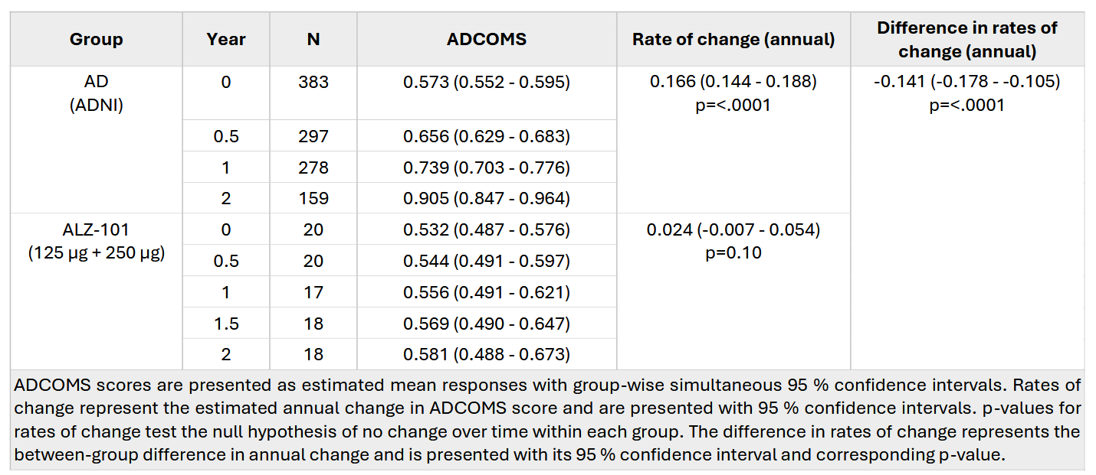

Inclusion/Exclusion Criteria, ALZ-C-001

Main inclusion criteria in Part A1 and A2:
- Male and female subjects between 50 and 83 years (inclusive) of age at the time of informed consent
- Subjects capable of providing valid independent informed consent and signing the informed consent form (the subjects' capacity to provide valid consent should be determined in accordance with applicable professional standards, and will be based on the Investigator's judgement)
- Subjects with MCI due to AD or mild AD according to National Institute of Aging - Alzheimer's Association (NIA-AA) core clinical criteria; subjects must have all of the following at screening:
- CDR global score (GS) of 0.5 or 1
- CDR memory score of ≥0.5
- MMSE score of ≥20 points
- Screening CSF results showing a pattern consistent with amyloid plaque load and indicative of AD pathology. The CSF results will be evaluated by the Investigator and will take into account the Aβ42/40 ratio (cut-off level set by the laboratory)
- If the subject is receiving an acetylcholine esterase inhibitor (AChEI) or memantine or both for the treatment of MCI or AD, this treatment must be on a stable dosage for at least 8 weeks prior to the first dosing of IMP. Treatment-naïve subjects may also be entered into the study
- Subjects must have an identified, reliable and knowledgeable study partner who is willing and able to support the participant and to provide follow-up information on the study participant throughout the course of the study. This person must, in the opinion of the Investigator, spend sufficient time with the study participant on a regular basis such that he or she can reliably fulfil the requirements of being a study partner (however, a study partner does not need to be living in the same household with the study participant)

Main inclusion criteria in Part B:
- Male and female subjects who have completed Visit 15 of Part A and are willing to continue in Part B of the study
- Subjects providing informed consent and signing the informed consent form. In case a subject is considered not to be capable of providing valid independent informed consent, the subject's legally acceptable representative (LAR) should consent to the study on behalf of the subject. In such a case, the subject should provide informed assent to continue in the study
- Subjects must have an identified, reliable and knowledgeable study partner who is willing and able to support the participant and to provide follow-up information on the study participant throughout the course of the study. This person must, in the opinion of the Investigator, spend sufficient time with the study participant on a regular basis such that he or she can reliably fulfil the requirements of being a study partner.

Main exclusion criteria in Part A1 and A2:
- Subjects having any contraindication to MRI scanning; or are unable to undergo brain MRI scanning according to the standard criteria of the MRI unit; or the Investigator believes that the subject will not be able to undergo further scans scheduled during the course of the study
- Screening MRI (3T) results showing evidence of clinically significant pathological lesions that could indicate a dementia-associated diagnosis other than early AD or cause a safety risk for the participant
- acute or subacute haemorrhage
- prior macrohaemorrhage* or prior subarachnoid haemorrhage, unless it can be documented that the finding is not due to an underlying structural or vascular abnormality (i.e., finding does not suggest subject is at risk of recurrent haemorrhage)
- >4 microhaemorrhages*
- superficial siderosis*
- cortical infarct*
- >2 lacunar infarcts*
- extensive white matter lesions as defined by a score of grade 3 on the age-related white matter changes scale (ARWMC)
- evidence of possibly clinically significant space-occupying lesions. Minor space-occupying lesions* (e.g., benign meningeoma) that are clinically stable, may be allowed based on Investigator’s judgment
- any finding that, in the opinion of the Investigator, might be a contributing cause of the participant’s early AD phenotype, might pose a risk to the participant, or might prevent a satisfactory MRI assessment for safety monitoring
* exact size criteria for exclusion based on specific MRI findings are detailed in the MRI manual
- Modified Hachinski Ischemia Score (mHIS) >4 at screening
- History of a cerebrovascular incident, including transient ischemic attack (TIA) or stroke, within 12 months of screening
- Subject with a history of seizures within 2 years of screening
- Any psychiatric diagnosis or symptoms (e.g. hallucinations, major depression, delusions, schizophrenia, bipolar disorder) that, in the opinion of the Investigator, could interfere with study procedures or assessments or participant safety. A subject with depression may, however, be included if treated with a stable dose of antidepressants for at least 8 weeks before screening and not fulfilling DSM-5 criteria for major depression at screening
- Significant risk of suicide (defined using the Columbia Suicide Severity Scale [C-SSRS], with the subject answering "yes" to suicidal ideation questions 4 or 5 or answering "yes" to suicidal behaviour) within 12 months of screening
- Disorder related to alcohol or drug abuse, as defined in DSM-5, within 2 years prior to screening
- Evidence of current or history of any significant autoimmune disease that, in the opinion of the Investigator, could interfere with evaluation of the study results or constitute a health hazard for the subject
- Evidence of an immune system that is compromised; including, but not limited to, a diagnosis of HIV (human immunodeficiency virus); or the subject has been splenectomised or has received an organ transplant (corneal transplants excluded), or is receiving chronic systemic immunosuppressive medication
- Evidence of current clinically significant and possibly unstable pulmonary, gastrointestinal, renal, hepatic, endocrine, haematological or cardiovascular system disease or metabolic disturbance
- Diagnosis of cancer (haematological or solid tumour) for which the subject is currently being treated, or for which there has been treatment within 5 years preceding screening, or for which there is still evidence of active disease. Subjects with local prostate cancer or local dermatological tumours, such as basal or squamous cell carcinoma, may be included
- Any clinically significant abnormalities in laboratory tests, vital signs, ECG or physical examination findings at screening that in the opinion of the Investigator require further investigation or treatment, or may interfere with study procedures or safety. These may include, but are not limited to, the following:
  - estimated glomerular filtration ratio (eGFR) <30 ml/min/1.73 m2, based on the CKD-EPI (Chronic Kidney Disease Epidemiology Collaboration) equation
  - plasma total bilirubin value >2 times the upper limit of the reference range
  - plasma alanine aminotransferase (ALAT) or aspartate aminotransferase (ASAT) value >2 times the upper limit of the reference range
  - low vitamin B12 or folate values that are considered to be clinically significant in relation to cognitive impairment. In such cases, re-screening is permissible after supplementation therapy has been provided for a sufficient time
  - prolonged QTcF interval of >470 ms
- Clinically suspected active neuroborreliosis, confirmed by the presence of Borrelia antibodies in CSF
- Contraindication to lumbar puncture (LP). These contraindications may include, but are not limited to, the following:
- increased intracranial pressure (ICP)
- skin infection at the LP site
- significant lumbar spine deformity
- bleeding diathesis (e.g., significant thrombocytopenia)
- taking anticoagulant therapy (e.g., warfarin, dabigatran, apixaban, or other blood factor or thrombin inhibitor). Use of anti-platelet therapy (e.g. low dose aspirin) may be permitted if deemed appropriate in the Investigator's judgement
- Current or anticipated use, or recent prior use (pre-study time limits specified in the main protocol text) of disallowed concomitant treatment
- Any vaccination within 2 weeks prior to screening
- History of severe drug allergy (anaphylactic shock or drug-induced hypersensitivity syndrome), or known hypersensitivity to vaccines, including constituents of vaccines
- Having received in another clinical trial
- any therapeutic monoclonal antibody, protein derived from a monoclonal antibody or immunoglobulin therapy within 6 months before screening
- active anti-amyloid immunization or other active immunization for the treatment of AD
- any other investigational medication (unless it can be documented that the subject received only placebo) or device within 3 months or 5 half-lives (whichever is longer) before screening
- Any condition that may be contributing to cognitive impairment above and beyond that caused by the subject's early AD
- Disease or medication that, in the opinion of the Investigator, could interfere with the assessments of safety, tolerability or immunogenicity
- Planned surgery that would take place during the double-blind treatment period of the study. Planned surgery not requiring general anaesthesia need not result in exclusion, if in the opinion of the Investigator this operation does not interfere with study procedures and participant safety
- Blood donation or loss of significant amount of blood within 3 months prior to the first screening visit
- Female subjects of childbearing potential
- Women who have had physiological (not drug-induced) amenorrhea and no pregnancy in the last 12 months prior to screening
- Women who have undergone surgical sterilization, e.g., hysterectomy, bilateral oophorectomy, bilateral tubal ligation

Main exclusion criteria in Part B:
- Any new condition that may be contributing to cognitive impairment above and beyond that caused by the subject's AD
- Any new disease or medication that, in the opinion of the Investigator, could interfere with the assessments of safety, tolerability or immunogenicity or constitute a health hazard for the subject participating in Part B of the study; however, a new disease or medication that would prevent CSF sample collection in Part B need not result in exclusion

Materials and Methods

MRI protocol

MRI protocols were acquired on 3T scanners at two sites using harmonised sequences optimised for structural assessment, white‑matter lesion detection, and identification of amyloid‑related imaging abnormalities (ARIA‑E and ARIA‑H) in participants with Alzheimer’s disease. At the Turku site, imaging was performed on a GE Signa Premier 3T scanner and included a 3‑plane localiser, two 3D sagittal T1‑weighted MPRAGE acquisitions, a 3D sagittal T2‑FLAIR Cube (HS1,4) sequence, axial T2*‑weighted fast gradient‑recalled echo (FGRE), axial dual‑echo proton‑density/T2‑weighted fast spin‑echo (FSE), and axial diffusion‑weighted imaging (DWI) using the MUSE multi‑shot technique (b = 1000 s/mm²). At the Helsinki site, a Siemens Magnetom Vida 3T scanner was used with an AAhead scout, two 3D sagittal T1‑weighted MPRAGE (p2_iso) acquisitions, a 3D sagittal T2‑weighted SPACE dark‑fluid (FLAIR‑equivalent) sequence, axial T2*‑weighted gradient‑echo (GRE), axial dual‑echo proton‑density/T2‑weighted turbo spin‑echo (TSE, 3 mm slice thickness), and axial multi‑shot DWI (RESOLVE 4‑scan trace, p2_224 matrix, b = 1000 s/mm²). All sequences were acquired within a single session.

Rabbit study – immunization and ELISA

New Zealand White Hra rabbits (Covance Research Products, Pennsylvania, USA) were immunised intramuscularly with 0.5 mL of 150 µg Aβ42CC oligomers (∼724 kDa, determined by SEC-MALS) formulated with 0.3% aluminium hydroxide (Brenntag/Croda, Denmark; batch #5167) on days 1, 21, and 42. Sera were collected on day 56.

The in vivo phase was conducted according to Covance Laboratories Ltd’s (now LabCorp Early Development Laboratories Ltd, UK) standard operating procedures. Although the in vivo part of the study was non-GLP, all procedures were fully aligned with international GLP standards.

For antibody characterization, 400 µL serum from each of four rabbits (two males and two females) was divided into two aliquots of 200 µL. One aliquot was diluted with 200 µL PBS, and the other with 200 µL PBS containing 2.9 mg/mL Aβ42 fibrils. Aβ42 fibrils were generated by incubating synthetic Aβ42 peptides (Bachem, Switzerland; cat# H-1368) at 10 mM HCl + 125 mM NaCl, 37 °C, 600 rpm for 29 h, followed by incubation in PBS (pH 7.4) at 37 °C, 600 rpm for 19 h. Both serum preparations were incubated at 30 °C for 1.5 h (500 rpm), centrifuged at 14,000 rpm for 15 min, and supernatants processed by Protein A chromatography using the NAb™ Protein A Plus Spin Kit (Thermo Scientific, cat# 89948) according to the manufacturer’s instructions. Antibody concentrations were determined by UV absorbance at 280 nm (A280/1.4=mg/mL), and purified samples were stored at −20 °C.

ELISA assays were performed using Maxisorp 96 well plates (Thermo Fisher Scientific, cat# 44 24004 21) coated for 16 h at 4 °C with 100 µL per well of either Aβ42 fibrils or Aβ42CC oligomer antigen diluted in PBS. Plates were washed three times with PBS + 0.05% Tween 20, then blocked with 170 µL 1% BSA in PBS for 45 min at 37 °C. After removing the blocking solution, 100 µL IgG (10 µg/mL in PBS + 0.1% BSA) was added to each well. The IgG concentration was calculated assuming approximately 10% antigen specific antibodies, yielding a theoretical anti-ALZ-101 concentration of 1 µg/mL. Control antibody 6E10 (Covance, UK; cat# SIG 39320) was used at 1 µg/mL in the same type of buffer. Each sample was serially diluted in three-fold steps. Plates were incubated 2 h at 23 °C (ambient temperature), washed three times, and 100 µL HRP conjugated goat anti rabbit IgG (Fc specific; Abcam, UK; cat# ab97200) diluted 1:2000 in PBS + 0.01% BSA was added. After a 1.25 h incubation at 23 °C, plates were washed again, and 100 µL per well of substrate solution (1.0 mg/mL OPD + H₂O₂ [4 µL/10 mL] in 0.1 M citric acid buffer, pH 4.5) was added. Absorbance was measured at 450 nm.

Clinical IgG/IgM/IgA ELISA

Immunogenicity of ALZ-101 was evaluated by measuring Aβ-specific antibodies in serum using ELISA. Ninety-six-well Maxisorp plates (Thermo Fisher Scientific cat# 430341) were coated with 500 ng/well of ALZ-101 diluted in 100 μL of phosphate-buffered saline (10 mM phosphate, 150 mM NaCl, pH 7.5; Thermo Fisher Scientific cat# 28348) and incubated for 2 hours. The plates were then washed twice with PBS containing 0.05% Tween-20 (PBS-Tween 20; Thermo Fisher Scientific cat# 28352). To block nonspecific binding, 100 μL per well of PBS with 3% bovine serum albumin (BSA; Sigma-Aldrich cat# A7030) was added, and the plates were incubated for 1 hour with shaking. Following blocking, the plates were washed twice again with PBS-Tween 20. Assay buffer, composed of 0.2% casein (Merck cat# 1.02241), 50 mM Tris-HCl (Merck cat# 108387), 0.2% gelatin from cold-water fish (Sigma-Aldrich cat# G7765), 3% NaCl, 0.2% BSA, and 0.05% Tween-20 (Sigma-Aldrich cat# P1379), adjusted to pH 8.5, was added at 45 μL per well. To this, 5 μL of human serum samples were added, resulting in a 1:10 dilution. The plates were incubated for 60 minutes with shaking. After incubation, the plates were washed twice with PBS-Tween 20 and europium-labeled detection antibodies were added in 100 μL assay buffer. The IgG isotype antibodies were detected with in-house europium-labeled Protein G (Thermo Fisher Scientific cat#21193) at 5 ng/mL. IgA and IgM antibodies were similarly measured using in-house europium-labelled goat anti-IgA (Thermo Fisher Scientific, cat#31140) at 40 ng/mL, and mouse anti-IgM (Sigma-Aldrich cat# SAB4700346) at 10 ng/mL. After a 60-minute incubation step, plates were washed four times with PBS-Tween 20, after which 200 μL per well of europium fluorescence intensifier (Kaivogen cat# 42-04) was added. The plates were incubated for at least 5 minutes with shaking prior to measurement. Plates were measured using a Victor Multilabel Counter equipped with Wallac 1420 software version 3.00 for data collection and MultiCalc version 2.7 for data analysis.

T-cell restimulation assays

The pattern of possible T-cell activation induced by ALZ-101 in peripheral blood mononuclear cells (PBMCs) was evaluated in all subjects. Blood samples for preparation of PBMCs were taken at baseline and at 4 and 26 weeks after the last dose of Part A1 (Week 20 and Week 42) for the placebo, 125 µg and 250 µg of ALZ-101 groups, and at baseline and 4 weeks after the last dose of Part A2 (Week 20) for the 400 µg of ALZ-101 group. PBMCs were prepared using BD Vacutainer® CPT™ tubes (BD Biosciences), frozen in liquid nitrogen within 8h of sampling, stored at -80°C for up to 72h, then transferred to liquid nitrogen for long-term storage. All samples were analysed at the end of the study. An ELISpot assay was set up and validated on in-study samples to measure cell viability and response to stimulation with a custom-synthesised mix of overlapping 15-mer Aβ peptide fragments with a four-residue overlap (SB Peptide), or with an anti-CD3 antibody as positive control. In brief, cells were thawed in benzonase (Merck-Millipore cat# 70664-3) and diluted to 2E+06 cells/mL in serum-free AimV medium (Thermo Fisher Scientific cat# 12055-083), then rested at 37°C, 5% CO₂, for 16-18h. Cells were counted and viability evaluated using acridine orange and DAPI (4′,6-diamidino-2-phenylindole) colouration with an automated cell counter (Chemometec NucleoCounter NC200). Cells were seeded at 1E+05 per well in triplicate and stimulated for 48±2h. Interferon-gamma (IFNγ; Mabtech cat# 3420-2APW-10) and interleukin-4 (IL-4; Mabtech cat#3410-2APW-10) were used as indicators of Th1 and Th2 responses and the assays performed according to the manufacturer’s recommendations. In parallel, a CEFT peptide pool—a defined set of peptides derived from common infectious agents known to activate T cells (JPT Peptide Technologies cat# PM-CEFT-3)—was used at 1 µg/mL to stimulate a quality control sample in the IFN-γ ELISpot assay, confirming T cell functionality and assay performance. Simultaneously, CD3 stimulation was employed in the IL-4 ELISpot assay to assess T cell activation in a complementary manner. Cells were read after drying using an ELISpot reader (Cellular Technologies Ltd.) and Immunospot software. Results are reported as spot forming colonies (SFC) per 10 million cells counted.

Exploratory external-comparator analysis of ADCOMS trajectories (expanded technical details)

Study population and data sources

The external‑comparator analysis included all participants randomised to ALZ‑101 125 μg or 250 μg in Part A1 of ALZ‑C‑001 who had at least one post‑baseline ADCOMS assessment. The two active‑dose groups were pooled (N=20) a priori to increase precision.

The external comparator was derived from the ADNI cohort described by Evenden et al. 2024 (Alzheimers Dement 16:e12540), restricted to participants with an AD baseline diagnosis. Baseline characteristics for this group (age, sex, ADCOMS, MMSE, ADAS‑Cog13, CDR‑SB) were taken from the main paper and Supplement and compared with those of the pooled ALZ‑C‑001 125/250 μg group. A detailed baseline table for both cohorts is provided in Supplementary Table 1.

Statistical analysis

A linear mixed‑effects model (LMM) was fitted to the ALZ‑C‑001 data with ADCOMS score as the dependent variable. Fixed effects comprised continuous time (years, centered at baseline) and treatment group (0 = placebo, 1 = active), entered via a time × treatment interaction. Subject‑level random effects were specified as random intercepts and random slopes for time, yielding an unstructured covariance for repeated measures within subjects. Residuals were assumed independent, homoscedastic, and approximately normally distributed. Parameters were estimated by restricted maximum likelihood. The LMM provided the annual rate of ADCOMS change (slope) and its standard error for the pooled active arm, while accounting for within‑subject correlation.

Summary ADCOMS statistics (means and standard deviations at approximately 0, 6, 12, and 24 months) for the ADNI AD baseline‑diagnosis group were incorporated as a historical reference. The within‑subject correlation structure estimated from the ALZ‑C‑001 LMM was combined with the reported ADNI standard deviations and sample sizes to construct an approximate covariance matrix for the ADNI mean‑value vector. A simple linear model of mean ADCOMS on time (years) was then fitted to these external means by generalised least squares (GLS), weighting observations according to their estimated precision and correlation.

The annual rate of change estimated for the ALZ‑101 active arm from the LMM was compared with the GLS slope from the ADNI AD cohort using a two‑sample z‑test, assuming independence between the trial and ADNI data as they arise from separate, non‑overlapping cohorts and ADNI is observational. Group‑wise simultaneous 95% confidence intervals for expected ADCOMS scores at months 0, 6, 12, 18, and 24 were generated for both the LMM (trial arms) and GLS (ADNI) fits by parametric simulation (10 000 draws) from the respective estimated covariance matrices. No imputation was performed for missing data; all available observations contributed to the likelihood.

Model diagnostics (residual plots, Q–Q plots, and influence diagnostics) supported the approximate normality and linearity assumptions. All analyses were conducted in R (version 4.3 or later) using nlme for LMM and GLS fitting and multcomp for simultaneous inference. Two‑sided p‑values < 0.05 were considered statistically significant; p‑values for slope comparisons are reported exactly.

Sensitivity and comparability considerations

The comparison between the pooled ALZ‑101 active group and the ADNI AD cohort rests on several important assumptions and should be regarded as hypothesis‑generating rather than confirmatory. First, the two populations are assumed to be broadly comparable in terms of baseline ADCOMS severity and progression behavior, and identical ADCOMS scoring algorithms are assumed to have been applied in both datasets. Second, the correlation structure estimated from ALZ‑C‑001 was imposed on the ADNI summary means as an approximation. Any substantial differences in underlying demographics, biomarker profiles, concomitant therapies, or ADCOMS assessment procedures between cohorts would limit the validity of the slope‑comparison test. Within these constraints, the hybrid modeling strategy — LMM on randomised trial data combined with GLS applied to external summary statistics — provides an efficient, correlation‑aware way to explore potential disease‑modifying signals when internal placebo data are sparse and sample sizes are small.

