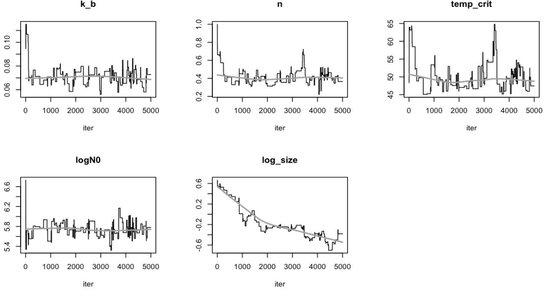
Figure S1. MCMC trace plots for the Peleg–Weibull model parameters.

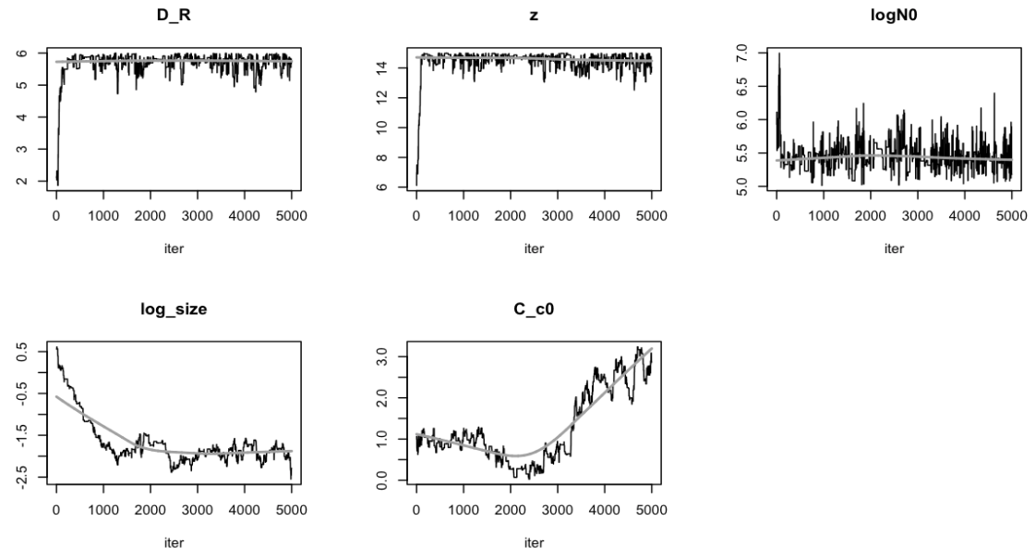
Figure S2. MCMC trace plots for the parameters of the Geeraerd model with shoulder.

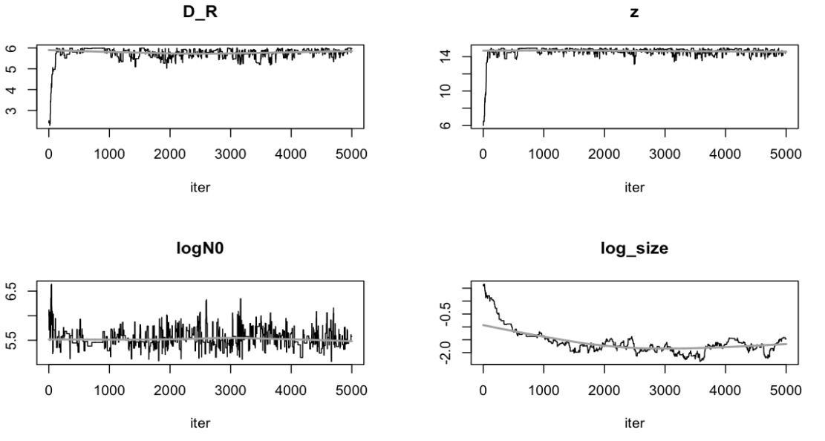
Figure S3. MCMC trace plots for the parameters of the Geeraerd model without shoulder.

