Engineering Liquid Metal-Based Nanozyme for Enhancing Microwave Dynamic Therapy in Breast Cancer PDX Model
Qiong Wu^{1,5#}, Yongnian Yu^{1,2,#}, Xiaorui Yu², Qijun Du^{3,4}, Li Gou^{2,}*, Longfei Tan^{1,5}, Changhui Fu^{1,5}, Xiangling Ren^{1,5}, Jun Ren^{1,5}, Kai Xiao^{4,}*, Xianwei Meng^{1,5,}*
¹ Laboratory of Controllable Preparation and Application of Nanomaterials, Technical Institute of Physics and Chemistry, Chinese Academy of Sciences, Beijing 100190, China
² College of Biomedical Engineering, Sichuan University, Chengdu 610065 China
³ Sichuan Kangcheng Biotechnology Co., LTD, No.28 Gaopeng Avenue, High-tech Zone, Chengdu, 610000, China
⁴ Precision Medicine Research Center & Sichuan Provincial Key Laboratory of Precision Medicine and National Clinical Research Center for Geriatrics, West China Hospital, Sichuan University, Chengdu 610041, China
⁵ CAS Key Laboratory of Cryogenics, Technical Institute of Physics and Chemistry, Beijing 100190, China
* Corresponding author. E-mail addresses: mengxw@mail.ipc.ac.cn, gouli@scu.edu.cn, xiaokaikaixiao@scu.edu.cn.

Fig. S1 Hydrodynamic size and Zeta potential of different materials. a) Hydrated particle size of LM@PVP NPs. b) Hydrated particle size of LZ NPs. c) Hydrated particle size of LZH nanozymes. d) Zeta potential of different materials.
Fig. S2 EDS element mapping images of LZH nanozymes and corresponding EDS.
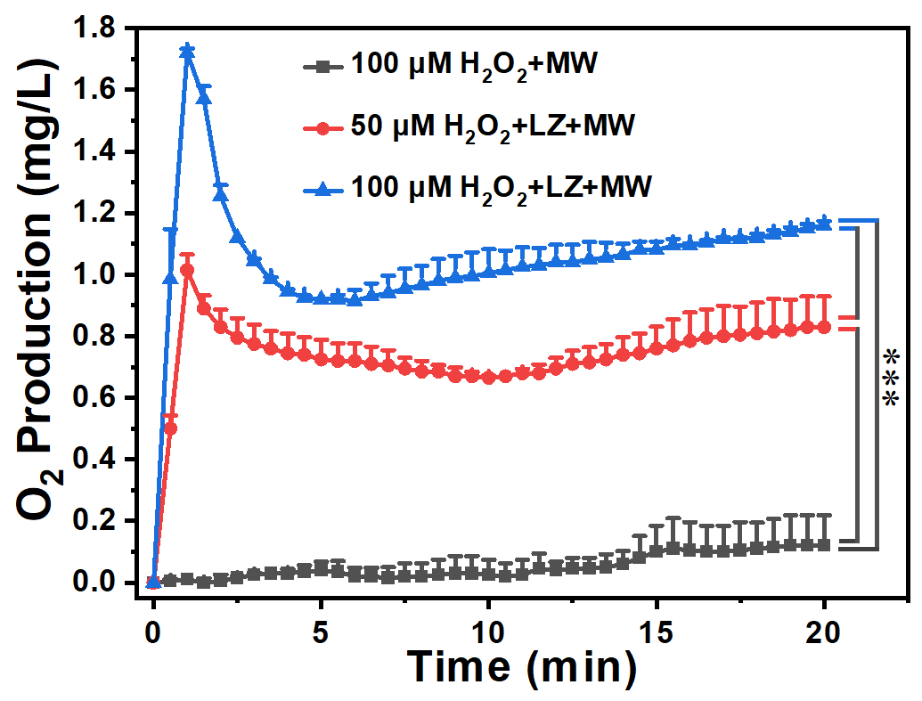
Fig. S3 The CAT-like activity of LZ NPs under microwave irradiation at different H₂O₂ concentrations (50 and 100 μM).
Fig. S4 Characterization of oxygen generation. a) Oxygen production diagrams of different concentrations of LZ NPs (0, 1, 3, 5 mg/mL). b) The net difference of oxygen production. c) B-scan ultrasonography of H₂O₂. d) B-scan ultrasonography of LZ+H₂O₂ (the red circle represents partial oxygen bubbles).
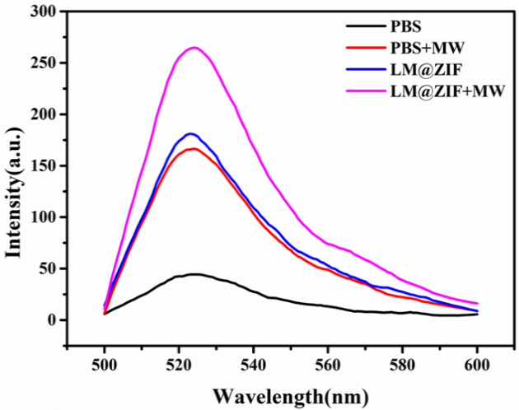
Fig. S5 Fluorescence intensity of DCF under different treatments.
Fig. S6 Flow cytometry results of ROS production at cellular level.
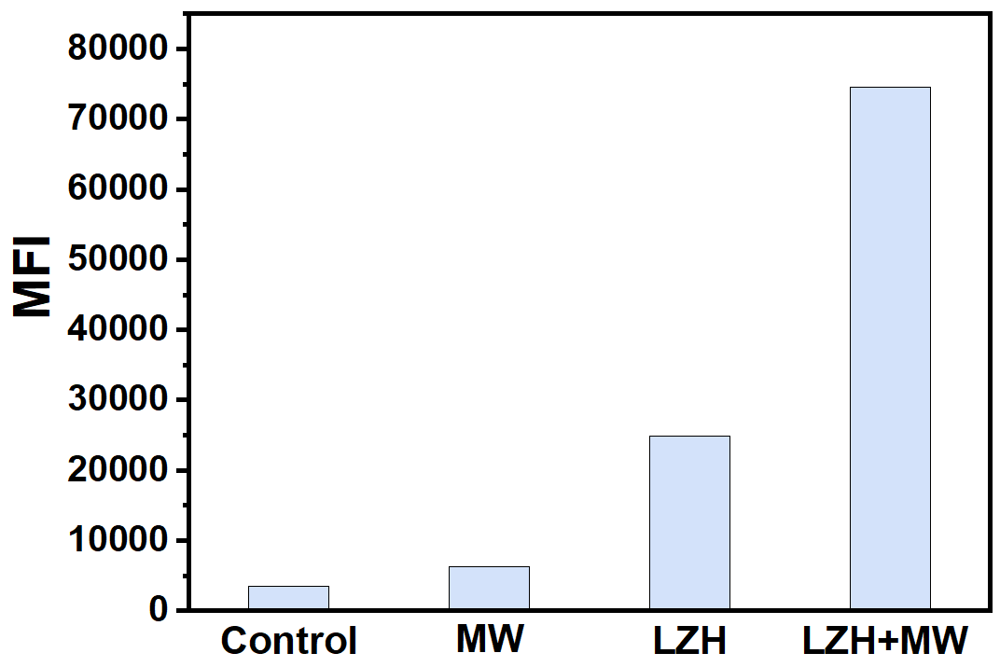
Fig. S7 Quantitative flow cytometric analysis of ROS production at cellular level.
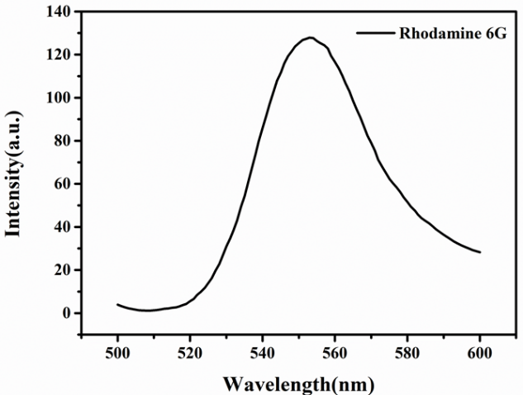
Fig. S8 Fluorescence spectra of Rhodamine 6G.
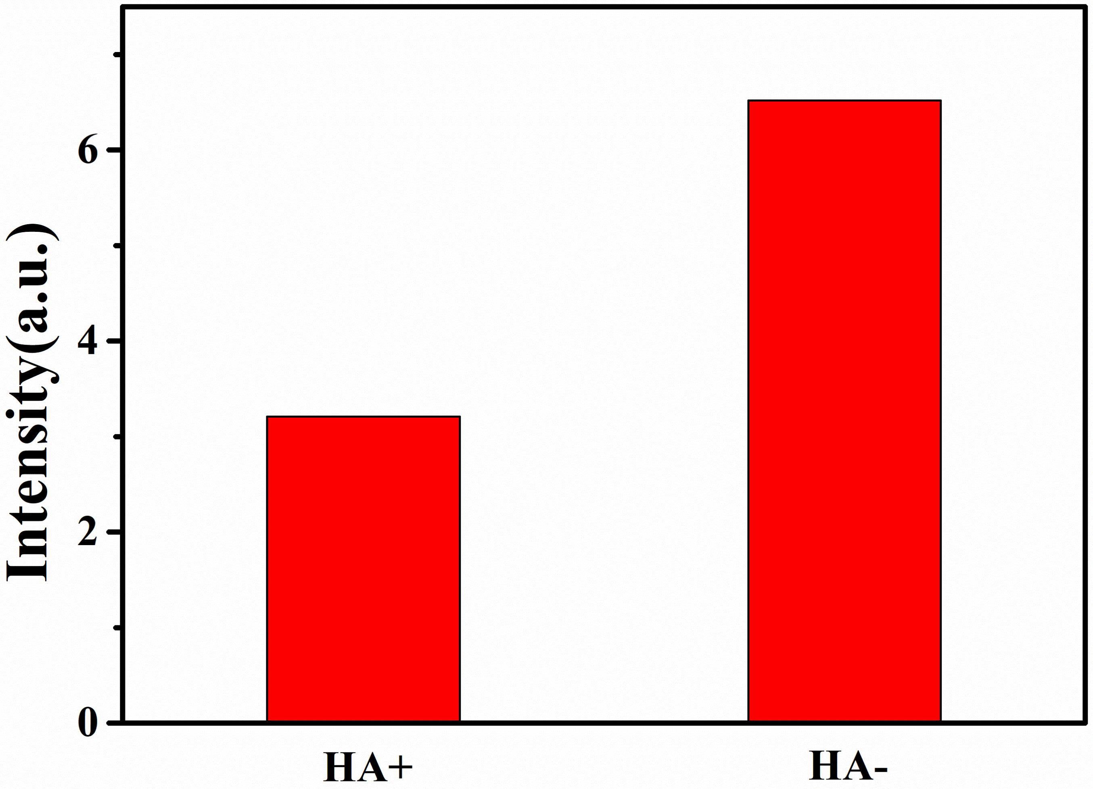
Fig. S9 Mean fluorescence intensity of Rhodamine 6G in targeting performance of HA.
Fig. S10 Flow cytometry results of CD44 targeting performance.
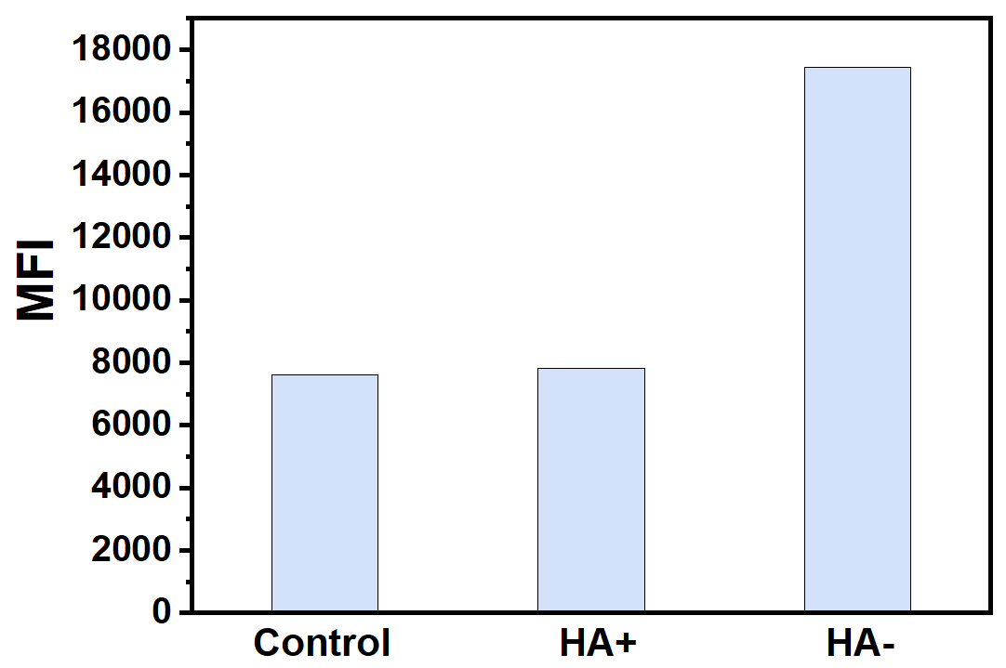
Fig. S11 Quantitative flow cytometric analysis of CD44 targeting performance.

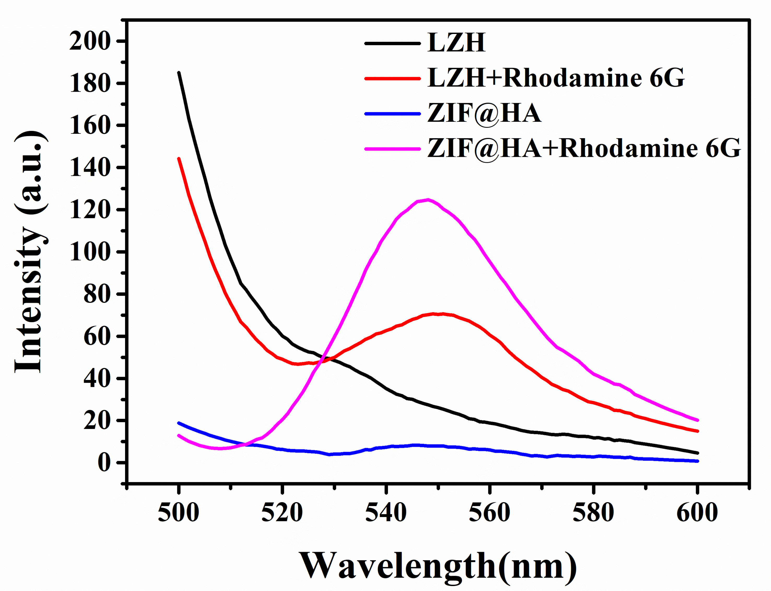
Fig. S12 Fluorescence absorption of ZIF@HA and LZH nanozymes loaded with Rhodamine 6G.
Fig. S13 Flow cytometry results of cellular endocytosis.
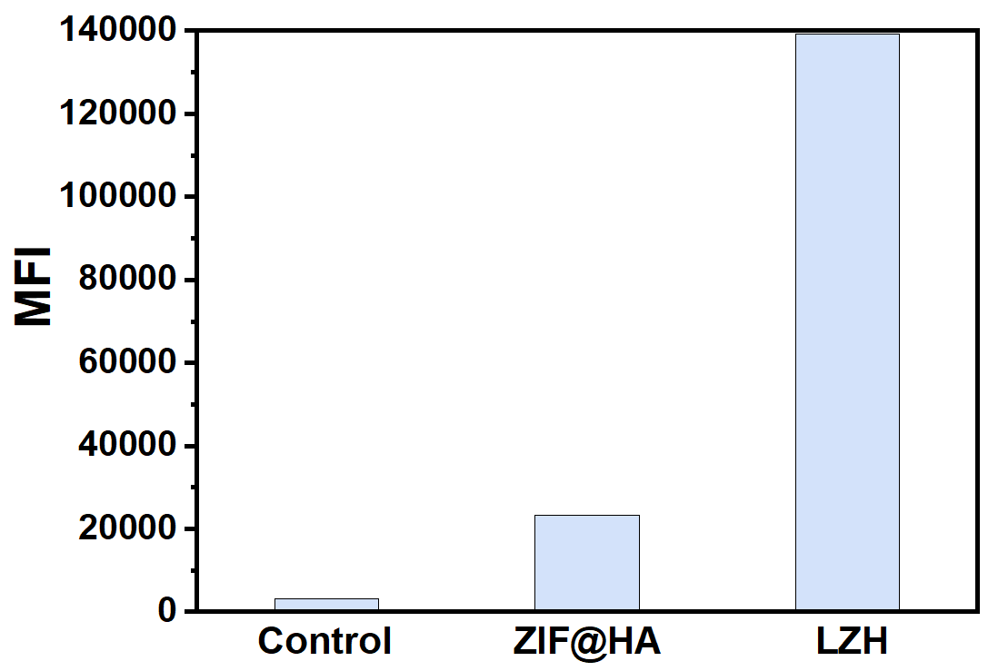
Fig. S14 Quantitative flow cytometric analysis of cellular endocytosis.
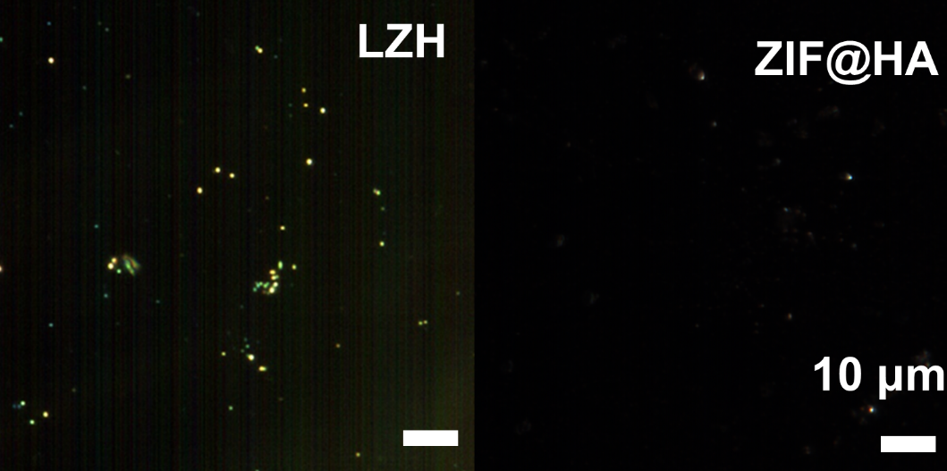
Fig. S15 Hyperspectral images of ZIF@HA and LZH nanozymes.
Fig. S16 The weight change curve of the mice.
Fig. S17 Blood routine analysis (blue: 0 mg/kg, cyan: 50 mg/kg, magenta: 100 mg/kg, yellow: 200 mg/kg).
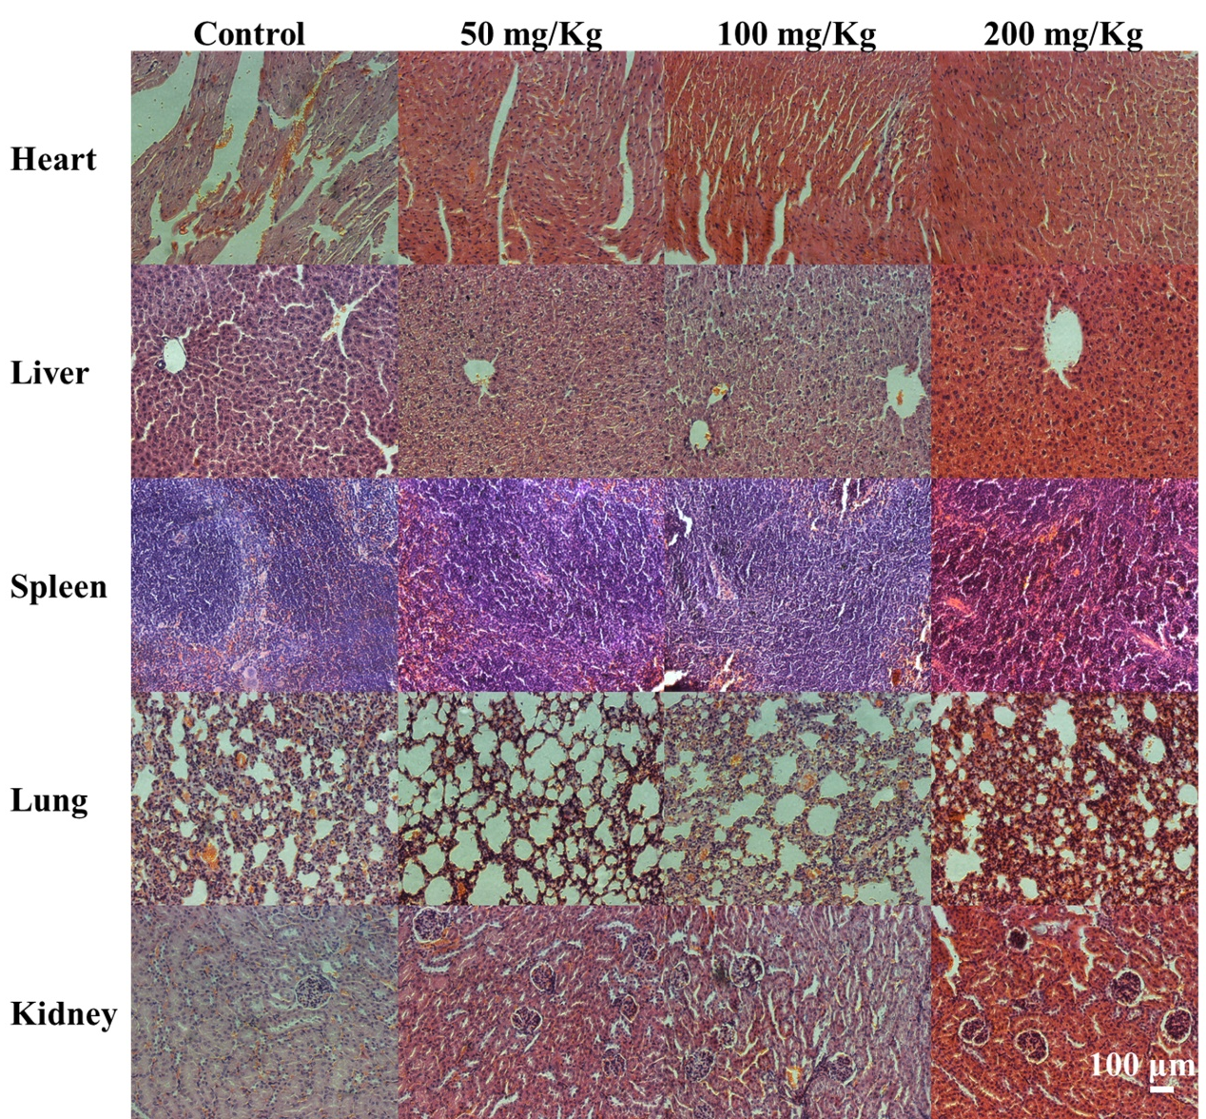
Fig. S18 H&E staining of the main organ sections of the mice.
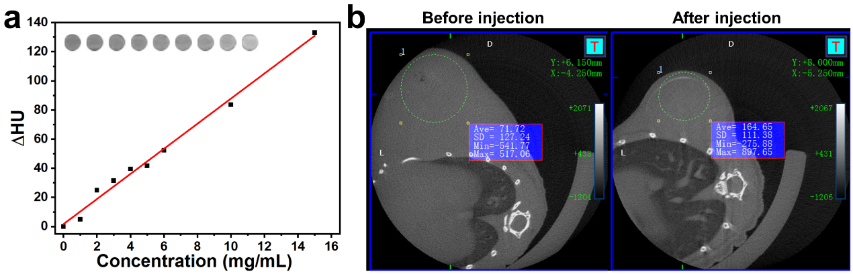
Fig. S19 CT imaging. a) CT imaging and HU values of LZ NPs. b) CT imaging in vivo before injection and after injection.
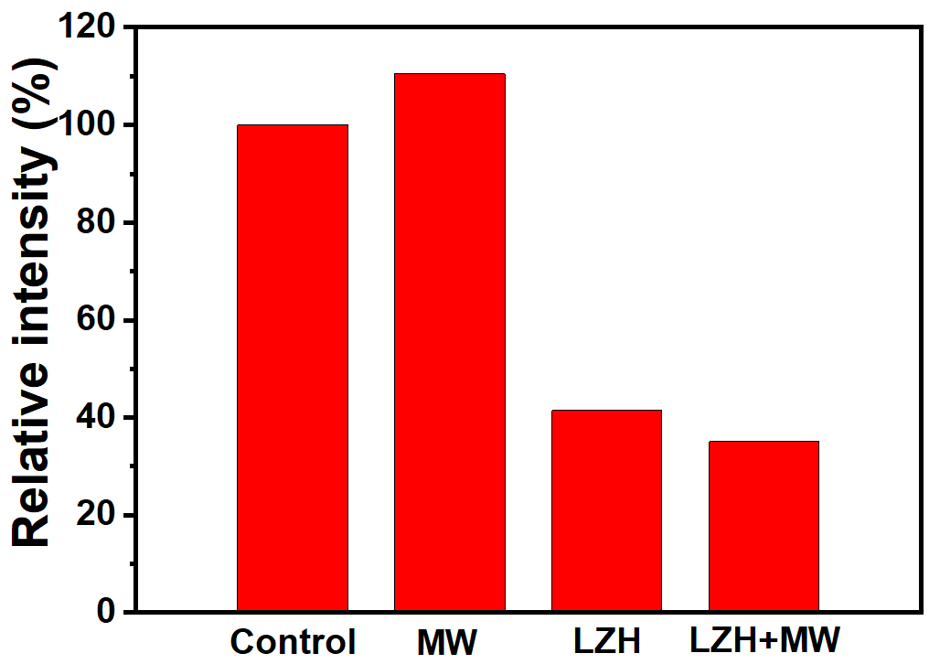
Fig. S20 Relative intensity of immunohistochemistry.

