Supplementary material

Figure S1. Flowchart for inclusion of study participants.

Table S1. Missing covariates (n = 18280).
Variable | Number of patients (% missing)
Age | 0 (0%)
Sex | 0 (0%)
Race/ethnicity | 0 (0%)
Educational level | 399 (2.18%)
Marital status | 885 (4.84%)
Drinking status | 2589 (14.16%)
Smoking status | 1318 (7.21%)
Physical activity | 0 (0%)
Body mass index | 204 (1.12%)
Family income | 2184 (11.95%)
Comorbid condition | 20 (0.11%)
Sleep duration | 1 (0.01%)
Sleep disturbance | 0 (0%)

Table S2. Characteristics of the included and excluded participants
Characteristic | Excluded | Included | p-value
Sample size | 3261 | 18280
Male, n (%) | 1491 (45.7) | 8954 (49.0) | 0.001
Age, y, mean (SD) | 50.72 (19.77) | 49.00 (18.42) | <0.001
Educational level, n (%) |  |  | <0.001
<High school | 893 (28.2) | 3514 (19.7)
Completed high school | 737 (23.3) | 4316 (24.1)
>High school | 1536 (48.5) | 10051 (56.2)
Race/ethnicity, n (%) |  |  | <0.001
Non-Hispanic White | 937 (28.7) | 6379 (34.9)
Non-Hispanic Black | 793 (24.3) | 4370 (23.9)
Mexican American | 392 (12.0) | 2595 (14.2)
Other Hispanic | 392 (12.0) | 1940 (10.6)
Other race/multiple races | 747 (22.9) | 2996 (16.4)
BMI, kg/m², mean (SD) | 28.89 (7.38) | 29.77 (7.42) | <0.001
Marital status, n (%) |  |  | <0.001
Married/Living with partner | 1697 (54.6) | 10275 (59.1)
Never married/Widowed /Divorced/Separated | 1409 (45.4) | 7120 (40.9)
Drinking status, n (%) |  |  | <0.001
Never drinking | 110 (36.2) | 2321 (14.8)
Former drinker | 28 (9.2) | 817 (5.2)
Current light/moderate drinker | 125 (41.1) | 9205 (58.7)
Current heavier drinker | 41 (13.5) | 3348 (21.3)
Smoking status, n (%) |  |  | <0.001
Never smoker | 1829 (60.4) | 9490 (55.9)
Former smoker | 661 (21.8) | 4204 (24.8)
Current smoker | 537 (17.7) | 3268 (19.3)
Physical activity, n (%)
Inactive | 1896 (58.1) | 9353 (51.2) | <0.001
Moderate | 644 (19.7) | 4233 (23.2)
Vigorous | 227 (7.0) | 1410 (7.7)
Both moderate and vigorous | 494 (15.1) | 3284 (18.0)
Comorbid condition, n (%) | 1370 (42.2) | 8417 (46.1) | <0.001
Family income, n (%)
Low income | 826 (33.7) | 4801 (29.8) | <0.001
Medium income | 963 (39.3) | 6391 (39.7)
High income | 664 (27.1) | 4904 (30.5)
Sleep duration, h, mean (SD) | 7.78 (1.99) | 7.64 (1.59) | <0.001
Sleep disturbance
Not at all | 120 (45.3) | 11214 (61.3)
Several days | 54 (20.4) | 4172 (22.8)
More than half the days | 36 (13.6) | 1323 (7.2)
Nearly every day | 55 (20.8) | 1571 (8.6)
Abbreviations: BMI, body mass index; SD, standard deviation.

Table S3. Univariate analysis of the association between depression symptoms with covariates
 | Statistics | OR (95% CI) | p-value
Sex
Female | 9326 (51.0) | Reference
Male | 8954 (49.0) | 0.62(0.53,0.72) | <0.001
Age groups
≥18, <40 | 5448 (31.3) | Reference
≥40, <60 | 5696 (32.7) | 0.93(0.79,1.09) | 0.360
≥60 | 6261 (36.0) | 0.84(0.68,1.03) | 0.090
Race/ethnicity
Non-Hispanic White | 6379 (34.9) | Reference
Non-Hispanic Black | 4370 (23.9) | 1.03(0.87,1.22) | 0.740
Mexican American | 2595 (14.2) | 0.88(0.66,1.19) | 0.400
Other Hispanic | 1940 (10.6) | 1.26(1.01,1.56) | 0.040
Other race/multiple races | 2996 (16.4) | 1.07(0.84,1.38) | 0.580
Educational level
<High school | 3514 (19.7)
Completed high school | 4316 (24.1) | 0.74(0.60,0.91) | 0.010
>High school | 10051 (56.2) | 0.53(0.45,0.64) | <0.001
Marital status
Never married/Widowed /Divorced/Separated | 7120 (40.9) | Reference
Married/Living with partner | 10275 (59.1) | 0.48(0.41,0.56) | <0.001
Drinking status
Never drinking | 2321 (14.8) | Reference
Former drinker | 817 (5.2) | 2.33(1.49,3.63) | <0.001
Current light/moderate drinker | 9205 (58.7) | 1.44(1.08,1.91) | 0.010
Current heavier drinker | 3348 (21.3) | 2.17(1.66,2.82) | <0.001
Smoking status
Never smoker | 9490 (55.9) | Reference
Former smoker | 4204 (24.8) | 1.39(1.14,1.69) | <0.001
Current smoker | 3268 (19.3) | 3.28(2.78,3.88) | <0.001
Physical activity
Inactive | 9353 (51.2)
Moderate | 4233 (23.2) | 0.64(0.51,0.81) | <0.001
Vigorous | 1410 (7.7) | 0.33(0.20,0.52) | <0.001
Both moderate and vigorous | 3284 (18.0) | 0.40(0.32,0.51) | <0.001
BMI category
<18.5 kg/m2 | 286 (1.6) | Reference
18.5 to <25.0 kg/m² | 4568 (25.3) | 0.48(0.25,0.91) | 0.030
25.0 to <30.0 kg/m² | 5700 (31.5) | 0.37(0.19,0.70) | 0.003
≥30.0 kg/m² | 7522 (41.6) | 0.63(0.36,1.11) | 0.100
Family income
Low income | 4801 (29.8) | Reference
Medium income | 6391 (39.7) | 0.53(0.45,0.61) | <0.001
High income | 4904 (30.5) | 0.27(0.23,0.33) | <0.001
Comorbid condition
No | 9843 (53.9) | Reference | <0.001
Yes | 8417 (46.1) | 1.88(1.72,2.04)
Sleep duration |  |  | <0.001
<6 h | 1767 (9.7) | Reference
6 to 8 h | 10917 (59.7) | 0.39(0.31,0.47) | <0.001
>8 h | 5595 (30.6) | 0.62(0.49,0.78) | <0.001
Sleep disturbance
Not at all | 11214 (61.3) | Reference | <0.001
Several days | 4172 (22.8) | 5.78(4.12, 8.12) | <0.001
More than half the days | 1323 (7.2) | 30.52(20.04, 46.47) | <0.001
Nearly every day | 1571 (8.6) | 95.21(72.84,124.45) | <0.001
Abbreviations: BMI, body mass index; CI, confidence interval; OR, odds ratio

Table S4. Associations of sleep midpoint with depression symptoms after adjusting for covariates that used the dummy variables to handle missing values (n = 18279).
 | OR (95% CI) | p-value
One-line model
per 1 hour increase | 1.02 (1.00, 1.04) | 0.021
Quantile regression model
Group 1 (>6:30 AM to ≤1:30 AM the next day) | 0.92 (0.69, 1.22) | 0.547
Group 2 (>1:30 AM to ≤2:30 AM) | Reference (1)
Group 3 (>2:30 AM to <3:25 AM) | 0.83 (0.53, 1.30) | 0.381
Group 4 (≥3:25 AM to ≤6:30 AM) | 1.23 (1.00, 1.52) | 0.053
Piecewise regression model
Sleep midpoint after 6:30 AM and before 2:30 AM the next day | 1.01 (0.99, 1.03) | 0.264
Sleep midpoint from 2:30 AM to 6:30 AM | 1.19 (1.07, 1.33) | 0.003
P value for nonlinear | <0.001
Abbreviations: CI, confidence interval; OR, odds ratio; Q, quantile; RCS, restricted cubic spline
Covariates that showed a nonlinear relationship with the outcome in the univariate analysis were adjusted as RCSs.
Adjust for age, sex, race/ethnicity, education level, marital status, family income, body mass index (RCS), smoking status, drinking status, physical activity, comorbid condition, sleep duration (RCS), and sleep disturbance. Sleep duration was a continuous variable and only one sample had missing values. The dummy variable method could not be used to handle missing values, so this sample was deleted.

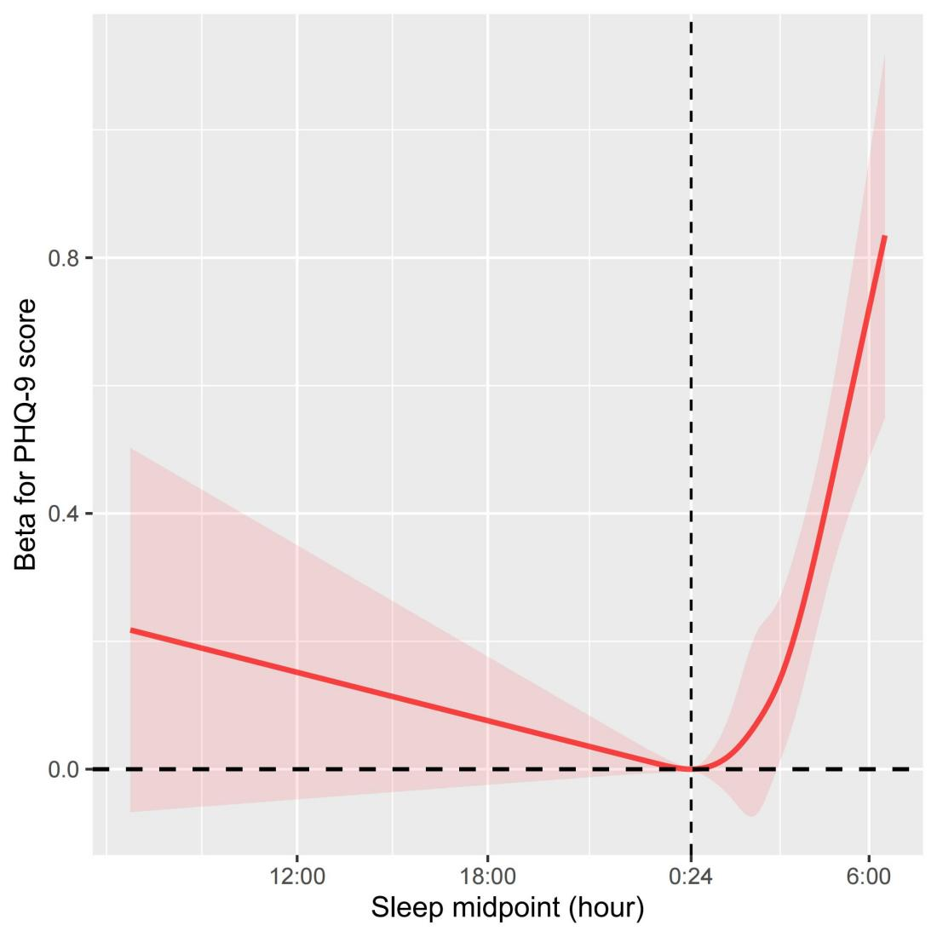
Fig. S2. Weighted restricted cubic spline of the association between sleep midpoint and Patient Health Questionnaire-9 score (with the sleep subitem removed). Shaded areas are 95% confidence intervals. The model is adjusted for age, sex, race/ethnicity, education level, marital status and family income, body mass index, smoking status, drinking status, physical activity, comorbid condition, sleep duration, and sleep disturbance (Model 3).

Table S5. Threshold effect analysis of sleep midpoint on Patient Health Questionnaire-9 score (n = 18280)
Crude modelª |  |  | Adjusted model^{b}
Inflection point | β (95% CI) | p-value | Inflection point | β (95% CI) | p-value
Sleep midpoint after 6:30 AM and before 2:18 AM the next day | -0.09 (-0.11, -0.06) | <0.001 | Sleep midpoint after 6:30 AM and before 0:24 AM the next day | 0.01 (-0.05, 0.06) | 0.791
Sleep midpoint from 2:18 AM to 6:30 AM | 0.61 (0.50, 0.72) | <0.001 | Sleep midpoint from 0:24 AM to 6:30 AM | 0.11 (0.05, 0.17) | 0.001
P value for nonlinear | <0.001 |  | P value for nonlinear | <0.001
Abbreviations: CI, confidence interval; RCS, restricted cubic spline.
Covariates that showed a nonlinear relationship with the outcome in the univariate analysis were adjusted as RCSs.
Adjust for age, sex, race/ethnicity, education level, marital status, family income, body mass index (RCS), smoking status, drinking status, physical activity, comorbid condition, sleep duration (RCS), and sleep disturbance (Model 3).

