Supplementary Figure 1 – Ceramide correlation matrix
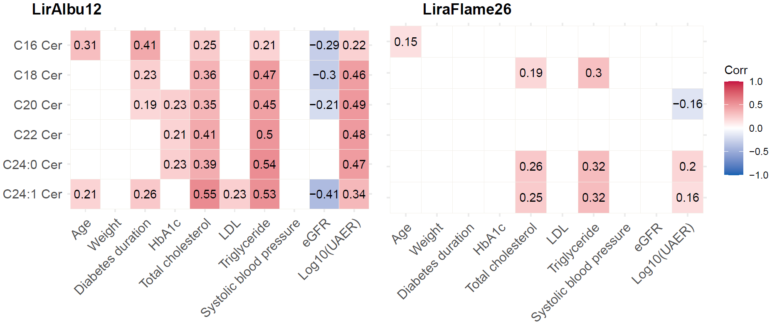
Pearson’s correlation between ceramides and possible confounders, numbers indicate estimates, only correlation with a p-value < 0.05 is shown. LDL: Low-density lipoprotein, eGFR: Estimated glomerular filtration rate, UAER: Urinary albumin excretion rate.

Supplementary Table 1 – Ceramide measures by treatment group in LirAlbu12
 | Before  liraglutide | After  liraglutide | Change liraglutide  (95% CI) | Before placebo | After placebo | Change placebo  (95% CI) | End vs. end liraglutide compared to  placebo (95% CI)
C16 Cer | 0.748 (0.162) | 0.732 (0.149) | -0.010 (-0.056; 0.036), P=0.665 | 0.752  (0.171) | 0.772 (0.167) | 0.020 (-0.016; 0.056), P=0.266 | -0.039 (-0.075;  -0.002), P = 0.039*
C18 Cer | 0.546 (0.164) | 0.534 (0.153) | -0.012 (-0.068; 0.044), P=0.657 | 0.550  (0.141) | 0.553 (0.142) | 0.004 (-0.030; 0.037), P=0.832 | -0.019 (-0.071;  .033), P = 0.455
C20 Cer | 0.644 (0.230) | 0.620 (0.227) | -0.021 (-0.106; 0.063), P=0.604 | 0.665  (0.239) | 0.667 (0.264) | 0.001 (-0.062; 0.064), P=0.969 | -0.046 (-0.142;  0.05), P = 0.333
C22 Cer | 2.620 (1.090) | 2.478 (1.182) | -0.194 (-0.607; 0.219), P=0.341 | 2.797 (1.246) | 2.829 (1.357) | 0.033 (-0.292; 0.357), P=0.837 | -0.381 (-0.81;  0.048), P =0.079
C24 Cer | 8.773 (4.824) | 7.984  (4.329) | -1.152 (-3.098; 0.794), P=0.233 | 9.620 (5.660) | 9.499 (5.445) | -0.121 (-1.435; 1.194), P=0.852 | -1.729 (-3.418;  -0.04), P = 0.045*
C24:1 Cer | 4.156 (1.360) | 4.373  (1.829) | 0.076 (-0.488; 0.640), P=0.782 | 4.357 (1.699) | 4.344 (1.557) | -0.013 (-0.380; 0.355), P=0.944 | -0.098 (-0.705;  0.509, P = 0.741

Mean (SD) ceramide amount in µg/ml, * indicate p-value <0.05. Mean change from start to end were tested using 2-sample t-tests. End vs end differences in ceramide concentration between liraglutide (1.8 mg/d) and placebo were assessed with paired t-test.

Supplementary Table 2 – Ceramide change following liraglutide adjusted for LDL
 |  | LirAlbu12 |  |  |  | LiraFlame26
 | Estimated ceramide change | Standard Error | P-value |  | Estimated ceramide change | Standard Error | P-value
C16 Cer | -0.013 | 0.024 | 0.591 |  | -2.81*10⁻⁴ | 1.26*10⁻⁴ | 0.028*
C18 Cer | -0.006 | 0.023 | 0.808 |  | -6.10*10⁻⁴ | 3.35*10⁻⁴ | 0.072
C20 Cer | -0.031 | 0.045 | 0.492 |  | 2.85*10⁻⁵ | 2.68*10⁻⁵ | 0.290
C22 Cer | -0.236 | 0.222 | 0.292 |  | -1.78*10⁻⁴ | 1.76*10⁻⁴ | 0.315
C24 Cer | -0.656 | 0.919 | 0.478 |  | -3.72*10⁻² | 1.89*10⁻² | 0.053
C24:1 Cer | 0.012 | 0.267 | 0.965 |  | -1.44*10⁻² | 6.67*10⁻³ | 0.033*

Linear mixed models were constructed for each ceramide in both trials with the following formula:
Ceramide ~ Treatment+Time + Treatment:Time + LDL + (1|Participant ID). * Indicate P-value <0.05.
Supplementary Table 3 – Ceramide change following liraglutide adjusted for total cholesterol
 |  | LirAlbu12 |  |  |  | LiraFlame26
 | Estimated ceramide change | Standard Error | P-value |  | Estimated ceramide change | Standard Error | P-value
C16 Cer | -0.015 | 0.026 | 0.561 |  | -2.751*10⁻⁴ | 1.205*10⁻⁴ | 0.025*
C18 Cer | 0.018 | 0.027 | 0.505 |  | -6.562*10⁻⁴ | 3.267*10⁻⁴ | 0.047*
C20 Cer | 0.021 | 0.043 | 0.629 |  | 3.016*10⁻⁵ | 2.640*10⁻⁵ | 0.256
C22 Cer | -0.008 | 0.216 | 0.972 |  | -1.228*10⁻⁴ | 1.692*10⁻⁴ | 0.470
C24 Cer | 0.041 | 0.924 | 0.964 |  | -3.540*10⁻² | 1.757*10⁻² | 0.047*
C24:1 Cer | 0.426 | 0.269 | 0.117 |  | -1.475*10⁻² | 6.275*10⁻³ | 0.021*

Linear mixed models were constructed for each ceramide in both trials with the following formula:
Ceramide ~ Treatment+Time + Treatment:Time + Cholesterol + (1|Participant ID). * Indicate P-value <0.05.

Supplementary Table 4 – Ceramide change following liraglutide adjusted for total triglyceride
 |  | LirAlbu12 |  |  |  | LiraFlame26
 | Estimated ceramide change | Standard Error | P-value |  | Estimated ceramide change | Standard Error | P-value
C16 Cer | -0.035 | 0.026 | 0.173 |  | -2.354*10⁻⁴ | 1.253*10⁻⁴ | 0.063
C18 Cer | -0.008 | 0.026 | 0.761 |  | -4.887*10⁻⁴ | 3.366*10⁻⁴ | 0.150
C20 Cer | -0.026 | 0.045 | 0.564 |  | 3.024*10⁻⁵ | 2.629*10⁻⁵ | 0.253
C22 Cer | -0.239 | 0.215 | 0.270 |  | -1.514*10⁻⁴ | 1.671*10⁻⁴ | 0.367
C24 Cer | -0.896 | 0.838 | 0.289 |  | -2.461*10⁻² | 1.836*10⁻² | 0.183
C24:1 Cer | 0.088 | 0.263 | 0.739 |  | -1.131*10⁻² | 6.431*10⁻³ | 0.082

Linear mixed models were constructed for each ceramide in both trials with the following formula:
Ceramide ~ Treatment+Time + Treatment:Time + Triglycerides + (1|Participant ID). * Indicate P-value <0.05.

Supplementary Table 5 – Change in UAER following liraglutide might mediate change in ceramide levels

 | LirAlbu12 |  |  |  |  | LiraFlame26
 | Total effect estimate | Total effect P-value | ACME estimate | ACME P-value |  | Total effect estimate | Total effect P-value | ACME estimate | ACME P-value | Total effect estimate
C16 Cer | 0.03  (-0.024;0.085) | 0.304 | 0.002  (-0.022;0.031) | 0.872 |  | 2.883*10⁻⁴ (4.133*10⁻⁵ ;5.397*10⁻⁴) | 0.02 | -4.061*10⁻⁵ (-1.156*10⁻⁴  ;3.403*10⁻⁵) | 0.264 | 2.883*10⁻⁴ (4.133*10⁻⁵ ;5.397*10⁻⁴)
C18 Cer | 0.016  (-0.051;0.081) | 0.612 | 0.01  (-0.009;0.043) | 0.35 |  | 6.447*10⁻⁴  (-5.754*10⁻⁵ ;1.316*10⁻³) | 0.076 | -8.054*10⁻⁵  (-3.151*10⁻⁴ ;7.562*10⁻⁵) | 0.332 | 6.447*10⁻⁴  (-5.754*10⁻⁵ ;1.316*10⁻³)
C20 Cer | 0.024  (-0.072;0.133) | 0.65 | 0.047  (0.003;0.127) | 0.03 |  | -3.459*10⁻⁵ (-9.307*10⁻⁵ ;1.941*10⁻⁵) | 0.234 | 1.876*10⁻⁵  (-1.824*10⁻⁶ ;4.053*10⁻⁵) | 0.066 | -3.459*10⁻⁵ (-9.307*10⁻⁵ ;1.941*10⁻⁵)
C22 Cer | 0.241  (-0.264;0.74) | 0.346 | 0.286  (0.035;0.688) | 0.016 |  | 1.308*10⁻⁴  (-2.038*10⁻⁴ ;4.675*10⁻⁴) | 0.428 | 8.857*10⁻⁶  (-6.075*10⁻⁵ ;1.160*10⁻⁴) | 0.784 | 1.308*10⁻⁴  (-2.038*10⁻⁴ ;4.675*10⁻⁴)
C24 Cer | 1.189  (-0.891;3.277) | 0.286 | 1.272  (0.236;2.673) | 0.008 |  | 3.075*10⁻²  (-6.074*10⁻³ ;6.806*10⁻²) | 0.096 | -3.568*10⁻³ (-1.669*10⁻² ;4.336*10⁻³) | 0.346 | 3.075*10⁻²  (-6.074*10⁻³ ;6.806*10⁻²)
C24:1 Cer | -0.069  (-0.675;0.558) | 0.828 | 0.266  (0.022;0.739) | 0.026 |  | 1.357*10⁻²  (-2.218*10⁻⁴ ;2.626*10⁻²) | 0.056 | -8.651*10⁻⁴ (-4.897*10⁻³ ;2.050*10⁻³) | 0.558 | 1.357*10⁻²  (-2.218*10⁻⁴ ;2.626*10⁻²)

Mediation effect was assessed by linear regression models with and without adjustment for the tested confounder the effect and significance were estimated by bootstrapping 1000 times using the mediator package in R. ACME: Average casual mediation effect. UAER: Urinary albumin excretion rate.

