Additional file 7: Global distribution of the total score of GOHI-FS.
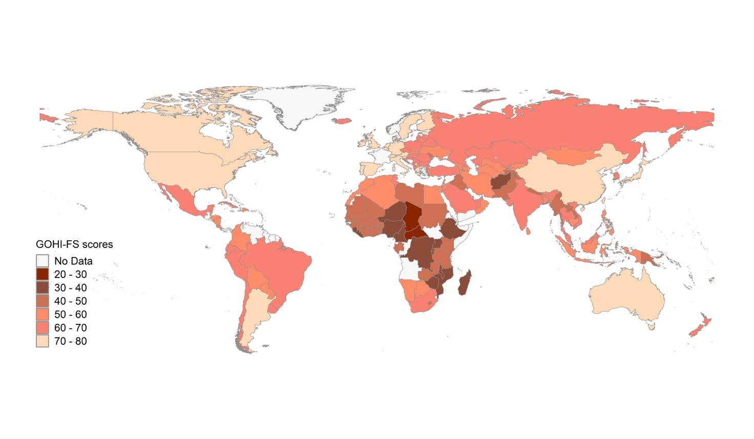Note: The countries/territories are colored by score range in the map. The map source was from R package ‘rworldmap’. The figure is used to show the global distribution of GOHI-FS scores and does not represent the authors’ position with respect to territorial claims in the map source.

