Figure S1. Self-developed high-intensity focused ultrasound instrument.

Figure S1

A
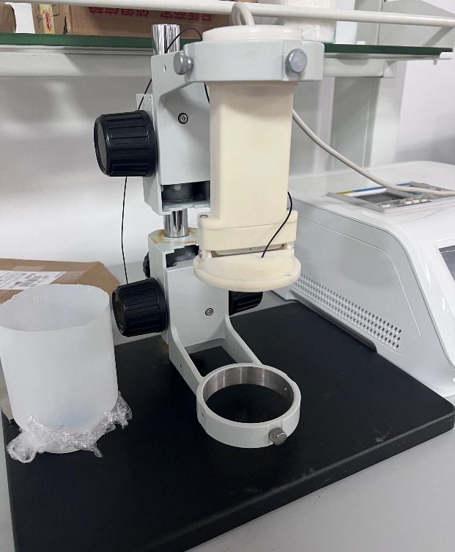

B
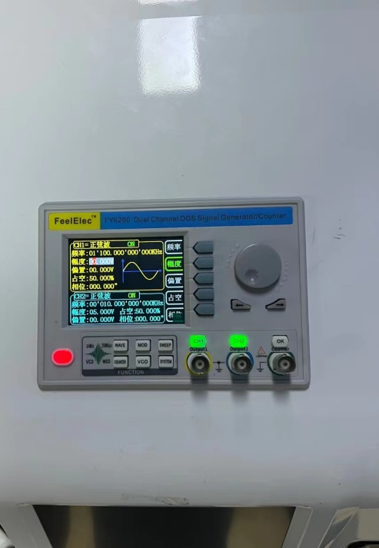

Figure S2. Characteristics of FeDOX@cellMBs. (A) Optical microscope images of FeDOX@cellMBs. (B) TEM images of MBs. (C) TEM images of cellMBs.

Figure S2

