Additional File 1
Comparison of certainty of evidence between the net benefit approach and the traditional Grading of Recommendations Assessment, Development, and Evaluation (GRADE) method using the data of Japanese Clinical Practice Guidelines for Management of Sepsis and Septic Shock 2020

Authors
Takero Terayama, Hiromu Okano, Sadatoshi Kawakami, Kenichi Kano, Masaaki Sakuraya, Yoshitaka Aoki, Committee of the Japanese Clinical Practice Guidelines for the Management of Sepsis and Septic Shock 2024
Affiliations
1. Department of Emergency, Self-Defense Forces Central Hospital, Ikeziri 1-2-24, Setagaya, Tokyo, Japan
2. Department of Critical Care Medicine, St. Luke's International Hospital, 9-1 Akashi-cho, Chuo-ku, Tokyo 104-8560, Japan
3. Department of Anesthesiology, Chiba University Graduate School of Medicine, 1-8-1
Inohana, Chuo-Ku, Chiba, 260-8670, Japan
4. Department of Emergency Medicine, Fukui Prefectural Hospital, Yotsui 2-8-1, Fukui city, Fukui, 910-8526, Japan
5. Department of Emergency and Intensive Care Medicine, JA Hiroshima General Hospital, Jigozen 1-3-3, Hatsukaichi, Hiroshima, 738-8503, Japan
6. Department of Anesthesiology and Intensive Care Medicine, Hamamatsu University School of Medicine, Shizuoka, Japan
Corresponding Author
Takero Terayama, M.D., PhD
Address: Department of Emergency, Self-Defense Forces Central Hospital, Ikeziri 1-2-24, Setagaya, Tokyo, Japan
E-mail: takero.for.medical.journal@gmail.com
Telephone: +81-3-3411-0151
Fax: +81-3-3411-0151

Table of Contents
Figure S1………………………………………………………………………………...3
Figure S2………………………………………………………………………………...4
Table S1………………………………………………………………………………….5

Figure S1. Steps to determining the certainty of the net effect estimate
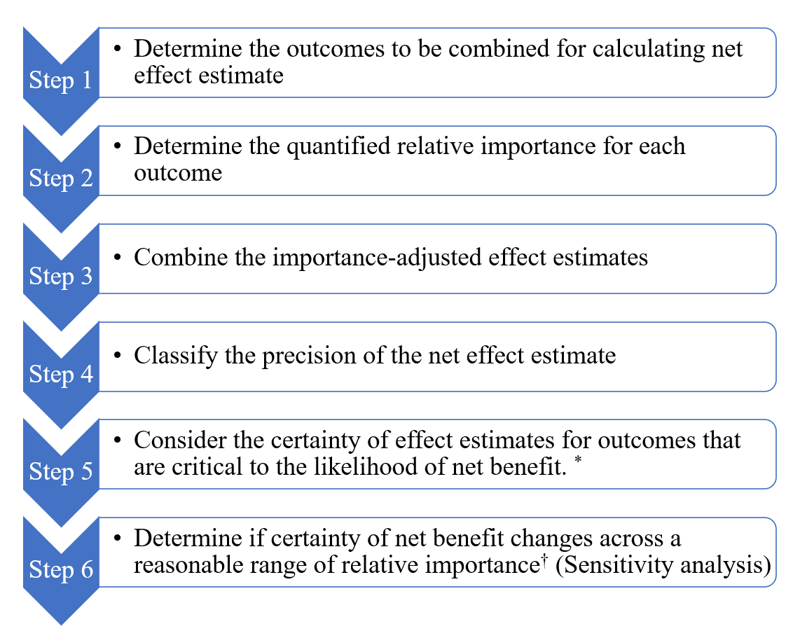
* These outcomes are:1) Outcomes for which removal of the outcome would change the classification of the precision of the net effect estimate. 2) Outcomes for which the addition of plausible increases to the effect estimate (effect estimates with lower certainty) would change the classification.
† In this study, a reasonable range was determined based on the range from the smallest to the largest value among the relative importance values determined in Step 2.

Figure S2. Patterns of change in certainty of evidence (CoE) between the traditional method and the net benefit approach by clinical question
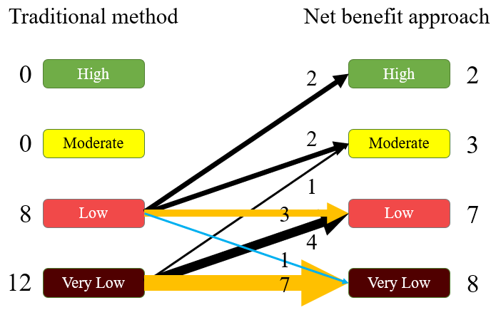
CoE, certainty of evidence.
* The classification of clinical questions was based on changes in the CoE using the net benefit approach as compared to using the traditional method: those with a decrease in the CoE (Group I), those with no change (Group II), and those with an increase (Group III).

Table S1. The details of the included Clinical Questions
Number | Clinical Questions | CoE by the traditional method | CoE by the net benefit approach
4-7 | Should continuous or extended infusion of β-lactam antibiotics be used for sepsis? | very low | very low
4-8 | Should de-escalation antimicrobial therapy be used for sepsis? | low | moderate
4-10 | Should relatively short-term (i.e. within 7 days) antimicrobial therapy be applied for sepsis? | very low | very low
5-2-1 | Should IVIG be administered to patients with streptococcal toxic shock syndrome (STSS)? | very low | very low
6-3 | Should vasopressors be used simultaneously or in the early stage (within 3 h) of initial fluid resuscitation in adult patients with sepsis? | very low | very low
6-9-1 | Should noradrenaline, dopamine, or phenylephrine be used as a first-line vasopressor in adult patients with sepsis? noradrenaline vs. dopamine | very low | moderate
6-9-2 | Should noradrenaline, dopamine, or phenylephrine be used as a first-line vasopressor in adult patients with sepsis? noradrenaline vs. phenylephrine | very low | low
7-2 | Should hydrocortisone and fludrocortisone be administered to patients with septic shock who do not respond to initial fluid resuscitation and vasopressors? | low | high
7-3 | Should corticosteroids (hydrocortisone) be administered to patients with sepsis without shock? | low | low
11-1 | Should furosemide be used to prevent or treat septic AKI? | low | low
11-2 | Should atrial natriuretic peptide (ANP) be used to prevent or treat septic AKI? | very low | very low
11-3 | Should dopamine be used to prevent or treat septic AKI? | very low | very low
11-5-2 | Should RRT be initiated early for septic AKI (Stage 3 vs. absolute indications) | very low | low
11-6 | Should a large RRT dose be delivered for septic AKI? | low | low
12-5 | Should parenteral nutrition be combined with enteral nutrition in septic patients? | very low | low
15-3 | Should antithrombin replacement therapy be administered in sepsis-associated DIC? | low | high
15-4 | Should heparin or heparin analogs be administered in sepsis-associated DIC? | very low | low
15-5 | Should recombinant thrombomodulin be administered to patients with sepsis-associated DIC? | low | moderate
15-6 | Should protease inhibitors be administered to patients with sepsis-associated DIC? | very low | very low
22-1 | Should antiulcer drugs be administered to septic patients to prevent gastrointestinal bleeding? | low | very low
CoE, certainty of evidence; AKI, acute kidney insufficiency; RRT, renal replacement therapy; DIC, disseminated intravascular coagulation.

