Supplemental material figure 1. Directed acyclic graph for the association between PTSD and cardiometabolic diseases.
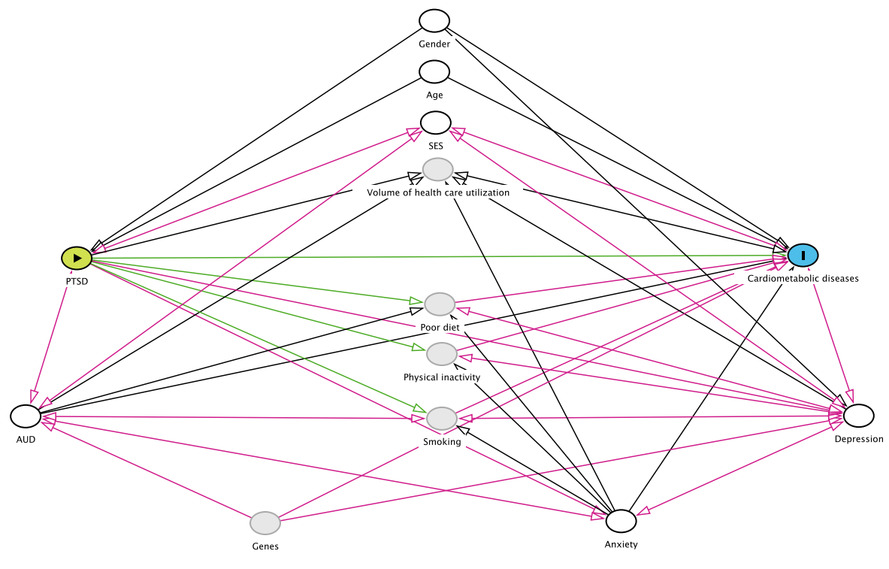

Further explanation about the directed acyclic graph could be found at [http://dagitty.net/].

Supplemental material table 1. E-values for the HRs of cardiometabolic comorbidities among PTSD patients compared to the population without PTSD
Event outcomes |  |  | Model 6
 |  |  | HR | CI*
Hypertensive diseases |  |  | 2.38 | 2.17
Ischaemic heart diseases |  |  | 2.59 | 2.29
Pulmonary heart diseases |  |  | 2.44 | 1.79
Cerebrovascular diseases |  |  | 2.35 | 1.93
Diabetes mellitus |  |  | 2.84 | 2.56
Obesity |  |  | 2.64 | 2.39
Metabolic disorders |  |  | 2.86 | 2.65
Model 6 = estimates adjusted for age, gender, SES indicator, comorbid anxiety, comorbid depression and comorbid AUD. *Lower bound of the 95% CI.

