FINAL PROGRESS REPORT
Grant # DE-SC0005029, Hunter College of the City University of New York
September 1, 2010 – February 28, 2014
NMR Studies of Materials for Electrochemical Energy Storage
Steven G. Greenbaum, PI

Date of Report: January 28, 2014
The work summarized herein dates back to the beginning of this BES grant funding in the Fall of 2010. In collaboration with colleagues from CNRS/Orsay (Dr. Patrick Judeinstein), Universite Jules Verne de Picardie (Prof. Michel Armand), and North Carolina State University (Prof. Wesley Henderson), our group was the first to demonstrate the feasibility of natural abundance ¹³C NMR standard pulsed field gradient methods to measure diffusion in ionic liquids (ILs). Several ILs based on some well-known cations such as N-alkyl-N-methylpyrrolidinium (PY1R+) and newly synthesized fluorine and hydrogen-free anions such as 4,5-dicarbonitrile-1,2,3-triazole (DCTA−) were prepared by W. Henderson’s group at NC State, as shown in Fig. 1.
Figure1. IL cation and anion structures studied in this work:1-alkyl-3-methyl imidazolium(IM10R+), N-alkyl-N-methyl pyrrolidinium(PY1R+), and 4,5- dicarbonitrile-1,2,3-triazole (DCTA−), where R is an alkyl group (i.e. 2, ethyl; 3, propyl; 4, butyl).
The ¹³C direct detection (no cross polarization) spectrum of a representative IL, with spectral assignment is displayed in Fig. 2. The planar anion is believed to reduce cation-anion interactions and the absence of fluorine may be beneficial for safety reasons, but presents an NMR spectroscopic challenge.
Figure 2. ¹³C NMR spectrum of IM₁₀₂ DCTA at 25°C.
By means of standard NMR pfg methods, but with about 8 hours of signal averaging per sample per temperature, we were able to measure the natural abundance ¹³C self-diffusion coefficients of the anions and cations. The values obtained for the cations were checked by the much more efficient proton NMR pfg and the good agreement obtained between ¹H and ¹³C values provide a strong measure of confidence for the anion values.

We obtained single crystals of LiMPO₄ (M = Fe, Co, Ni, Mn) from a colleague at DoE Ames Lab and Iowa State University (Dr. David Vaknin), which we then investigated by broad band NMR, including the use of a custom designed low field NMR apparatus necessitated by the very strong paramagnetic broadening and shifting characteristic of these compounds. A ³¹P NMR rotation pattern about the [010] crystallographic axis of LiFePO₄ is shown in Fig. 3. The simulated spectra are in pretty good agreement with the experimental ones, with the major source of disagreement attributed to alignment error when moving the crystal from the x-ray diffractometer to the NMR spectrometer. Similar rotation patterns were obtained about the three orthogonal principal crystallographic axes in the Fe and Co analogues for both ³¹P and ⁷Li. Diagonalizing the NMR chemical shift tensor, one finds the principal axis system of the NMR nuclei and the direction cosines with respect to the crystallographic axes, depicted in Fig. 4 for ³¹P and Fig. 5for ⁷Li). Interestingly, the Li tensor appears to be approximately diagonal in the crystallographic frame and the principal component of the nuclear electric quadrupole tensor (not shown) is along or nearly along [010], which coincidentally or not, is the direction of maximum Li ion mobility.
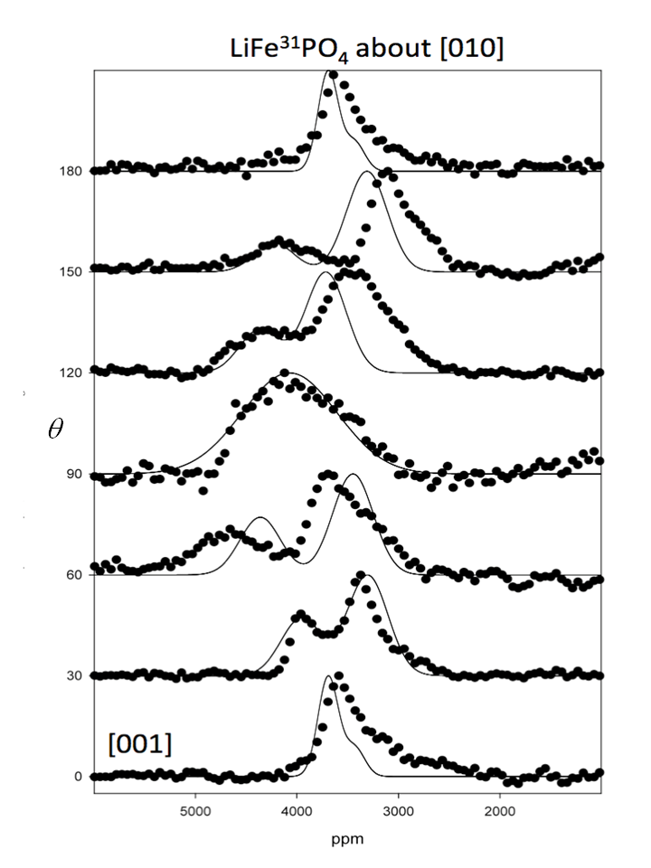
Figure 3. Representative ³¹P resonances of a single crystal of LiFePO₄ rotated about [010] as a function of rotation angle  between [001] and the magnetic field (0° ≤ ϴ ≤ 180°). The solid line simulations were created using Gaussian functions
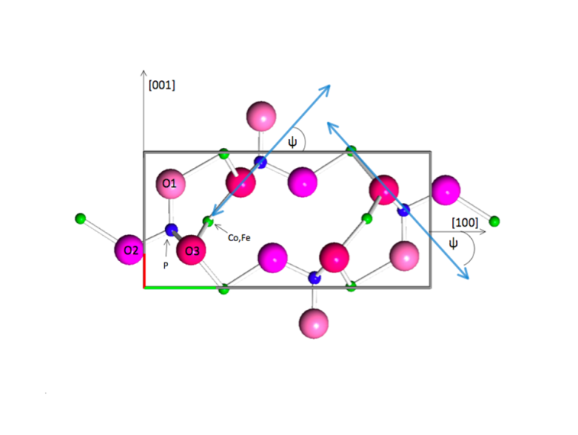
Figure 4. Phosphate sites in a 4-unit cell of the LiMPO₄ olivine lattice structure of space group Pnma. The view is along [010] with phosphorus (blue), iron or cobalt (green), and oxygen (O1, O2, O3) atoms given. The fourth oxygen atom of the phosphate tetrahedron is structurally identical to O3 and directly behind O3 in this view. The largest paramagnetic principal axis is shown in the plane as the double arrow for the two phosphate sites, oriented at ψ relative to the [100] direction. Note that the arrow closely follows the line defined by the P-O3-M atomic arrangement.

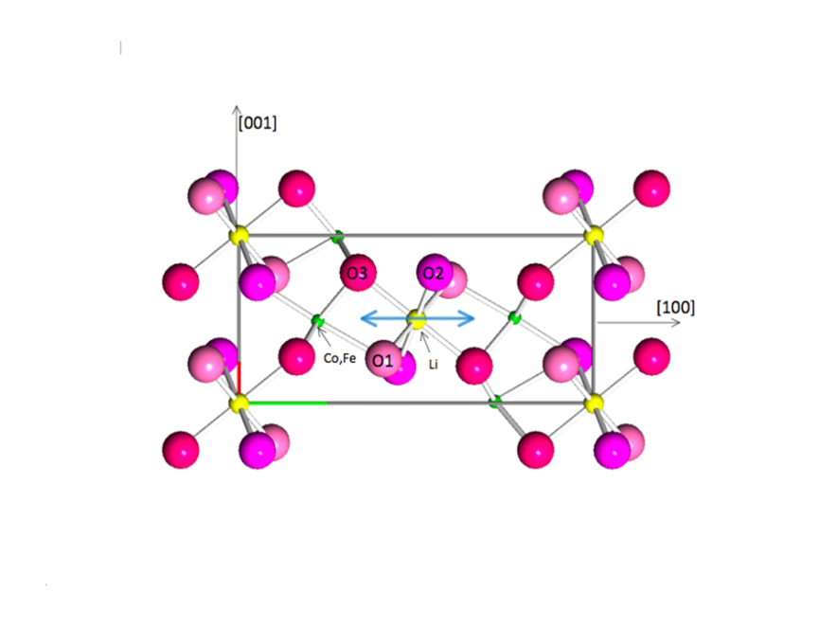
Figure 5. Principal axis system of 7Li. View along [010] with lithium (yellow), iron or cobalt (green), and oxygen (O1, O2, O3); largest paramagnetic principal axis: double arrow along [100] in x-z plane. Principal electric field gradient (quadrupole interaction) component is along [010] the direction of max. Li ion conductivity.
In collaboration with Dr. Marshall Smart at NASA/JPL, we characterized SEI formation on lithium ion graphite (MCMB) anodes using solid state ⁷Li, ¹⁹F, and ³¹P NMR in cells containing various electrolyte additives and subjected to accelerated aging. A series of ⁷Li spectra of harvested LiNi_{0.8}Co_{0.2}O₂ cathodes is shown in Fig. 6. The features at ~ 0 ppm represent irreversible Li in the SEI, and the broad, shifted features around 200 ppm correspond to Li in the active cathode material. The large shift is attributable to paramagnetic Ni³⁺ and the variations in peak shift arise from corresponding variations in Ni³⁺/Ni⁴⁺ ratio, which in turn is directly related to the average state of charge of the cell prior to disassembly. The fraction of irreversible Li can be obtained by direct spectral integration.
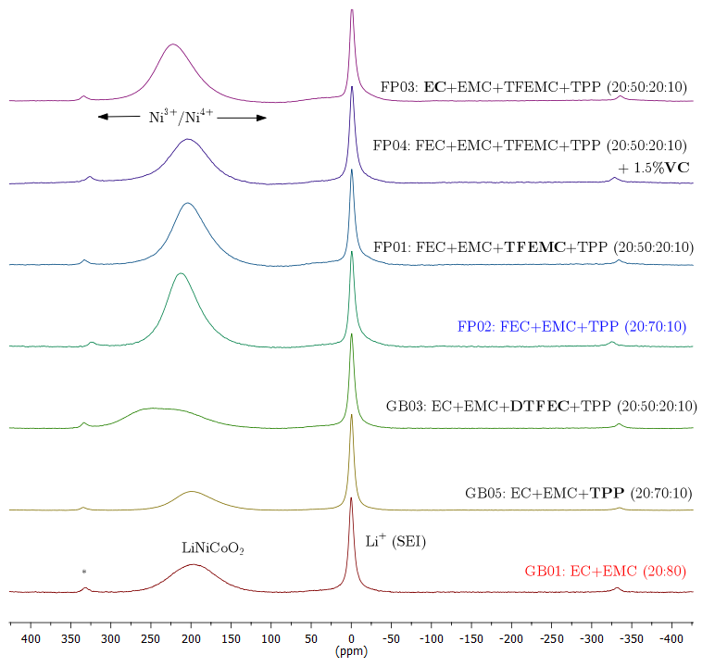
Figure 6. ⁷Li MAS NMR spectra of LiNi_{0.8}Co_{0.2}O₂ cathode material harvested from cycled cells, with novel electrolyte formulations indicated. The baseline compound appears at the bottom. The new components are mono-fluoroethylene carbonate (FEC), bis (2,2,2-trifluoroethyl) carbonate (DTFEC), 2,2,2-trifluoroethyl methyl carbonate (TFEMC), and triphenyl phosphate (TPP).

In collaboration with Emanuel Peled (who invented the concept of SEI) and Dina Golodnitsky at Tel Aviv University, we have investigated partially oriented polymer electrolytes based on high molecular weight poly (ethylene oxide) (PEO), prepared by solvent casting under an inhomogeneous magnetic ﬁeld. Polymer electrolytes (PE) containing only 1% of aromatic diphenylalanine peptide nanotubes coated with ferroﬂuid (FF-PNT) increases the total PE conductivity at room temperature by two orders of magnitude, as compared to pristine PEs. Even after 1 month of storage at70°C. The magnetically oriented composite PE retains conductivity values that are very close to that of the freshly-cast ﬁlm. As opposed to other ﬁllers tested so far, the incorporation of FF-PNT to the pristine PE eliminates formation of large spherulites. A highly homogeneous, ﬁne-grained morphology with well-deﬁned round-shaped crystallites develops in this composite PE under an applied MF. The XRD patterns make it clear that the applied magnetic ﬁeld inﬂuences the crystallinity of the PE containing FF-PNTs more strongly than it does that of pristine ﬁlms. The conductivity results are summarized in the Fig.7 below. Though the enhancement is dramatic, unfortunately the baseline conductivity of these very concentrated electrolytes (where the magnetic enhancement is most apparent) is too low for technological applications. Signiﬁcant orientation effects are observed for LiTf:P(EO)₃+1%(w/w)FF-PNTs by ⁷Li nuclear magnetic resonance measurements as well, as illustrated in Fig. 8 below.
Figure 7. Effect of applied magnetic ﬁeld on the bulk and grain boundary conductivity of pristine and composite LiTf:P(EO)₃ polymer electrolytes at 65°C.

Figure 8. NMR spectra at different orientations of composite FF-PNT modiﬁed LiTf:P(EO)3 polymer electrolytes typically cast with and without strongly inhomogeneous magnetic ﬁeld. Differences in quadrupole satellite structure provide evidence of local orientation about the Li ions.

In collaboration with Glenn Amatucci at Rutgers University, we have investigated conversion materials based on metal ﬂuorides, which offer enhanced charge capacity as positive electrodes in Li-ion electrochemical cells. However, to date, little is understood about the interactions these structurally dynamic materials have with nonaqueous electrolytes during both lithiation and delithiation. Our recent work was on bismuth (III) ﬂuoride in detailing the evolution of the electrolyte decomposition products at both highly oxidizing potentials (4.5 V vs. Li/Li+) and during delithiation of the positive electrode after having formed a decomposition layer via electrochemical reduction of the electrolyte solvents. For the ﬁrst time, the impact of the electrolyte reactions on the surface and subsurface chemistry of the inorganic conversion material using NMR was explored. Observed results offer an explanation for the direct inﬂuence of electrolyte choice on cycling efﬁciency of metal ﬂuoride conversion materials. In particular, it was found that the formation of Li₂CO₃ originating from partially ¹³C-enriched ethylene carbonate (EC) eventually leads to the conversion of the Bi fluoride to Bi oxyfluoride on the electrode surface. Current work on FeF2 based conversion cathodes has been transitioned to the PI’s recent joining of the NECCES EFRC and will not be included in this proposal going forward.

Figure 9. Carbonate region of ¹³C NMR of BiF₃ nanocomposites cycled in EC* enriched electrolyte. Li₂CO₃ is not observed after charging the BiF₃ nanocomposite (both half and full reconversion).

In collaboration with Michel Armand, Teofilo Rojo, and coworkers at CIC Energigune in Spain, we have investigated novel single Na⁺ ion conducting polymer electrolytes prepared by a the novel method of functionalizing silica nanoparticles with anionic groups. ²³Na NMR was used to characterize Na⁺ mobility while ¹⁹F NMR verified the absence of appreciable cationic transport.
Figure 10. Schematic of synthesis of silica nanoparticles functionalized with anionic groups. Two strategies were attempted, one with the anion only and the other with a additional grafting of PEG groups. These are then added to PEO, whereby the Na⁺ ions are released

In another collaboration with Emanuel Peled and Dina Golodnitsky at Tel Aviv University, we have undertaken a characterization of electrochemically lithiated thin-film CuS. These materials were developed for 3-dimensional microbatteries, where channels etched completely through 0.4 mm Si wafers can be conformally coated with cathode, polymer electrolyte, and anode. Test samples were subjected to analysis by x-ray absorption spectroscopy at Brookhaven’s NSLS. Both copper k-edge and sulfur k-edge spectra were recorded. Comparison with several standards reveals that in some samples, all three (0, +1, +2) oxidation states are present.
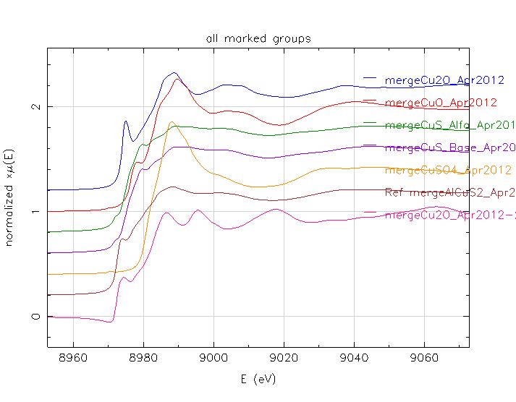
Figure 11. X-ray absorption spectra of electrochemically lithiated CuS thim films, with different levels of Li and including spectra of reference compounds. Top: Cu k-edge; bottom, S k-edge.
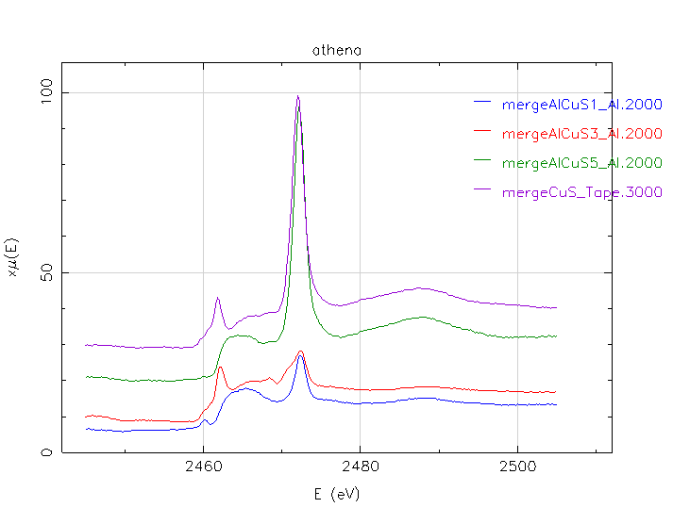
In collaboration with the University of Puerto Rico and the NASA Jet Propulsion Lab,we have studied the effect of a relatively simple LiCl flux treatment in the synthesis of the layered Li cathode material Li₂MnO₃: LiMn_{1/3}Ni_{1/3}Co_{1/3}O₂ (with 1:1 ratio) prepared by our colleague Will West at JPL. Although the x-ray diffraction results were somewhat inconclusive, solid state ^{6,7}Li NMR measurements showed unambiguously that firing the mixture of the starting compounds in the presence of LiCl flux facilitates interdiffusion of Li⁺ ions between the phases and leads to a true solid solution rather than a phase separated nanocomposite. In particular, a new site within the Li layers is observed and correlated with superior reversible capacity.
Figure 12. ⁶Li MAS NMR spectra at 23 kHz of the Li₂MnO₃–LiMn_{1/3}Ni_{1/3}Co_{1/3}O₂ after firing 48 hours at 800º C with no LiCl flux; after firing 48 hours at 800º C with LiCl flux; after firing 6 hours at 1000º C with LiCl flux.
The final project summarized here is from a collaboration with Medtronic, Inc., which has the largest worldwide market share for sales of cardiac pacemakers and implantable defibrillators (ICDs). Although the batteries which power ICDs are primary batteries, the NMR methods developed and refined in our lab were found to be directly applicable to an interesting problem in battery electrochemistry. It is hypothesized that the lifetime of these batteries can be extended without sacrificing power capability (which is required for defibrillation) by using a hybrid cathode made with CF_{x}, which provides the extended energy, and silver vanadate (SVO), which gives high current. The rationale is that during rapid discharge, most of the current will come from the SVO. During the resting phase, the CF_{x} will actually recharge the SVO through physical contact between particles of the two materials. We have demonstrated this conclusively at the molecular level using multinuclear NMR as shown below.
Figure 13. ¹⁹F (left) and ⁷Li (right) NMR spectra of CF_{x}/SVO hybrid cathodes following 50% DoD and disassembly after 0, 1, and 3 months. The growth in the LiF component (left) and relative decrease in the Li intercalated in the SVO (smaller spectral feature on right) provides unambiguous proof of the recharge process. Three different kinds of CF_{x} used in forming the mixtures were investigated.

Papers acknowledging DoE BES support published, accepted, or submitted, with reprint of acknowledgements:

“Diffusion Coefficients from ¹³C PGSE-NMR Measurements— Fluorine-Free Ionic Liquids with DCTA⁻ and DCA⁻ Anions”, with Cristelle Portet, Sufia Khatun, Eric Fox, Patrick Judeinstein, Michel Armand, and Wesley Henderson, Journal of Physical Chemistry Letters, 3, 441-444 (2012).
This material is based on work supported, in part, by the U.S. DOE BATT Program under Contract No. DE-AC02-05- CH11231. The work performed at Hunter College was supported by a grant from the U.S. DOE-Basic Energy Sciences under Contract No. DE-SC0005029.

“⁷Li and ³¹P Nuclear Magnetic Resonance Studies of Single Crystal LiMPO₄ (M = Co, Fe)”, with P. Sideris, R. Samueli, P.E.Stallworth, and D. Vaknin, in Advances in Inorganic Phosphate Materials, Ceramic Transactions, vol. 233, American Ceramic Society, Wiley, 2012, p.117-123.
This work was supported by the U.S. Department of Energy Office of Basic Energy Sciences, Grant No. DE-SC0005029. The authors would like to acknowledge the contributions of Dr. Louis Todaro of the Gene Center X-ray Facility at Hunter College, supported by the National Institutes of Health, Grant No. RR 003037. Ames Laboratory is supported by the U.S.Department of Energy, Oflice of Basic Energy Sciences, Division of Materials Sciences and Engineering under Contract No. D E-AC02-07CH11358.

“Solid State Multinuclear Magnetic Resonance Investigation of Electrolyte Decomposition Products on Lithium Ion Electrodes”, with J.H.S.R. DeSilva, V. Udinwe, P.J. Sideris, M. C. Smart, F.C. Krause, C. Hwang, and K. A. Smith, Electrochemical Society Transactions, Volume 41, Issue 41, p 207-214 (2012).
The work at Hunter College was supported by the U.S. Department of Energy Office of Basic Energy Sciences, Grant No. DE-SC0005029. An NMR facility infrastructure grant from the National Institutes of Health, Grant No. RR 003037, is also acknowledged. The portion of the work carried out at the Jet Propulsion Laboratory, California Institute of Technology, was performed under contract with the National Aeronautics and Space Administration (NASA) and under sponsorship of the NASA- Exploration Systems Mission Directorate (ESRT) and the Department of Energy (BATT Program-LBNL).

“Effect of Peptide Nanotube Filler on Structural and Ion-transport Properties of Solid Polymer Electrolytes”, with K. Goldstein, D. Golodnitsky, E. Peled, L. Adler-Abramovich, E. Gazit,and S. Khatun, Solid State Ionics, 220, 39-46 (2012).
We thank the United States–Israel Binational Science Foundation (research grant 2006149) for ﬁnancial support of the project. The work (NMR measurements) at Hunter College was supported by Grant # DE-SC0005029 from the United States Department of Energy.

“Advanced Techniques to Elucidate Electrochemical Reactions in Lithium Ion Batteries”, with P.J. Sideris, Encyclopedia Of Sustainability Science And Technology, Springer, Volume no. 9, pp. 6067—6097 (2012).
The authors thank past and present members of the solid-state NMR group at Hunter College for their contributions and gratefully acknowledge support from the US Department of Energy and the U.S. Office of Naval Research. Note – this is a review article

“Subsurface Diffusion of Oxide Electrolyte Decomposition Products in Metal Fluoride Nanocomposite Electrodes, with Andrew J. Gmitter, Anna Halajko, Paul J. Sideris, and Glenn G. Amatucci, Electrochimica Acta, 88, 735-744 (2013).
This material is based upon work supported as part of the Northeastern Center for Chemical Energy Storage (NECCES), an Energy Frontier Research Center funded by the U.S. Department of Energy, Ofﬁce of Science, Ofﬁce of Basic Energy Sciences under Award Num- ber DE-SC0001294. This award ﬁnanced the electrochemical trials and XPS analyses. The NMR work performed at Hunter College was supported by the U.S. Department of Energy – Division of Basic Energy Sciences under Contract No. DE-SC0005029. The authors thank Prof. G.K.S. Prakash of the University of Southern California for providing the enriched EC and DEC.

“A structural, spectroscopic and electrochemical study of a lithium ion conducting Li10GeP2S12 solid electrolyte” , with Jusef Hassoun, Roberta Verrelli, Priscilla Reale, Stefania Panero, Gino Mariotto, and Bruno Scrosati, Journal of Power Sources, 229, 117-122 (2013).
This work was carried out within the SEED Project “REALIST” sponsored by the Italian Institute of Technology (IIT). One of us (SG) acknowledges the U.S. Department of Energy, Division of Basic Energy Sciences for travel salary support during his sabbatical leave from Hunter College.

“Examination of Methods to Determine Free-Ion Diffusivity and Number Density from Analysis of Electrode Polarization”, with Yangyang Wang, Che-Nan Sun, Fei Fan, Joshua R. Sangoro, Marc B. Berman, Thomas A. Zawodzinski, and Alexei P. Sokolov, Physical Review E, 87, 042308 (2013).
The authors thank A. L. Agapov and M. Nakanishi for fruitful discussions. This research was sponsored by the Laboratory Directed Research and Development Program of Oak Ridge National Laboratory, managed by UT-Battelle, LLC, for the US Department of Energy. F.F. thanks the NSF Polymer Program (DMR-1104824) for funding. J.R.S. and A.P.S. acknowledge the financial support from the DOE- BES Materials Science and Engineering Division. The NMR program at Hunter College is supported by a grant from the US DOE-BES under Contract No. DE-SC0005029.

“Cation-only Conduction in New Polymer/SiO₂ Nano Hybrid Electrolytes, with Irune Villaluenga, Michel Armand, Xavier Bogle, Izaskun Gil de Muro and Teófilo Rojo, Journal of Materials Chemistry A, 2013, 1, 8348.
This work was supported by ETORTEK no. CIC Energigune-10 from the Basque Government. The NMR program at Hunter College is supported by the Basic Energy Sciences Division of the US Department of Energy. We would like to thank Dr Inaki Orue and Dr Idoia Ruiz de Larramendi for their contribution to the electrochemical measurements.

“PEO-NaTFSI polymer electrolyte for sodium-based battery application”, J. Serra Moreno, M. Armand, M.B.Berman, S.G. Greenbaum, B. Scrosati, and S. Panero, Journal of Power Sources, , Volume 248, 15 February 2014, Pages 695–702.
This work has been carried out within the SEED Project “REALIST” sponsored by Italian Institute of Technology (IIT). The NMR program at Hunter College is supported by the Basic Energy Sciences Division of the U.S. Department of Energy (contract No.DE-SC0005029).

“Influence of Solvent on Ion Aggregation and Transport in pyr₁₅TFSI Ionic Liquid – Aprotic Solvent Mixtures” with Oleg Borodin, Eric Fox, Wesley A. Henderson, Marc Berman, and Mallory Gobet, Journal of Physical Chemistry B, 117 , 10581–10588 (2013) DOI: 10.1021/jp406541e.
The authors wish to express their gratitude to the U.S. Department of Energy (DOE) which fully supported the experimental part of this work. The modeling work at ARL was supported by the Multiscale Modeling Program. The NMR measurements were supported by the DOE Division of Materials Sciences & Engineering under award DE- SC0005029. The synthesis of the PY15TFSI and additional experimental measurements was supported by the DOE Division of Materials Chemistry under award DE-DC0001912.

"Layered-Layered Composite Li₂MnO₃- LiMO₂ (M=Mn, Ni, Co) Synthesis Using LiCl Molten Flux for Cathodes Materials in Li-ion Batteries", with Edwin Ortiz-Quiles, Jessica Soler, Mallory Gobet, Tetiana Nosach, Oscar Resto, Omar Garcia-Ricard, Arturo Hernandez-Maldonado, William West, Carlos Cabrera, RSC Advances, in press.
This work was carried out at the University of Puerto Rico and at the Jet Propulsion
Laboratory, California Institute of Technology, under contract with the National Aeronautics and
Space Administration within the NASA Office of Chief Technologist. The project was partially funded by NASA-URC Grant Number NNX10AQ17A. NMR measurements at Hunter College
were supported by Grant No. DE- SC0005029.

“Charge Transfer in Li/CF_{x}-Silver Vanadium Oxide Hybrid Cathode Batteries Revealed By Solid State ⁷Li and ¹⁹F Nuclear Magnetic Resonance Spectroscopy” , Paul J. Sideris, Rowena Yew, Ian Nieves, Kevin Chen, Gaurav Jain, Craig L. Schmidt, Steve G. Greenbaum, Journal of Power Sources, Volume 254, 15 May 2014, Pages 293–297. doi.org/10.1016/j.jpowsour.2013.12.108
The battery materials NMR program at Hunter College is funded by the Department of Energy, Division of Basic Energy Sciences, Grant no. DE-SC0005029. I.N. thanks the Hunter College Center for Gene Structure and Function, funded by the National Institutes of Health (RR 003037) for Fellowship Support. P.J.S and S.G.G. thank the City University of New York Collaborative Incentive Research Grant (CUNY CIRG) Round 20 for ﬁnancial support.

“Polymer Electrolytes for Solid State Batteries”, with Sabina Abbrent, in Handbook of Solid State Batteries, ed. N.J. Dudney, W.C. West, J. Nanda, World Scientific, in press.
The authors acknowledge the U.S. Office of Naval Research for previous support on oriented polymer electrolytes reviewed herein and the U.S. Department of Energy for more recent support during the time this article was prepared. Note- this is a review article

“A Ceramic/Polymer Separator for a Rechargeable Alkali-Ion Battery”, with Kyusung Park, Joon Hee Cho, Kadhiravan Shanmuganathan, Jie Song, Jing Peng, Mallory Gobet, Christopher J. Ellison, and John B. Goodenough, Angewante Chemie, submitted.

“Structural Characterization and Li dynamics in new Li₃PS₄ ceramic ion conductor by solid-state and pulsed-field gradient NMR”, with M. Gobet, G. Sahu, C. Liang, in final preparation.

Personnel supported:
- Paul Sideris, postdoc, 100%, Sept. 2010 – Aug. 2012, now tenure track faculty member at Queensborough Community College of CUNY.

- Mallory Gobet, postdoc, 100%, January 2013 – present.

- Sohan DeSilva, PhD student, 50% Sept. 2010 till graduation Sept. 2011, now NMR Facility Manager at University of Texas, El Paso.

- Sufia Khatun, PhD student, 50%, Nov. 2010 till graduation Dec. 2011, now postdoc at Rutgers University.

- Tetiana Nosach, Ph.D. student, 50%, Jan. 2012 – present.

- Marc Berman, Ph.D. student, 50%, Jan. 2012 – present.

- Lisa Cirrincione, 25%, July 2013 – present.

- Kartik Pilar, 25%, July 2013 – present.

- PI summer salary, one month in 2011 and one month in 2012.

- Dr. Cherno Jaye, an unfunded co-I in the current grant, has secured a permanent position (beamline physicist) with NIST.

Two students, Tetiana Nosach, and Armando Rua (Armando funded by NIH Fellowship) will complete their Ph.D. degrees by June 2014.

Anticipated unexpended funds by the end of the grant period (28 February): None

